
Monthly Market Recap

July 2023 Market Recap

The stock market delivered another solid month for investors as both the broad market S&P 500® (SPX) and the tech-heavy NASDAQ Composite Index (COMP) added to multi-month gains. Without much surprise or fanfare, the Federal Reserve (Fed) raised interest rates in July after taking a break in June. While some hope this will prove to be the last hike of the year, the fact is that inflation remains above the Fed's 2% target rate despite showing signs of moderating in recent months. Plus, the latest Gross Domestic Product (GDP) report – which was released after the Fed's meeting – showed surprising economic resilience in the face of increasing interest rate pressure, which could give the Fed more confidence to continue raising rates in the second half of the year.

Stocks Continue Climbing
July marked the fifth consecutive month of gains for the large-cap SPX and the technology-based COMP, as retail and institutional investors continue to demonstrate strong demand for equities, and tech stocks in particular. The SPX gained 3.1% for the month while the COMP was up 4.1%. The popular Dow Jones Industrial Average® (DJIA) also added to its turnaround, delivering a second straight month of gains after an up-and-down start to the year. On a longer-term basis, most areas of the market are showing strength. Factors that are likely driving this positive trend are encouraging inflation data, strong economic growth, relatively high consumer confidence, and subsiding recession fears.

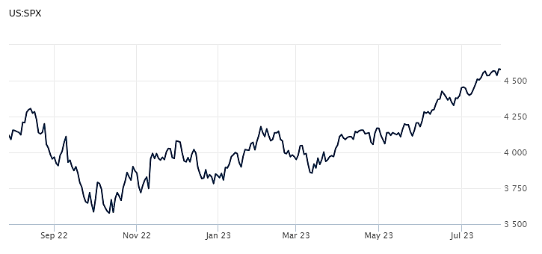
Source: Wall Street Journal

Fed Resumes Rates Hiking Efforts
As expected, the Fed approved a 25-basis point interest rate hike at its latest July meeting. The move brings the benchmark federal funds target rate to the 5.25% – 5.5% range, the highest level in more than two decades. With inflation still above the Fed's 2% target, the hike was highly anticipated and may not be the last one we see in 2023, particularly in light of recent economic data. Better-than-expected economic growth – as measured by Gross Domestic Product, or GDP – may be great news to some, but it also means the Fed’s work to slow economic activity (and thus lower prices) isn’t done yet. It can take months for the effects of monetary tightening to play out, so the Fed will closely monitor a number of economic metrics ahead of its September decision. According to Fed Chairman Jerome Powell:

It is certainly possible that we will raise rates again at the September meeting,” he said. “And I would also say it’s possible that we would choose to hold steady at that meeting. Source: AP

Economic Growth Still Humming
The latest report from the US Bureau of Economic Analysis showed that despite headwinds from rising interest rates, inflation, and uncertainty surrounding the possibility of a recession, the US economy continues to hum along. GDP grew at an annualized rate of 2.4% during the second quarter, faster than the prior quarter and significantly above economists’ estimates of a 1.8% bump. Driving these results were business investment, government expenditure, and consumer spending, the latter of which was up 1.6% for the period. And while the report shows that consumers – who account for 70% of economic activity – are still spending, the 1.6% increase falls short of the 4.2% delivered during the first quarter as shoppers pulled back on durable goods like washing machines and cars. Since the report shows cooling consumer demand along with moderate top-line growth, the Fed appears to be making meaningful progress toward its goal of taming inflation without throwing the economy into a recession. That economic resilience could also spell more interest rate hikes down the road. Source: CNN

More Good Inflation News
Inflation continues to dominate financial headlines but has shown signs of improving for several months now. While inflation remains above the Fed’s target rate of 2%, the latest report from the US Bureau of Labor Statistics suggests prices are coming back down to earth. The upbeat report showed that the Consumer Price Index (CPI) was up just 0.2% in June. Compared to a year ago, prices were up just 3%, the lowest year-over-year reading since March 2021. Both results beat Dow Jones estimates, which called for increases of 0.3% and 3.1%, respectively. Core CPI – which strips out the more volatile components of food and energy – was up 0.2% for the month and 4.8% compared to a year ago. Both those results beat estimates as well. Source: CNBC

This material represents an assessment of the market and economic environment at a specific point in time and is not intended to be a forecast of future events, or a guarantee of future results. Forward-looking statements are subject to certain risks and uncertainties. Actual results, performance, or achievements may differ materially from those expressed or implied. Information is based on data gathered from what we believe are reliable sources. It is not guaranteed as to accuracy, does not purport to be complete and is not intended to be used as a primary basis for investment decisions. It should also not be construed as advice meeting the particular investment needs of any investor. Past performance does not guarantee future results.

Indices are unmanaged and investors cannot invest directly in an index. Unless otherwise noted, performance of indices does not account for any fees, commissions or other expenses that would be incurred. Returns do not include reinvested dividends.

The Standard & Poor's 500 (S&P 500) is an unmanaged group of securities considered to be representative of the stock market in general. It is a market value weighted index with each stock's weight in the index proportionate to its market value.

The Nasdaq Composite Index is a market-capitalization weighted index of the more than 3,000 common equities listed on the Nasdaq stock exchange. The types of securities in the index include American depositary receipts, common stocks, real estate investment trusts (REITs) and tracking stocks. The index includes all Nasdaq listed stocks that are not derivatives, preferred shares, funds, exchange-traded funds (ETFs) or debentures.

The Dow Jones Industrial Average (DJIA) is a price-weighted average of 30 actively traded “blue chip” stocks, primarily industrials, but includes financials and other service-oriented companies. The components, which change from time to time, represent between 15% and 20% of the market value of NYSE stocks.

The Gross Domestic Product Price Index (GDP) measures changes in the prices of goods and services produced in the United States, including those exported to other countries. Prices of imports are excluded.

A Consumer Price Index (CPI) is a price index, the price of a weighted average market basket of consumer goods and services purchased by households. Changes in measured CPI track changes in prices over time.

©2023 Wealthcare Capital Management LLC and Wealthcare Advisory Partners LLC ("Wealthcare") is a registered investment advisor with the U.S. Securities and Exchange Commission (SEC) under the Investment Advisors Act of 1940. All Rights Reserved.

Information contained herein is at a point in time and subject to change without notice. Information is derived from sources which are believed to be reliable but are not independently audited.

This content is for informational purposes only and is not advice for any individual or a recommendation of any specific investment product or strategy. Wealthcare cannot guarantee any specific financial return results for any client or guarantee a client will in all circumstances of changing personal financial goals and market conditions be able to remain in a client's Wealthcare Plan Comfort Zone®. Past performance is not a guide to future returns. All investments carry a degree of risk of loss of principal and there is no assurance that an investment will provide positive performance over any period of time.



Two James Center, 1021 East Cary Street, Suite 702 | RICHMOND, VA 23219 | 804.644.4711
WealthcareGDX.com

