
Monthly Market Recap

August 2023 Market Recap

August has historically been a difficult month for the stock market, and this past month was no different. The broad market S&P 500® (SPX), the tech-heavy NASDAQ Composite Index (COMP), and the Dow Jones Industrial Average® (DJIA) all pulled back in August, snapping a steady string of monthly gains. Meanwhile, the latest GDP (Gross Domestic Product) data shows that the US economy remains resilient, even though the consumer spending component is cooling. Consumer confidence also took a hit in August as the effects of higher interest rates are starting to be felt more by families. Comments delivered by Federal Reserve leadership sent mixed signals about future interest rate hikes, with some experts suggesting that July's rate hike could be the last of the central bank’s aggressive campaign to curb inflation.

Stocks Pull Back
August marked the first time in the last six months that US stocks pulled back. The mega-cap SPX fell 2.4% for the month while the COMP dropped by 2.2%. The popular DJIA also fell, dropping 1.8% in August. Driving these results, in part, was uncertainty surrounding the Fed’s next move. The apparent strength of the US economy and labor market despite surging interest rates — which tend to squeeze business margins and raise the cost of capital — is both encouraging and puzzling for investors and financial experts. Longer term, all markets appear strong and continue to add to uptrends that started last October.

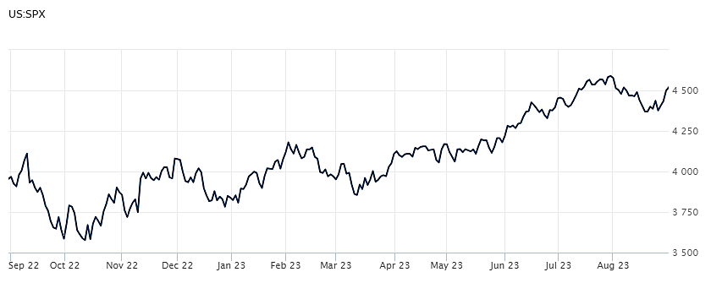

Source: Wall Street Journal

Economy Still Expanding
The US economy grew at an annual rate of 2.1% during the second quarter, up from the 2% growth rate recorded during the first quarter, as the economy continues to hum along despite headwinds from rising interest rates, inflation, and a downtick in consumer confidence. This latest GDP report by the Bureau of Economic Analysis was revised from the 2.4% annual growth rate first projected by the bureau earlier in the quarter. The government releases two preliminary GDP estimates before finalizing their numbers. The report revealed that consumer spending — which accounts for the lion's share (70%) of US economic growth — rose at a rate of 1.7% annually. While that important growth rate is still in positive territory, it's off the 4.2% recorded during the first quarter. Looking forward, the Atlanta Fed's GDPNow model is calling for annual growth of 5.9% for the third quarter. Source: AP, GDPNow

Consumer Confidence Dips
The way Americans feel about the job market and the economy at large declined in August, falling to 106.1 from July's 114.0 rating on the Conference Board Consumer Confidence Index, which gauges consumer sentiment. The Present Situation Index — which is based on how consumers feel about current labor and market conditions — dropped to 144.8 from 153.0. Meanwhile, the Expectations Index — a measure of consumers' feelings about future labor and market conditions — also fell to 80.2 from 88.0. Dana Peterson, Chief Economist at The Conference Board, added "Write-in responses showed that consumers were once again preoccupied with rising prices in general, and for groceries and gasoline in particular. The pullback in consumer confidence was evident across all age groups."
Source: CNN

Was July’s Rate Hike the Last?
At the Federal Reserve’s Annual Economic Symposium in Jackson Hole, Chairman Jerome Powell signaled that future interest rate hikes are not off the table. The closely watched speech also sent mixed signals about the state of the economy. On the one hand, the central bank’s efforts to curb economic activity don’t appear as effective as intended, with Powell admitting, "the economy may not be cooling as expected." On the other hand, he also noted that the Fed thinks current interest rates may be high enough to restrain growth and bring inflation under control. The Fed "will proceed carefully as we decide whether to tighten further or, instead, to hold the policy rate constant and await further data." In other words, it may take more time for the ripple effects of the Fed’s rate hikes to be revealed. While the Fed appears to remain committed to its 2% inflation target, many economists and investors believe July's rate hike is likely the last for the Fed. Many also believe that the chance of a recession this year is quickly fading. Source: CBS

This material represents an assessment of the market and economic environment at a specific point in time and is not intended to be a forecast of future events, or a guarantee of future results. Forward-looking statements are subject to certain risks and uncertainties. Actual results, performance, or achievements may differ materially from those expressed or implied. Information is based on data gathered from what we believe are reliable sources. It is not guaranteed as to accuracy, does not purport to be complete and is not intended to be used as a primary basis for investment decisions. It should also not be construed as advice meeting the particular investment needs of any investor. Past performance does not guarantee future results.

Indices are unmanaged and investors cannot invest directly in an index. Unless otherwise noted, performance of indices does not account for any fees, commissions or other expenses that would be incurred. Returns do not include reinvested dividends.

The Standard & Poor's 500 (S&P 500) is an unmanaged group of securities considered to be representative of the stock market in general. It is a market value weighted index with each stock's weight in the index proportionate to its market value.

The Nasdaq Composite Index is a market-capitalization weighted index of the more than 3,000 common equities listed on the Nasdaq stock exchange. The types of securities in the index include American depositary receipts, common stocks, real estate investment trusts (REITs) and tracking stocks. The index includes all Nasdaq listed stocks that are not derivatives, preferred shares, funds, exchange-traded funds (ETFs) or debentures.

The Dow Jones Industrial Average (DJIA) is a price-weighted average of 30 actively traded “blue chip” stocks, primarily industrials, but includes financials and other service-oriented companies. The components, which change from time to time, represent between 15% and 20% of the market value of NYSE stocks.

The Conference Board creates the Present Situation Index (PSI) from survey data of approximately 5000 households across the United States to gauge public opinion about the U.S. economy. When the index is positive, people feel good about the current economic situation. When negative, people are less optimistic. The (PSI) along with the Expectations Index are used by The Conference Board to create the Consumer Confidence Index (CCI) which tells us how optimistic (or not) people are about the future of the economy.

The Expectations Index is a component of the Consumer Confidence Index® (CCI), which is published each month by the Conference Board. The CCI reflects consumers’ short-term—that is, six-month—outlook for, and sentiment about, the performance of the overall economy as it effects them. The Expectations Index is made up of the average of the CCI components that deal with six-month outlooks for business, employment, and income.

A Consumer Price Index (CPI) is a price index, the price of a weighted average market basket of consumer goods and services purchased by households. Changes in measured CPI track changes in prices over time.

©2023 Wealthcare Capital Management LLC and Wealthcare Advisory Partners LLC ("Wealthcare") is a registered investment advisor with the U.S. Securities and Exchange Commission (SEC) under the Investment Advisors Act of 1940. All Rights Reserved.

Information contained herein is at a point in time and subject to change without notice. Information is derived from sources which are believed to be reliable but are not independently audited.

This content is for informational purposes only and is not advice for any individual or a recommendation of any specific investment product or strategy. Wealthcare cannot guarantee any specific financial return results for any client or guarantee a client will in all circumstances of changing personal financial goals and market conditions be able to remain in a client's Wealthcare Plan Comfort Zone®. Past performance is not a guide to future returns. All investments carry a degree of risk of loss of principal and there is no assurance that an investment will provide positive performance over any period of time.



Two James Center, 1021 East Cary Street, Suite 702 | RICHMOND, VA 23219 | 804.644.4711
WealthcareGDX.com

