
Monthly Market Recap

September 2023 Market Recap

The markets continued to pull back in September as investor sentiment waned following the Federal Reserve’s assertion that rates are likely to remain high for longer than previously expected. All three major market indexes posted losses for the second consecutive month to end the quarter in the red. Meanwhile, many across the country breathed a collective sigh of relief as Congress reached a resolution late last Saturday to avert a government shutdown that would have surely put more negative pressure on the financial markets.

As expected, the Federal Reserve (Fed) opted to leave interest rates unchanged following its September meeting. There had been some optimism that July's rate hike would end up being the last, but those hopes are likely dashed now in light of the latest inflation numbers, which revealed that prices weren’t moderating as quickly as intended. How US consumers feel about their current and future economic prospects also took a dip in September as interest rate hikes and uncertainty over prices and jobs took their toll.

Rough Quarter for Stocks
The broad-market S&P 500 (SPX) fell 4.9% for the month after declining 1.8% in August, while the tech-heavy Nasdaq Composite (COMP) lost 5.8% on the month after sliding 2.2% in August. The Dow Jones Industrial Average (DJIA) also fell 3.5% for the month. These were to worst monthly performances of the year for each index.

Factors driving this widespread decline included fear of an impending government shutdown (which was ultimately avoided), the specter of “higher for longer” interest rates, and renewed concerns regarding the outlook for the economy and ongoing inflation. Big picture, the economy and employment remain strong, which should bode well for the markets going forward.

S&P 500® (SPX): 12-Month Performance

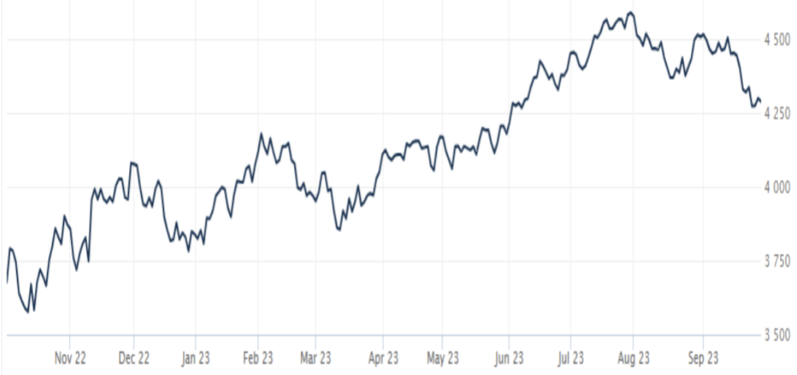

Source: Wall Street Journal

Government Stays Open
The threat of a government shutdown was narrowly avoided late Saturday night as Congress crafted a 71-page stop-gap funding bill to extend government operations for another 45 days. The funding resolution averts a shutdown that may have negatively impacted those affiliated with federal programs, including troops, border control agents, office workers, scientists, and many others. Goldman Sachs estimated a shutdown would have reduced economic activity by 0.2% for every week it lasted. Since the current agreement isn't a long-term solution, we may see another chaotic rush to resolve government spending before the November 17 deadline. That will likely inject new uncertainty into the markets, especially with the potential for another interest rate hike before the end of the year. CNBC

Fed Holds Rates for Now
The Fed decided not to raise interest rates during its September meeting. The move was expected and kept the Fed Funds rate in the 5.25% to 5.50% range. Even though inflation has moderated since its highs last summer, the 3.7% annual rate remains well above the Fed's 2% target, signaling that July’s rate hike likely won’t be the last one we see this year.

The markets are now anticipating another rate hike prior to year-end. The central bank has raised rates 11 times in the last year and a half, with July's rate hike being the most recent one. According to Fed Chairman Powell, "We have come very far very fast in the rate increases that we've made…I think it was important at the beginning that we move quickly and we did. As we get closer to the rate that we think — the stance of monetary policy that we think — is appropriate to bring inflation down to 2% over time, the risks become more two-sided." NPR

Consumer Confidence Slips Again
According to the Consumer Confidence Index, the way Americans feel about their current and future economic prospects fell to 103.0 in September from an upwardly revised 108.7 in August. The decline was larger than expected and points to growing concern among consumers, who account for 70% of all US economic activity. Perhaps most concerning was the decline in the Expectations Index, which fell to 73.7 in September after falling to 83.3 in August. That index is now below 80, which can indicate that consumers expect a recession within the next year. According to Dana Peterson, Chief Economist at The Conference Board, “Consumer confidence fell again in September 2023, marking two consecutive months of decline. September’s disappointing headline number reflected another decline in the Expectations Index, as the Present Situation Index was little changed. Write-in responses showed that consumers continued to be preoccupied with rising prices in general, and for groceries and gasoline in particular. AP, Conference Board

This material represents an assessment of the market and economic environment at a specific point in time and is not intended to be a forecast of future events, or a guarantee of future results. Forward-looking statements are subject to certain risks and uncertainties. Actual results, performance, or achievements may differ materially from those expressed or implied. Information is based on data gathered from what we believe are reliable sources. It is not guaranteed as to accuracy, does not purport to be complete and is not intended to be used as a primary basis for investment decisions. It should also not be construed as advice meeting the particular investment needs of any investor. Past performance does not guarantee future results.

Indices are unmanaged and investors cannot invest directly in an index. Unless otherwise noted, performance of indices does not account for any fees, commissions or other expenses that would be incurred. Returns do not include reinvested dividends.

The Standard & Poor's 500 (S&P 500) is an unmanaged group of securities considered to be representative of the stock market in general. It is a market value weighted index with each stock's weight in the index proportionate to its market value.

The Nasdaq Composite Index is a market-capitalization weighted index of the more than 3,000 common equities listed on the Nasdaq stock exchange. The types of securities in the index include American depositary receipts, common stocks, real estate investment trusts (REITs) and tracking stocks. The index includes all Nasdaq listed stocks that are not derivatives, preferred shares, funds, exchange-traded funds (ETFs) or debentures.

The Dow Jones Industrial Average (DJIA) is a price-weighted average of 30 actively traded “blue chip” stocks, primarily industrials, but includes financials and other service-oriented companies. The components, which change from time to time, represent between 15% and 20% of the market value of NYSE stocks.

The Conference Board creates the Present Situation Index (PSI) from survey data of approximately 5000 households across the United States to gauge public opinion about the U.S. economy. When the index is positive, people feel good about the current economic situation. When negative, people are less optimistic. The (PSI) along with the Expectations Index are used by The Conference Board to create the Consumer Confidence Index (CCI) which tells us how optimistic (or not) people are about the future of the economy.

The Expectations Index is a component of the Consumer Confidence Index® (CCI), which is published each month by the Conference Board. The CCI reflects consumers’ short-term—that is, six-month—outlook for, and sentiment about, the performance of the overall economy as it effects them. The Expectations Index is made up of the average of the CCI components that deal with six-month outlooks for business, employment, and income.

©2023 Wealthcare Capital Management LLC and Wealthcare Advisory Partners LLC ("Wealthcare") is a registered investment advisor with the U.S. Securities and Exchange Commission (SEC) under the Investment Advisors Act of 1940. All Rights Reserved.

Information contained herein is at a point in time and subject to change without notice. Information is derived from sources which are believed to be reliable but are not independently audited.

This content is for informational purposes only and is not advice for any individual or a recommendation of any specific investment product or strategy. Wealthcare cannot guarantee any specific financial return results for any client or guarantee a client will in all circumstances of changing personal financial goals and market conditions be able to remain in a client's Wealthcare Plan Comfort Zone®. Past performance is not a guide to future returns. All investments carry a degree of risk of loss of principal and there is no assurance that an investment will provide positive performance over any period of time.



Two James Center, 1021 East Cary Street, Suite 702 | RICHMOND, VA 23219 | 804.644.4711
WealthcareGDX.com

