Quarterly Letter


Third Quarter 2023 Quarterly Letter

The third quarter saw the Russell 3000 post a -4.7% loss, yet year-to-date stocks are still up 14%. Bonds were down -3.2% on the quarter and down -1.2% on the year as measured by the Bloomberg Aggregate. A typical 60% equity / 40% fixed income portfolio is up a respectable 6.4% year to date. Investors should have a smile on their faces from this number, yet the level of anxiety is high. Case in point, here were some selected headlines over this past quarter:

August 1st | Fitch downgrades the credit rating of the United States.
September 30th | A potential government shutdown is averted, having just averted a debt default.
September 29th | Bilateral trade between China and Russia rose by 32%.
September 29th | Torrential rains shut down ½ of 'NYC's subway lines.
September 13th | The who's who of the tech world meets with senators behind closed doors to debate A.I.

These headlines are a microcosm of what Ray Dalio, founder of hedge fund giant Bridgewater, has labeled the five forces that he speculates will create a period of great disorder. They are 1) Debt Accumulation, 2) Domestic Schisms, 3) New International World Order, 4) Acts of Nature, and 5) Technology.

- Debt Accumulation: U.S. public debt has exploded, growing from 100% of GDP a decade ago to 120% today. Given the higher interest rate environment, the cost to service this debt will increase.
- Domestic Schisms: Income and wealth inequality are higher in the U.S. than in almost any other developed country where the top 10% of households control 70% of the country's wealth. The values gap is equally pernicious, ranging from vaccines, climate change, and the value of college education. The result is a dysfunctional political system that has spilled over into violent conflict.
- International World Order: The Russian invasion of Ukraine and the COVID-19 pandemic have accelerated a new world order split into two spheres, one centered on Washington and the other on Beijing. Globalization and fair trade have morphed into self-sufficiency and onshoring. President Xi has said unifying Taiwan must be achieved, while President Biden has stated that he would defend Taiwan. Red lines have been drawn.
- Acts of Nature: Rising temperatures tied to climate change magnify the intensity and frequency of natural disasters, increasing stress on economies and countries.
- Technology: In just a matter of four months, A.I. flunked the bar exam and then aced it with a 90th percentile rank. Should we be excited or scared of A.I., or both? Will A.I. increase my efficiency at work or replace me? Will A.I. and robotics solve the labor shortage? What happens if A.I. replaces hundreds of thousands of workers, what will be the effect on individuals, society, and the stock market?

Based on the gravity of the list above, investor anxiety is justified.

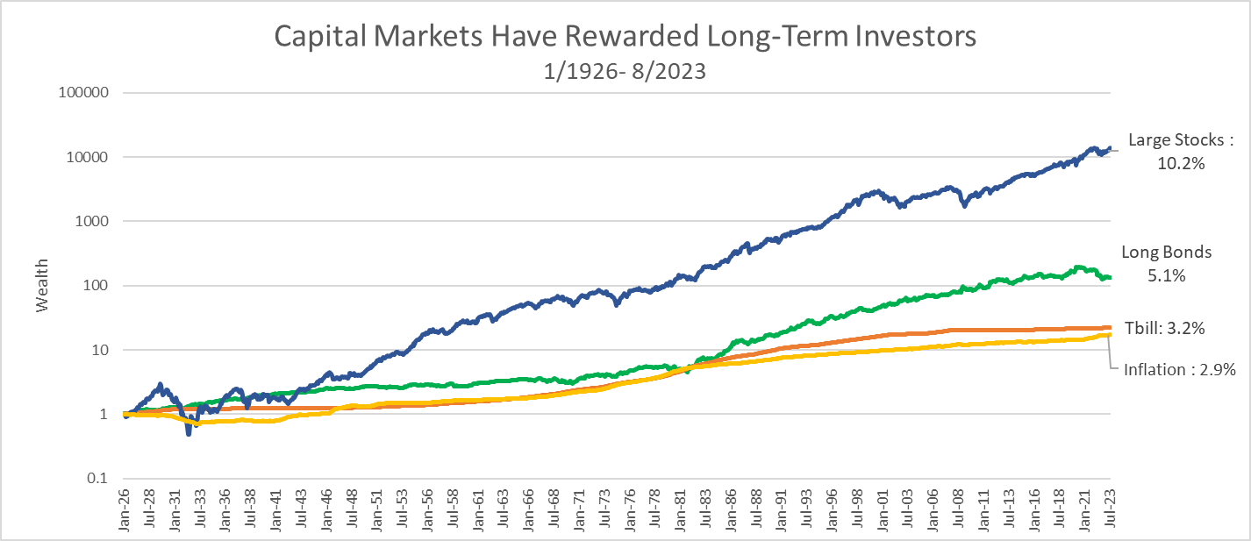

The above chart shows the historical long-term growth from 1926 to the present for equity, bonds, cash, and inflation investments. As represented by large stocks in the blue line, equity markets have compensated investors for bearing risks such as those in Dalio's five forces and others. The last century was marked by two World Wars, a Great Depression, and a Global Financial Crisis. Nonetheless, U.S. large-cap stocks have posted a 10.2% per year return, far outpacing inflation and bonds. The news always seems to be full of new things that create the crisis of the day. Holding equities for the long term requires optimism in the face of
the day's crises.

It requires the heart of an optimist to be a successful long-term investor in stocks because of how volatility interacts with our cognitive biases. Equities have a large standard deviation of returns, around 17%. This volatility is catnip for our faulty cognitive biases. For example, our desire to see patterns in randomness drives us to attempt to time markets, which is a fool's errand. Another example is known as the availability heuristic. This type of cognitive bias helps us make fast, but sometimes incorrect, assessments based on information readily available to us. So, scary news primes us to overweight the probability of negative events and, therefore, causes us to underinvest in stocks.
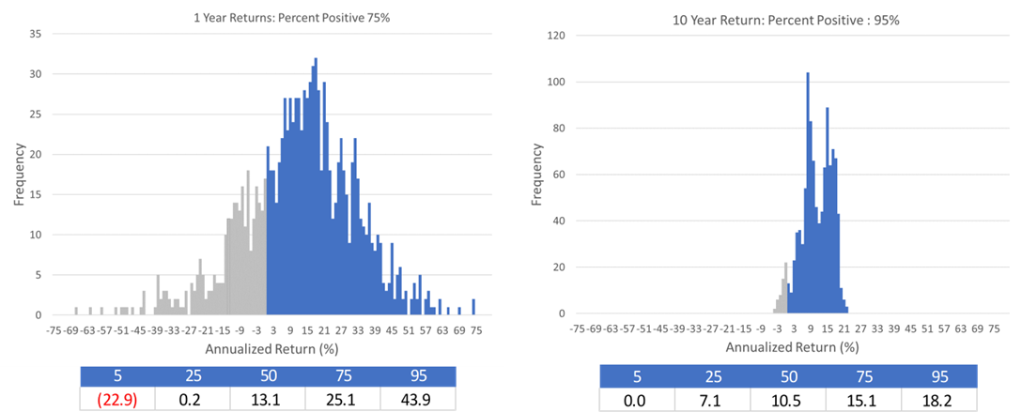
The above charts are based on the same monthly U.S. stock returns from 1926 to 2023. The left chart shows the frequency of one year returns, while the chart on the right shows the frequency of ten-year returns. In each case, the gray bars reflect the frequency of losing money over the time horizon, and the blue bars reflect the positive outcomes. Seventy-five percent of the time, stocks posted a positive return over a one-year horizon, but on a ten-year horizon, the frequency increases to ninety-five percent of the time that stocks have posted positive returns. These probabilities rise when looking at post-WWII returns.

We believe the best way to counteract cognitive biases, and to win as an equity investor, is to focus on longer horizons. While the ten-year probability distribution is extremely favorable, the psychological burden of holding for a decade can be substantial. Just think of all the wars, crises, economic turmoil, and short-term panics that occur in markets over any given decade.

Feel free to reach out to me to discuss tools and techniques to extend your time horizon as an investor. We can review whether you have an appropriate amount of risk in your portfolio, assess how diversified your portfolio is, and discuss how a goals-based planning process focusing on attaining long term goals can help you maintain this critical long-term perspective.

Source: Morningstar, MPI Stylus, Wealthcare, Data sources include IA SBBI Large Stocks, Long Term Govt Bonds, Tbills, Inflation.

©2023 Wealthcare Capital Management LLC ("Wealthcare") is a registered investment advisor with the U.S. Securities and Exchange Commission (SEC) under the Investment Advisors Act of 1940. All Rights Reserved.
This content is for educational purposes only and not to be considered a solicitation for the purchase or sale of any security and should not be relied upon as financial, tax, or legal advice. The views expressed are those of the author/presenter and all data is derived from sources believed to be reliable.

All market indices discussed are unmanaged and are not illustrative of any particular investment. Indices do not incur management fees, costs, or expenses. Investors cannot invest directly in indices. All economic and performance data is historical and not indicative of future results. Information contained herein is at a point in time and subject to change without notice. Information is derived from sources which are believed to be reliable, but are not independently audited. Wealthcare cannot guarantee any specific financial return results for any client. Past performance is not a guide to future returns.

Two James Center 1021, East Cary Street, Suite 702 | RICHMOND, VA 23219 | 804.644.4711

Wealthcaregdx.com

60/40 Portfolio consists of allocation is 2% cash; 51% Russell 3000 Index; 9%MSCI World Ex USA; 38% Bloomberg Aggregate Index. Performance is gross of all fees.

