
Monthly Market Recap

November 2023 Market Recap

Investors breathed a sigh of relief in November as all the major stock indices staged major comebacks. The S&P 500® (SPX), the Dow Jones Industrial Average® (DJIA), and the NASDAQ Composite Index (COMP) all recorded significant gains to snap months-long losing streaks. An analysis of Black Friday sales suggests there were more holiday shoppers than last year, but spending per shopper declined modestly. The latest inflation report indicated a continuing downward trend in prices, both overall and among core goods. Encouraging inflation data, steady economic growth, and moderating yields for 10-year Treasuries support the consensus that the Federal Reserve (Fed) is likely done raising rates for this year. Recession concerns have also eased as the prospect of a “soft landing” seems increasingly realistic.

Markets Roar Back
After a difficult few months, November saw US stocks rebound in a big way. The broad-market SPX gained 8.9% on the month after falling 2.2% in October. Likewise, the tech-heavy COMP gained 10.7% while the DJIA climbed 8.8%. Each of the indexes posted their best monthly performance of the year.

Factoring into this impressive surge is a consensus among investors and traders that the Fed is likely done raising interest rates this year, driven by positive economic news, especially on the inflation front. Also adding to the interest in stocks is the moderating 10-year Treasury note, which has recently fallen to 4.3% after peaking at 5%. Declining yields for the 10-year note can signal that investors are more willing to swap less risky fixed income investments for riskier investments like stocks. It also means that general financing costs may be headed lower since many loan types are tied to the 10-year note.
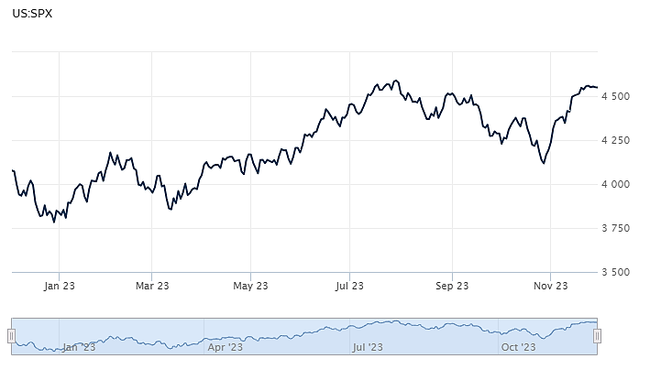
Source: Wall Street Journal

More Shoppers, But Flat Sales on Black Friday
According to the latest data from the National Retail Federation (NRF), about 200.4 million people – more than 60% of the US population – shopped over the Black Friday weekend, which typically runs from Thanksgiving through Cyber Monday. The 2023 results outpaced the record 197 million Black Friday shoppers in 2022. The results also beat the NRF's own forecast, which called for just 182 million shoppers.

Even though the number of shoppers went up, the amount they spent over Black Friday edged down slightly. Consumers spent an average of $321.41 over the weekend, slightly lower than the $325.44 spent over the same period last year.
This year's results are also lower than the $361 spent over pre-covid Black Friday in 2019. And while clothing, accessories, and toys were heavily sought-after, personal care and beauty items were among the most popular gifts purchased over the weekend. The NRF also said that Black Friday beat out Cyber Monday as the most popular online shopping day. Black Friday is critical because it kicks off the holiday season, which makes up about 20% of retailers' sales for the entire year. CNN

Inflation Flat for October
The Consumer Price Index (CPI) was flat in October compared to the prior month. Compared to a year ago, prices were up 3.2%. Both results were slightly below expectations, which called for readings of 0.1% and 3.3%, respectively. Excluding the more volatile components of food and energy, core CPI was up 0.2% for the month and 4% for the year, also beating forecasts of 0.3% and 4.1%, respectively. Core CPI is now at its lowest level in two years. Shelter costs – a key component of the index – grew just 0.3% in October, half the gain recorded in September. Meanwhile, vehicle costs – which were a key inflation component during the inflation spike of 2021-22 – fell in October. New vehicle prices dropped 0.1% while used vehicle prices dropped 0.8% during October and 7.1% compared to a year ago. With top-line CPI and core CPI significantly off their recent highs and trending down, the Fed now has more evidence that inflation is moderating, which may mean that the central bank's tightening cycle is coming to an end. CNBC

Home Sales Hit Multi-Year Lows
Existing home sales were 4.1% lower in October than they were in September, according to the National Association of Realtors (NAR). That translated to sales of just 3.8 million units – the slowest pace since August 2010 – and 14.6% lower than a year ago. According to Lawrence Yun, NAR’s chief economist, "Prospective home buyers experienced another difficult month due to the persistent lack of housing inventory and the highest mortgage rates in a generation." At the close of October, there were 1.15 million homes for sale, 5.7% lower than a year ago and about half the inventory available pre-Covid. That inventory represents a 3.6-month supply, while a six-month supply is typically considered necessary for a balanced market. Tight inventory has also pressured prices, with the median price of an existing home sitting at $391,800, up 3.4% compared to a year ago. CNBC

This material represents an assessment of the market and economic environment at a specific point in time and is not intended to be a forecast of future events, or a guarantee of future results. Forward-looking statements are subject to certain risks and uncertainties. Actual results, performance, or achievements may differ materially from those expressed or implied. Information is based on data gathered from what we believe are reliable sources. It is not guaranteed as to accuracy, does not purport to be complete and is not intended to be used as a primary basis for investment decisions. It should also not be construed as advice meeting the particular investment needs of any investor. Past performance does not guarantee future results.

Indices are unmanaged and investors cannot invest directly in an index. Unless otherwise noted, performance of indices does not account for any fees, commissions or other expenses that would be incurred. Returns do not include reinvested dividends.

The Standard & Poor's 500 (S&P 500) is an unmanaged group of securities considered to be representative of the stock market in general. It is a market value weighted index with each stock's weight in the index proportionate to its market value.

The Nasdaq Composite Index is a market-capitalization weighted index of the more than 3,000 common equities listed on the Nasdaq stock exchange. The types of securities in the index include American depositary receipts, common stocks, real estate investment trusts (REITs) and tracking stocks. The index includes all Nasdaq listed stocks that are not derivatives, preferred shares, funds, exchange-traded funds (ETFs) or debentures.

The Dow Jones Industrial Average (DJIA) is a price-weighted average of 30 actively traded “blue chip” stocks, primarily industrials, but includes financials and other service-oriented companies. The components, which change from time to time, represent between 15% and 20% of the market value of NYSE stocks.

A Consumer Price Index (CPI) is a price index, the price of a weighted average market basket of consumer goods and services purchased by households. Changes in measured CPI track changes in prices over time.

©2023 Wealthcare Capital Management LLC and Wealthcare Advisory Partners LLC ("Wealthcare") is a registered investment advisor with the U.S. Securities and Exchange Commission (SEC) under the Investment Advisors Act of 1940. All Rights Reserved.

Information contained herein is at a point in time and subject to change without notice. Information is derived from sources which are believed to be reliable but are not independently audited.

This content is for informational purposes only and is not advice for any individual or a recommendation of any specific investment product or strategy. Wealthcare cannot guarantee any specific financial return results for any client or guarantee a client will in all circumstances of changing personal financial goals and market conditions be able to remain in a client's Wealthcare Plan Comfort Zone®. Past performance is not a guide to future returns. All investments carry a degree of risk of loss of principal and there is no assurance that an investment will provide positive performance over any period of time.



Two James Center, 1021 East Cary Street, Suite 702 | RICHMOND, VA 23219 | 804.644.4711
WealthcareGDX.com

