
Monthly Market Recap

December 2023 Market Recap

The markets finished the year on a high note, driven by encouraging economic numbers and the conclusion of the Federal Reserve’s (Fed) rate-hiking campaign. The NASDAQ Composite Index (COMP) recorded its best year since 2020, the Dow Jones Industrial Average® (DJIA) set a new high, and S&P 500® (SPX) – while short of a record – rose for nine straight weeks to end the year. The yield on the benchmark 10-year Treasury Note is now well off its October highs, providing relief for borrowers, hope for a stagnant housing sector, and indicating that investors are warming up to stocks. The latest reports on growth and inflation also continue to point to more good news in 2024.

Markets Finish 2023 with a Bang
For the second month in a row, the markets posted impressive gains to close out 2023 with a bang. The tech-heavy Nasdaq led the way, gaining 5.5% in December after surging 10.7% in November. For 2023, the index gained 43.4% – its best year since 2020. The broad market S&P 500 gained 4.4% for the month after climbing 8.9% the prior month. For the year, the SPX gained 24.2%. Meanwhile, the Dow Jones went up 4.8% in December after rising 8.8% in November. In 2023, the popular index gained 13.7%.

Likely behind the strong finish to 2023 was the Fed signaling that it's done raising rates and could even begin cutting rates in 2024. Stronger-than-expected inflation, jobs, and growth numbers also encouraged investors. Investors' willingness to buy riskier investments like stocks is reflected in the declining yield on the benchmark 10-year Treasury note, which now sits at less than 3.9% after reaching a high of 5% in October. The decline in the 10-year Treasury also translates to lower financing costs, including mortgage rates and consumer loans.

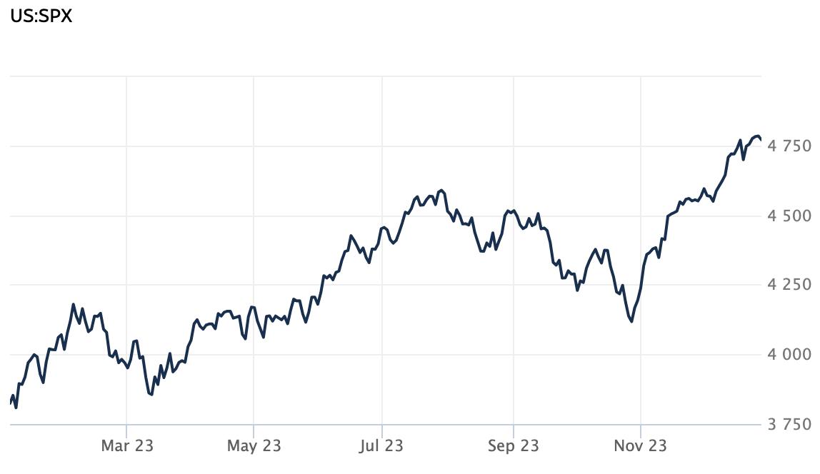
Source: Wall Street Journal

US Economic Growth Remains Strong
According to the latest numbers from the US Bureau of Economic Analysis, US economic output grew at an annualized rate of 4.9% during the third quarter from July through September. The final estimate of third-quarter growth was down slightly from the 5.2% previously projected but still revealed a robust and resilient economy. Growth in the third quarter was the strongest in almost two years and reflected increases in private inventory investment, exports, government spending, and residential and nonresidential fixed investment. Consumer spending – which accounts for about two-thirds of all economic activity in the US – edged down slightly to 3.1% from 3.6% but remains on a positive trajectory. CNN

Fed Keeps Rates Steady, Signals Cuts in 2024
During its December meeting, the Fed held interest rates steady for the third straight time, keeping the benchmark federal funds rate in the 5.25%-5.5% range. This move (or lack thereof) was widely anticipated and brought an end to one of the most aggressive rate-hiking cycles in US history. The central bank raised rates 11 times since March 2022.

The Fed signaled that interest rate cuts may be on the horizon in 2024. The markets appeared to price in an aggressive series of cuts totaling 1.5% next year, higher than what the central bank has suggested. According to Fed Chairman Powell, "Inflation has eased from its highs, and this has come without a significant increase in unemployment. That’s very good news." The Fed now sees core inflation falling to 3.2% in 2023, 2.4% in 2024, and 2.2% in 2025. In 2026, the Fed anticipates inflation will hit its target rate of 2%. CNBC

Inflation Continues to Ease
Speaking of inflation, the latest report shows continuing price easing. According to the US Bureau of Labor Statistics, consumer prices rose 0.1% in November after no change in October. Compared to a year ago, prices were up 3.1%. The latest report shows a continuing downward trend in price inflation that began last summer when inflation hit a 9% peak. Core inflation – which strips out the more volatile components of food and energy – was up 4% in November compared to a year ago and was unchanged from the reading in October.
The price moderation in November was partly due to a decline in gas prices, which have dropped about 6% in the past month. While some grocery items like beef and cereal continue to rise, other grocery staples like eggs have fallen significantly. In addition, declining inflation hasn't torpedoed economic growth and jobs, which both remain strong. Consumer spending has also remained resilient, with consumers spending a record $9.8 billion online on Black Friday, 7.5% more than last year. ABC

This material represents an assessment of the market and economic environment at a specific point in time and is not intended to be a forecast of future events, or a guarantee of future results. Forward-looking statements are subject to certain risks and uncertainties. Actual results, performance, or achievements may differ materially from those expressed or implied. Information is based on data gathered from what we believe are reliable sources. It is not guaranteed as to accuracy, does not purport to be complete and is not intended to be used as a primary basis for investment decisions. It should also not be construed as advice meeting the particular investment needs of any investor. Past performance does not guarantee future results.

Indices are unmanaged and investors cannot invest directly in an index. Unless otherwise noted, performance of indices does not account for any fees, commissions or other expenses that would be incurred. Returns do not include reinvested dividends.

The Standard & Poor's 500 (S&P 500) is an unmanaged group of securities considered to be representative of the stock market in general. It is a market value weighted index with each stock's weight in the index proportionate to its market value.

The Nasdaq Composite Index is a market-capitalization weighted index of the more than 3,000 common equities listed on the Nasdaq stock exchange. The types of securities in the index include American depositary receipts, common stocks, real estate investment trusts (REITs) and tracking stocks. The index includes all Nasdaq listed stocks that are not derivatives, preferred shares, funds, exchange-traded funds (ETFs) or debentures.

The Dow Jones Industrial Average (DJIA) is a price-weighted average of 30 actively traded “blue chip” stocks, primarily industrials, but includes financials and other service-oriented companies. The components, which change from time to time, represent between 15% and 20% of the market value of NYSE stocks.

A Consumer Price Index (CPI) is a price index, the price of a weighted average market basket of consumer goods and services purchased by households. Changes in measured CPI track changes in prices over time.

The Core Consumer Price Index (CPI) measures the changes in the price of goods and services, excluding food and energy. The CPI measures price change from the perspective of the consumer. It is a key way to measure changes in purchasing trends and inflation.

©2024 Wealthcare Capital Management LLC and Wealthcare Advisory Partners LLC ("Wealthcare") is a registered investment advisor with the U.S. Securities and Exchange Commission (SEC) under the Investment Advisors Act of 1940. All Rights Reserved.

Information contained herein is at a point in time and subject to change without notice. Information is derived from sources which are believed to be reliable but are not independently audited.

This content is for informational purposes only and is not advice for any individual or a recommendation of any specific investment product or strategy. Wealthcare cannot guarantee any specific financial return results for any client or guarantee a client will in all circumstances of changing personal financial goals and market conditions be able to remain in a client's Wealthcare Plan Comfort Zone®. Past performance is not a guide to future returns. All investments carry a degree of risk of loss of principal and there is no assurance that an investment will provide positive performance over any period of time.



Two James Center, 1021 East Cary Street, Suite 702 | RICHMOND, VA 23219 | 804.644.4711
WealthcareGDX.com

