Quarterly Letter
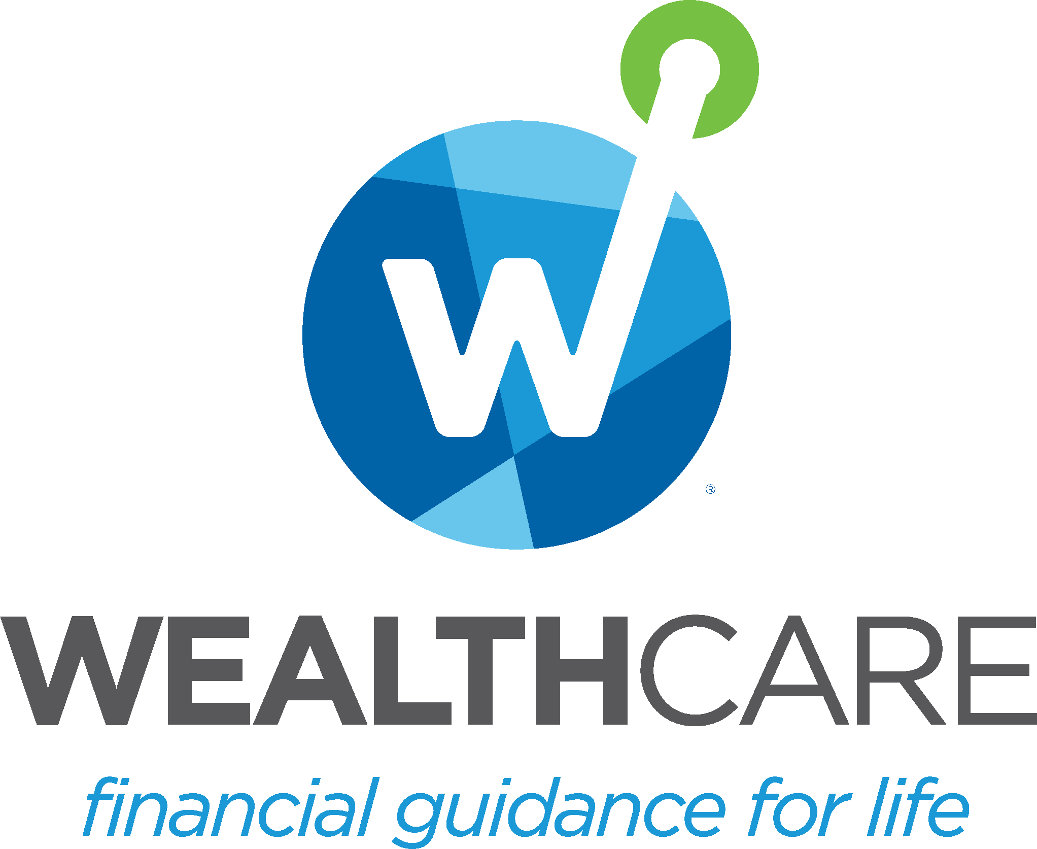

Fourth Quarter 2023 Quarterly Letter

The end of the year is the time to look back and look ahead. Reflecting on 2023, Scott Galloway, NYU Professor and podcaster, proclaimed the biggest business story of the past year was not Taylor Swift's Eras tour nor Artificial Intelligence but the advent of blockbuster weight loss drugs (see thumbnail).
NEW YEARS RESOLUTION SURVEY
According to a Forbes’ survey, below are the top 5 New Year’s Resolutions for 2024
- 48% resolved to exercise more
- 38% resolved to improve finances
- 36% resolved to improve their mental health
- 34% resolved to lose weight
- 32% resolved to eat healthier
The miracle weight loss drugs Galloway referenced may help us conquer two of the above resolutions - lose weight and eat healthier. These drugs have also been found to improve cardiovascular health as well as reduce cravings for everything ranging from biting our nails to gambling. Improving finances climbed two spots from the start of 2023 from #4 to #2.
The biggest story of 2023 for the equity markets was the performance of the Magnificent Seven (Facebook, Apple, Microsoft, Nvidia, Tesla, Google and Amazon). These seven stocks propelled the S&P 500 to finish the year up 26%, accounting for 78% of the gains. As for bonds, the Bloomberg Aggregate finished the year up 5.5% thanks to a huge rally in the last two months.
However, there are a lot of questions on investors' minds as we turn the calendar to 2024. Will that recession that has been predicted ever occur? Can the Fed declare "mission accomplished" in its battle against inflation? Will the equity markets sustain their momentum? How will budget negotiations, including a possible shutdown, affect the deficit, economic growth, and corporate earnings? Will the Israeli-Hamas metastasize into a wider conflict, causing supply chains and oil prices to unravel? And, of course, how will markets react to the looming presidential election?
To answer these questions, a plethora of 2024 Year Outlooks are published by virtually every investment bank and asset manager. Are these publications useful in predicting markets, or are they Trojan Horse marketing predictions to coax us into purchasing investment products?

Below is evidence that you don't want to base your investment strategy on market forecasters:

- Here's where the sharpest brains on Wall Street predicted the S&P 500 would end 2023 after beginning the year at 3,823, along with their projected price return:
 | Firm | Ending S&P 500 | Price Return (%)
 | Barclays | 3,675 | (3.9)
 | Morgan Stanley | 3,900 | 2.0
 | UBS | 3,900 | 2.0
 | Citi | 3,900 | 2.0
 | BlackRock | 3,930 | 2.8
 | Actual | 4,783 | 25.1
- In James Montier's book Behavioral Investing (2007), he shows aggregate forecasts from Wall Street's most famous oracles through time, next to the actual trajectory of the forecast variable. In all cases, the analysts appear to do a noteworthy job of describing what just happened but appear to have no vision whatsoever about what is about to happen next. This applies to interest rates, the level of stock indices, and aggregate earnings.

- CXO Advisory has been tracking and publishing gurus' forecasts of market direction since 1998. Over 14 years, CXO concluded that the average guru's accuracy in calling the market's direction has been about 47%, or slightly worse than a coin toss.
Many people market to the desire for certainty, but it does not exist in the investing world. There are no "miracle" managers or products. We should realize everybody's crystal balls are, at best, cloudy, and the sooner we realize that the better we can focus on items we can control.

Please reach out to me to discuss how we can improve your finances for the coming year. Similar to the weight loss drugs, we can potentially tackle two common resolutions: 1) to improve your finances and 2) in doing so, you will have additional confidence, clarity, and control as we head into 2024.

In particular, I would like to highlight our goals-based planning approach. We do not advise making decisions about your investments or wealth plan based on a one-year forecast. Rather than chase the one-year forecast, planning on horizons much longer than one year is more effective while managing risk and goals at least annually. We use plausible forward-looking capital markets and stress the probability of success given market uncertainties to keep you in the Comfort Zone® and on track to realize your life vision. Instead of chasing the market, chase your dreams with the Comfort Zone.

I want to wish you a happy and healthy New Year.

https://www.cxoadvisory.com/gurus/

©2024 Wealthcare Capital Management LLC ("Wealthcare") is a registered investment advisor with the U.S. Securities and Exchange Commission (SEC) under the Investment Advisors Act of 1940. All Rights Reserved.
This content is for educational purposes only and not to be considered a solicitation for the purchase or sale of any security and should not be relied upon as financial, tax, or legal advice. The views expressed are those of the author/presenter and all data is derived from sources believed to be reliable.

All market indices discussed are unmanaged and are not illustrative of any particular investment. Indices do not incur management fees, costs, or expenses. Investors cannot invest directly in indices. All economic and performance data is historical and not indicative of future results. Information contained herein is at a point in time and subject to change without notice. Information is derived from sources which are believed to be reliable, but are not independently audited. Wealthcare cannot guarantee any specific financial return results for any client. Past performance is not a guide to future returns.

Two James Center 1021, East Cary Street, Suite 702 | RICHMOND, VA 23219 | 804.644.4711

Wealthcaregdx.com

