
Monthly Market Recap

January 2024 Market Recap

After finishing 2023 on an upswing, the stock market continued on a positive trajectory to start 2024 with each of the major stock indexes posting gains in January. As expected, the Federal Reserve (Fed) kept interest rates unchanged for the fourth straight meeting and gave no clear indication of when interest rate cuts could begin, disappointing investors and analysts. Meanwhile, a strong jobs market report and a tick higher in inflation add to a mixed bag of economic reports that continues to put the Fed – and investors – in a quandary about what's next for the markets.

Markets Continue Higher in January
The Dow Jones Industrial Average® (DJIA), S&P 500® (SPX), and NASDAQ Composite Index (COMP) each closed the month in the green, driven by positive investor sentiment. Stocks have now delivered increases in three consecutive months. The broad market SPX led the way in January, gaining 1.6% on the month. The move was less than the 4.4% gain recorded in December but still in solid territory. The popular DJIA also rose in January, up 1.2% after delivering 4.8% gains in December. The tech-heavy COMP also climbed in January, up just over 1% on the month.

Each of these indexes is now significantly off the lows they recorded in October 2022, when rising rates and economic uncertainty dragged on investors. Likely driving the interest in US equities is encouraging news on the economic front, moderating (but not yet tamed) inflation, and strong growth projections. The decline in the yield of the 10-year Treasury also indicates an increased appetite for equities as investors opt for riskier investments instead of safer ones like fixed-income securities. The decline in the 10-year Treasury also makes a number of financing options more attractive for consumers and businesses. As a reminder, the 10-year Treasury is used as a benchmark for many consumer loans, including mortgage rates.

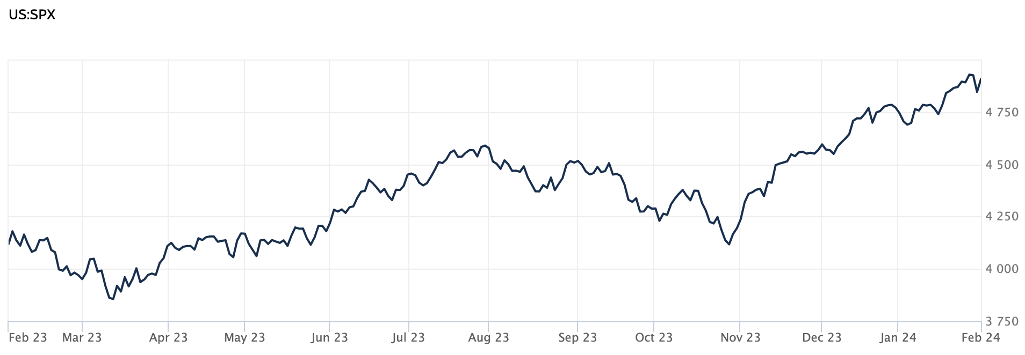

Source: Wall Street Journal

Interest Rates Unchanged but Future Cuts Unknown
As anticipated, the Fed left interest rates unchanged during its January meeting, keeping the fed funds target rate in the 5.25% to 5.5% range. The Fed did signal that interest rate hikes are likely off the table but was less clear about when interest rate cuts might begin. According to the Fed's statement, "the Committee does not expect it will be appropriate to reduce the target range until it has gained greater confidence that inflation is moving sustainably toward 2 percent." The fed's statement and Chairman Jerome Powell's comments put to rest the possibility of commencing rate cuts in March, as many investors and analysts had hoped.
During its December meeting, the US central bank's policymakers indicated that there could be three quarter-point interest rate cuts over the course of 2024. While that regimen may still be in the cards, the frequency and degree of the cuts are far from certain. Surprisingly resilient economic growth, a strong jobs market, and moderating inflation have forestalled analysts' predictions from last year, which called for widespread layoffs and tepid growth. While parts of the tech sector have been rattled by layoffs in recent weeks, the otherwise encouraging economic reports are all positive factors for the Fed as they consider loosening monetary policy going forward. AP News

Job Market Continues to Hum
According to the latest report from the US Bureau of Labor Statistics, the US job market continues to hum along, adding 216,000 jobs in December. The better-than-expected numbers that closed out 2023 appear to have defied predictions, many of which have consistently called for an eventual slow-down in jobs. The job gains in December were well above economists' estimates, which called for a jump of 170,000. December's solid job numbers also point to continuing good news for job seekers, despite an aggressive interest rate policy from the Fed. During the month of December, hiring rose in the government, health care, and construction sectors. On the other hand, the warehousing and transportation sectors saw the number of jobs decrease. The December jobs data also reported 71,000 fewer combined jobs in October and November than was originally estimated.

The unemployment rate remained at 3.7% during the month, a historically low rate. Wages rose 0.4% in December and 4.1% compared to a year ago, adding more good news for workers, but also adding to inflationary pressures and drawing more attention from the central bank. Axios

Inflation Ticks Higher
Consumer prices ticked up more than expected in December, suggesting inflation will likely continue to be on everyone's radar for the time being. The Consumer Price Index (CPI) rose 0.3% during the month, slightly above estimates that called for a 0.2% rise. On a year-over-year basis, prices were up 3.4%, also above the 3.2% that economists surveyed by Dow Jones were expecting. Core CPI – which strips out the more volatile components of food and energy – rose 0.3% for the month and 3.9% compared to a year ago. Both numbers were also above expectations.

Much of the increase in December prices was due to the rise in shelter costs, which are now 6.2% higher than a year ago and will continue to be an area of concern for the Fed. In December, services rose 5.3% compared to a year ago, which is also likely to get the attention of the Fed since they can be an indicator of durable moderating inflation. Despite the less-than-desired inflation news, the markets seem to be looking for six rate cuts this year. Meanwhile, the Fed is anticipating just three cuts. CNBC

This research material was prepared by Tifin Marketing Automation.

This material represents an assessment of the market and economic environment at a specific point in time and is not intended to be a forecast of future events, or a guarantee of future results. Forward-looking statements are subject to certain risks and uncertainties. Actual results, performance, or achievements may differ materially from those expressed or implied. Information is based on data gathered from what we believe are reliable sources. It is not guaranteed as to accuracy, does not purport to be complete and is not intended to be used as a primary basis for investment decisions. It should also not be construed as advice meeting the particular investment needs of any investor. Past performance does not guarantee future results.

Indices are unmanaged and investors cannot invest directly in an index. Unless otherwise noted, performance of indices does not account for any fees, commissions or other expenses that would be incurred. Returns do not include reinvested dividends.

The Standard & Poor's 500 (S&P 500) is an unmanaged group of securities considered to be representative of the stock market in general. It is a market value weighted index with each stock's weight in the index proportionate to its market value.

The Nasdaq Composite Index is a market-capitalization weighted index of the more than 3,000 common equities listed on the Nasdaq stock exchange. The types of securities in the index include American depositary receipts, common stocks, real estate investment trusts (REITs) and tracking stocks. The index includes all Nasdaq listed stocks that are not derivatives, preferred shares, funds, exchange-traded funds (ETFs) or debentures.

The Dow Jones Industrial Average (DJIA) is a price-weighted average of 30 actively traded “blue chip” stocks, primarily industrials, but includes financials and other service-oriented companies. The components, which change from time to time, represent between 15% and 20% of the market value of NYSE stocks.

A Consumer Price Index (CPI) is a price index, the price of a weighted average market basket of consumer goods and services purchased by households. Changes in measured CPI track changes in prices over time.

The Core Consumer Price Index (CPI) measures the changes in the price of goods and services, excluding food and energy. The CPI measures price change from the perspective of the consumer. It is a key way to measure changes in purchasing trends and inflation.

©2024 Wealthcare Capital Management LLC and Wealthcare Advisory Partners LLC ("Wealthcare") is a registered investment advisor with the U.S. Securities and Exchange Commission (SEC) under the Investment Advisors Act of 1940. All Rights Reserved.

Information contained herein is at a point in time and subject to change without notice. Information is derived from sources which are believed to be reliable but are not independently audited.

This content is for informational purposes only and is not advice for any individual or a recommendation of any specific investment product or strategy. Wealthcare cannot guarantee any specific financial return results for any client or guarantee a client will in all circumstances of changing personal financial goals and market conditions be able to remain in a client's Wealthcare Plan Comfort Zone®. Past performance is not a guide to future returns. All investments carry a degree of risk of loss of principal and there is no assurance that an investment will provide positive performance over any period of time.



Two James Center, 1021 East Cary Street, Suite 702 | RICHMOND, VA 23219 | 804.644.4711
WealthcareGDX.com

