
Monthly Market Recap

February 2024 Market Recap

The financial markets finished February at record highs and show little sign of slowing their momentum in the near future. We're seeing a consistent flow of robust economic data, highlighting improvements in economic expansion and employment. Although the housing market's progress isn't extraordinary, it's showing vitality with the easing of mortgage rates. Insights from the recent Federal Reserve (Fed) meeting indicate persistent inflation concerns, but we anticipate that interest rate cuts should occur within the year.

Stock Market Continues to Soar
The markets continued their surge as investors poured into stocks. The broad market S&P 500® (SPX) and the Dow Jones Industrial Average® (DJIA) recently made new highs, while the tech-heavy NASDAQ Composite Index (COMP) isn't far behind. All three of the major indices have now recorded four consecutive months of gains. The COMP led the way in February, gaining 6.1% compared to the prior month. Meanwhile, the SPX and the DJIA also booked gains, rising 5.2% and 2.2%, respectively.

The surge in US stock prices is likely driven by encouraging economic updates for growth, employment, and inflation. Optimism is further buoyed by the prospect of Fed rate cuts later this year, though the timing and scale of these remain unclear. Also adding to the interest in stocks is the long-term decline of 10-year Treasury yields, which serve as an important benchmark for consumer and business borrowing rates.

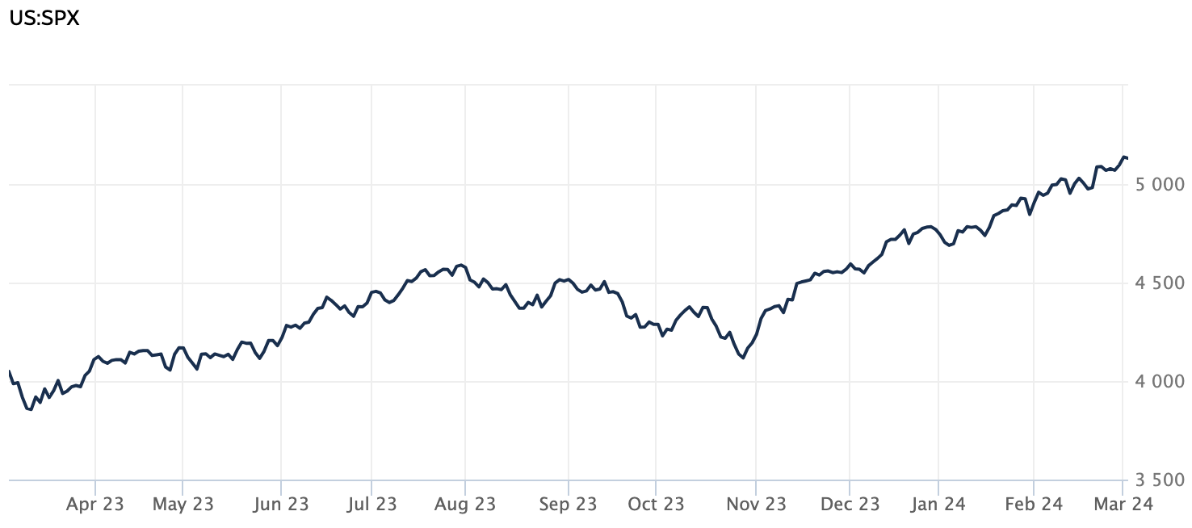

Source: Wall Street Journal

US Economy Keeps Humming Along
Gross Domestic Product (GDP) accelerated at a 3.2% annualized rate during the fourth quarter of 2024, according to the latest data from the Bureau of Economic Analysis. While this estimate is down a hair from the 3.3% rate that analysts had originally predicted, the results reveal a strong and resilient US economy. US growth has eclipsed 2% for six straight quarters, defying expectations that high interest rates would slow growth and punish businesses.
Consumer spending -– which accounts for 70% of US economic activity — grew at a 3% annualized rate during the October through December period, outpacing the overall growth rate. Meanwhile, spending by local and state governments grew at a 5.4% annual rate, the fastest since 2019. Looking ahead, the International Monetary Fund expects the US to expand by 2.1% in 2024 — more than twice its forecasts for other major advanced economies Japan, Germany, and the United Kingdom. AP News

New Home Sales Come in Lower Than Expected
Sales of new US single-family homes increased 1.5% last month to an annual rate of 661,000 units, according to the latest sales data from the US Census Bureau. Compared to a year ago, sales were up 1.8%. The new home sales in January were less than the 680,000 units expected by economists. The median home price was $420,700 in January, marking a 2.6% decrease compared to a year ago. However, the pace of the decline is slowing as builders offer fewer incentives and price cuts. Freezing temperatures across the nation likely forced many potential home buyers to stay home last month, depressing the results. Economists expect mortgage rates to continue to trend lower, especially once the Fed begins lowering rates, which could have a resurgent effect on home sales. Existing housing inventory may increase as well as mortgage holders see lower mortgage rates on the horizon. Yahoo Finance

Rate Cuts Are Likely, But When?
Investors and Wall Street were disappointed that the Fed decided to keep interest rates steady coming out of its January meeting. The details of the US central bank's minutes reveal the reason: the Fed is still worried about inflation. While Fed policymakers admitted that "significant progress" had been made toward taming inflation, persistently robust economic and job growth could put a damper on that progress. Most Fed officials were also concerned that lowering their benchmark interest rate too early could exacerbate inflationary pressures. Very few felt the opposite: that not lowering rates could put the brakes on economic and job growth. Officials "noted the risk that progress toward price stability could stall, particularly if aggregate demand strengthened." The Fed also indicated that rate cuts will likely not start following its March meeting. Still, many market participants feel that two or more interest rate cuts are on the table for 2024. AP News

This research material was prepared by Tifin Marketing Automation.

This material represents an assessment of the market and economic environment at a specific point in time and is not intended to be a forecast of future events, or a guarantee of future results. Forward-looking statements are subject to certain risks and uncertainties. Actual results, performance, or achievements may differ materially from those expressed or implied. Information is based on data gathered from what we believe are reliable sources. It is not guaranteed as to accuracy, does not purport to be complete and is not intended to be used as a primary basis for investment decisions. It should also not be construed as advice meeting the particular investment needs of any investor. Past performance does not guarantee future results.

Indices are unmanaged and investors cannot invest directly in an index. Unless otherwise noted, performance of indices does not account for any fees, commissions or other expenses that would be incurred. Returns do not include reinvested dividends.

The Standard & Poor's 500 (S&P 500) is an unmanaged group of securities considered to be representative of the stock market in general. It is a market value weighted index with each stock's weight in the index proportionate to its market value.

The Nasdaq Composite Index is a market-capitalization weighted index of the more than 3,000 common equities listed on the Nasdaq stock exchange. The types of securities in the index include American depositary receipts, common stocks, real estate investment trusts (REITs) and tracking stocks. The index includes all Nasdaq listed stocks that are not derivatives, preferred shares, funds, exchange-traded funds (ETFs) or debentures.

The Dow Jones Industrial Average (DJIA) is a price-weighted average of 30 actively traded “blue chip” stocks, primarily industrials, but includes financials and other service-oriented companies. The components, which change from time to time, represent between 15% and 20% of the market value of NYSE stocks.

A Consumer Price Index (CPI) is a price index, the price of a weighted average market basket of consumer goods and services purchased by households. Changes in measured CPI track changes in prices over time.

The Core Consumer Price Index (CPI) measures the changes in the price of goods and services, excluding food and energy. The CPI measures price change from the perspective of the consumer. It is a key way to measure changes in purchasing trends and inflation.

©2024 Wealthcare Capital Management LLC and Wealthcare Advisory Partners LLC ("Wealthcare") is a registered investment advisor with the U.S. Securities and Exchange Commission (SEC) under the Investment Advisors Act of 1940. All Rights Reserved.

Information contained herein is at a point in time and subject to change without notice. Information is derived from sources which are believed to be reliable but are not independently audited.

This content is for informational purposes only and is not advice for any individual or a recommendation of any specific investment product or strategy. Wealthcare cannot guarantee any specific financial return results for any client or guarantee a client will in all circumstances of changing personal financial goals and market conditions be able to remain in a client's Wealthcare Plan Comfort Zone®. Past performance is not a guide to future returns. All investments carry a degree of risk of loss of principal and there is no assurance that an investment will provide positive performance over any period of time.



Two James Center, 1021 East Cary Street, Suite 702 | RICHMOND, VA 23219 | 804.644.4711
WealthcareGDX.com

