
Monthly Market Recap

April 2024 Market Recap

Stocks pulled back in April after five straight months of gains, driven by the latest lackluster economic reports on growth and inflation. As happens after any long stretch of gains, some investors and wealth managers sell assets to take advantage of ballooned prices and realize profits, which can also cause stocks to dip in the short term. The latest data on the inflation front revealed stubborn price increases above the Federal Reserve's (Fed) preferred target of 2%. Consumer confidence also suffered in April, falling to its lowest level in 18 months as consumers worry about jobs and income.

Markets Pull Back
After compiling five straight months of gains, the markets displayed higher volatility in April and ultimately slid on the month. Leading the way lower was the Dow Jones Industrial Average® (DJIA), which fell 5.0%. The broad market S&P 500® (SPX) also fell in April, losing 4.2% since March. The tech-heavy NASDAQ Composite Index (COMP) also lost ground, falling 4.4%. However, the last week of the month saw all three major indices gain ground compared to the prior week to finish April on an upswing – a positive sign for investors.
Contributing to the down month was a discouraging report on economic growth that fell significantly short of expectations and an inflation reading that isn't improving at the expected rates. Together, these point to a delay in what many had hoped would be a new series of interest rate reductions. Profit-taking also contributed to the slide, as investors sold off portions of their portfolios to collect gains while prices were high.

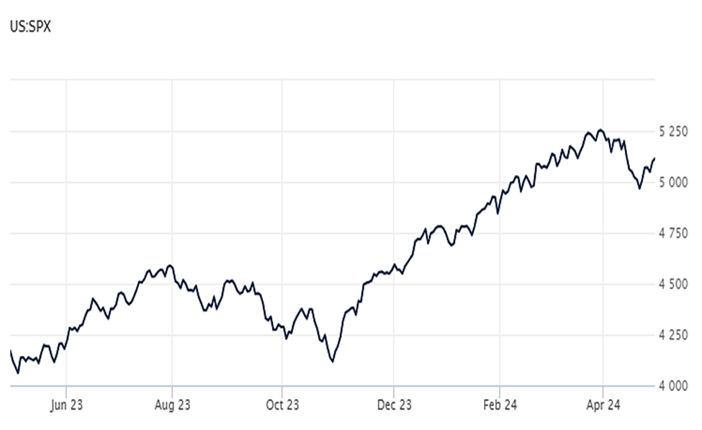

Source: Wall Street Journal

Economic Growth Slows
Taking many by surprise, Gross Domestic Product (GDP) fell during the first quarter, according to the advance estimate of the US Bureau of Economic Analysis. The broad measure of US goods and services increased at an annual rate of just 1.6%, significantly below Dow Jones estimates, which called for an increase of 2.4%. Quarterly growth is also on track to finish below the 3.4% rate for Q4 and the 4.9% rate for Q3, illustrating a downward trend.
Consumer spending increased by 2.5% during the quarter, off the 3.3% pace set during the fourth quarter and below estimates as well. Fixed investment and state and local government spending contributed to GDP growth during the quarter while a fall in private inventory investment detracted from GDP growth. However, residential investment surged 13.9% during the period, marking the largest increase since 2020 as the housing market continues to rebound. CNBC

Worrisome Inflation Persists
Consumer prices rose faster than expected last month. According to the latest report from the US Bureau of Labor Statistics, the Consumer Price Index (CPI) increased at an annual rate of 3.5% during the 12-month period ending in March. The increase was well above February's 3.2% jump and marked the highest annual gain in the last six months. March's 3.5% annual CPI increase was also above estimates, which called for a rise of 3.4%.

While gas and shelter costs accounted for more than half of the monthly gain, the upward trajectory in prices was widespread, touching just about every price category. The so-called core CPI – which strips out the more volatile components of gas and food – rose 0.4% on the month and 3.8% on the year. The stubborn core CPI numbers have dampened expectations for interest rate cuts by the Federal Reserve in 2024. CNN

Consumer Confidence Tumbles
Consumer confidence tumbled in April as consumers expressed concern regarding the labor market and income. The Conference Board's consumer confidence index fell to 97.0 in April, its lowest level since July 2022. April's numbers also included a downwardly revised consumer confidence reading of 103.1 in March. The results were also below estimates, which called for a level of 104.0.

According to Dana Peterson, chief economist at the Conference Board, "Confidence retreated further in April as consumers became less positive about the current labor market situation and more concerned about future business conditions, job availability, and income." Peterson added, "According to April's write-in responses, elevated price levels, especially for food and gas, dominated consumer’s concerns, with politics and global conflicts as distant runners-up." Yahoo Finance

This research material was prepared by Tifin Marketing Automation.

This material represents an assessment of the market and economic environment at a specific point in time and is not intended to be a forecast of future events, or a guarantee of future results. Forward-looking statements are subject to certain risks and uncertainties. Actual results, performance, or achievements may differ materially from those expressed or implied. Information is based on data gathered from what we believe are reliable sources. It is not guaranteed as to accuracy, does not purport to be complete and is not intended to be used as a primary basis for investment decisions. It should also not be construed as advice meeting the particular investment needs of any investor. Past performance does not guarantee future results.

Indices are unmanaged and investors cannot invest directly in an index. Unless otherwise noted, performance of indices does not account for any fees, commissions or other expenses that would be incurred. Returns do not include reinvested dividends.

The Standard & Poor's 500 (S&P 500) is an unmanaged group of securities considered to be representative of the stock market in general. It is a market value weighted index with each stock's weight in the index proportionate to its market value.

The Nasdaq Composite Index is a market-capitalization weighted index of the more than 3,000 common equities listed on the Nasdaq stock exchange. The types of securities in the index include American depositary receipts, common stocks, real estate investment trusts (REITs) and tracking stocks. The index includes all Nasdaq listed stocks that are not derivatives, preferred shares, funds, exchange-traded funds (ETFs) or debentures.

The Dow Jones Industrial Average (DJIA) is a price-weighted average of 30 actively traded “blue chip” stocks, primarily industrials, but includes financials and other service-oriented companies. The components, which change from time to time, represent between 15% and 20% of the market value of NYSE stocks.

A Consumer Price Index (CPI) is a price index, the price of a weighted average market basket of consumer goods and services purchased by households. Changes in measured CPI track changes in prices over time.

The Core Consumer Price Index (CPI) measures the changes in the price of goods and services, excluding food and energy. The CPI measures price change from the perspective of the consumer. It is a key way to measure changes in purchasing trends and inflation.

©2024 Wealthcare Capital Management LLC and Wealthcare Advisory Partners LLC ("Wealthcare") is a registered investment advisor with the U.S. Securities and Exchange Commission (SEC) under the Investment Advisors Act of 1940. All Rights Reserved.

Information contained herein is at a point in time and subject to change without notice. Information is derived from sources which are believed to be reliable but are not independently audited.

This content is for informational purposes only and is not advice for any individual or a recommendation of any specific investment product or strategy. Wealthcare cannot guarantee any specific financial return results for any client or guarantee a client will in all circumstances of changing personal financial goals and market conditions be able to remain in a client's Wealthcare Plan Comfort Zone®. Past performance is not a guide to future returns. All investments carry a degree of risk of loss of principal and there is no assurance that an investment will provide positive performance over any period of time.



Two James Center, 1021 East Cary Street, Suite 702 | RICHMOND, VA 23219 | 804.644.4711
WealthcareGDX.com

