
Monthly Market Recap

May 2024 Market Recap

After a brief pullback in April, the markets roared higher in May as investors poured into the stock market. All the major indices are now at new record highs, buoyed by a continuing slew of positive reports on the economic front. Inflation took a welcome step back during the month while the housing market showed new signs of life. The Federal Reserve (Fed) remains cautious about inflation, but many expect at least one interest rate reduction this year.

Markets Deliver Fresh New Highs
After pulling back in April, stocks surged for most of May and set fresh new highs. The tech-heavy NASDAQ Composite Index (COMP) led the way, gaining 6.9% for the month. The broad market S&P 500® (SPX) and the popular Dow Jones Industrial Average® (DJIA) also booked strong months, gaining 4.8% and 2.3%, respectively.
The markets have now recorded six up months out of the last seven while continuing to add to a bullish run that began in October 2022. Factors driving the interest in stocks by investors included continuing good economic news, a resilient job market, solid corporate profits, and a better-than-expected inflation report. And while prices are still above the Fed's target level of 2%, the chance of at least one rate cut this year appears to be resurrected. That outlook is confirmed by the moderation in the yield of the 10-year Treasury note, which is down from its late April highs.

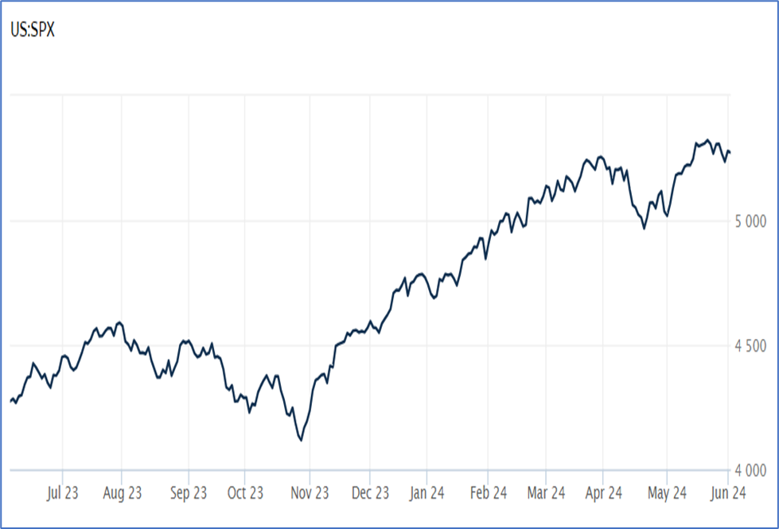

Source: Wall Street Journal

Prices Cool Unexpectedly
Inflation in the US cooled unexpectedly last month, giving the markets a welcome sigh of relief. The latest CPI (Consumer Price Index) report from the US Bureau of Labor Statistics showed that prices rose 0.3% in April, down from the 0.4% reading in March. On a year-over-year basis, prices also ticked down to 3.4% from 3.5%, marking the first year-over-year decline this year. Excluding the more volatile components of food and energy, so-called “core CPI” also showed improvement, rising 0.3% after three straight months of 0.4% increases. The year-over-year numbers were also positive, with core prices rising 3.6%, down significantly from the 3.8% reading in March.
The latest report appears to open the door to a resumption of the steady retreat in prices which began in earnest during the second half of 2023. And while that may resurrect hopes that the Fed will lower rates at least once this year, policymakers are likely looking for more evidence that inflation is moderating before switching gears. AP News
Are Higher Rates Still Working?
Speaking of the Fed, after inflation eased considerably last year, the traditional tool of raising interest rates to cool prices appeared to be working as planned. With that in mind, the markets were looking to the Fed to begin lowering rates this year, perhaps multiple times.

But things haven't quite gone to plan, with the fight against inflation delivering mixed results this year. Notably, the minutes from the central bank's May policy meeting show that some central bankers are now questioning whether decades-high interest rates remain sufficient to tame inflation. According to the minutes, some members wondered whether high interest rates may be "having smaller effects than in the past." As a result, "various participants mentioned a willingness" to continue to raise rates if certain inflationary risks materialized. And while that latest report on inflation showed progress, according to Fed governor Christopher Waller "if I were still a professor and had to assign a grade to this inflation report, it would be a C+ — far from failing but not stellar either." Axios

Housing Market Struggles
Sales of previously owned homes fell 1.9% in April compared to March to 4.14 million units, according to the National Association of Realtors (NAR). While the results were less than forecasts – which called for a slight gain – the figures are based on closings in February and March when mortgage rates were rising quickly to 7% plus levels. Housing inventory was 1.2 million units in April, up 9% compared to the prior month and up 16% compared to the year-ago period.

While increased inventory can encourage sales, current inventory stands at just 3.5 months of supply, significantly below the preferred 6 months. Those tight supplies have put pressure on prices, pushing the median price of an existing home to $407,600, a new record high and 5.7% more than a year ago. Due to strong demand, 27% of sales were above list price. While high prices are good news for homeowners, the market appears to be balancing as more inventory becomes available. According to Lawrence Yun, chief economist for the NAR, "Home prices reaching a record high for the month of April is very good news for homeowners. However, the pace of price increases should taper off since more housing inventory is becoming available." CNBC

This research material was prepared by Tifin Marketing Automation.

This material represents an assessment of the market and economic environment at a specific point in time and is not intended to be a forecast of future events, or a guarantee of future results. Forward-looking statements are subject to certain risks and uncertainties. Actual results, performance, or achievements may differ materially from those expressed or implied. Information is based on data gathered from what we believe are reliable sources. It is not guaranteed as to accuracy, does not purport to be complete and is not intended to be used as a primary basis for investment decisions. It should also not be construed as advice meeting the particular investment needs of any investor. Past performance does not guarantee future results.

Indices are unmanaged and investors cannot invest directly in an index. Unless otherwise noted, performance of indices does not account for any fees, commissions or other expenses that would be incurred. Returns do not include reinvested dividends.

The Standard & Poor's 500 (S&P 500) is an unmanaged group of securities considered to be representative of the stock market in general. It is a market value weighted index with each stock's weight in the index proportionate to its market value.

The Nasdaq Composite Index is a market-capitalization weighted index of the more than 3,000 common equities listed on the Nasdaq stock exchange. The types of securities in the index include American depositary receipts, common stocks, real estate investment trusts (REITs) and tracking stocks. The index includes all Nasdaq listed stocks that are not derivatives, preferred shares, funds, exchange-traded funds (ETFs) or debentures.

The Dow Jones Industrial Average (DJIA) is a price-weighted average of 30 actively traded “blue chip” stocks, primarily industrials, but includes financials and other service-oriented companies. The components, which change from time to time, represent between 15% and 20% of the market value of NYSE stocks.

©2024 Wealthcare Capital Management LLC and Wealthcare Advisory Partners LLC ("Wealthcare") is a registered investment advisor with the U.S. Securities and Exchange Commission (SEC) under the Investment Advisors Act of 1940. All Rights Reserved.

Information contained herein is at a point in time and subject to change without notice. Information is derived from sources which are believed to be reliable but are not independently audited.

This content is for informational purposes only and is not advice for any individual or a recommendation of any specific investment product or strategy. Wealthcare cannot guarantee any specific financial return results for any client or guarantee a client will in all circumstances of changing personal financial goals and market conditions be able to remain in a client's Wealthcare Plan Comfort Zone®. Past performance is not a guide to future returns. All investments carry a degree of risk of loss of principal and there is no assurance that an investment will provide positive performance over any period of time.



Two James Center, 1021 East Cary Street, Suite 702 | RICHMOND, VA 23219 | 804.644.4711
WealthcareGDX.com

