
Monthly Market Recap

June 2024 Market Recap

The stock market continued to climb in June as investors flocked to US equities. All three major stock indexes posted new record levels, buoyed by positive economic reports and increasing interest in AI-driven companies. Despite the positive outlook for US growth, consumer spending has weakened. Other headwinds include a mixed consumer confidence report and a housing market that’s still in search of sustained sales.

Market Surging Higher
The tech-heavy NASDAQ Composite Index (COMP) led the widespread stock surge last month, gaining 6%. The broad market S&P 500® (SPX) and Dow Jones Industrial Average® (DJIA) were also up in June, climbing 3.5% and 1.1%, respectively. June’s gains punctuated a strong first half of the year, during which the COMP was up 18.1%, the SPX was up 14.5%, and the DJIA was up 3.8%.

This positive momentum was driven by strong economic reports on the employment, growth, and inflation fronts, as well as continued hype surrounding Artificial Intelligence applications across various fields. Also contributing to surging stock prices is the belief among investors that the Fed will likely begin lowering interest rates before year-end, most likely in September.

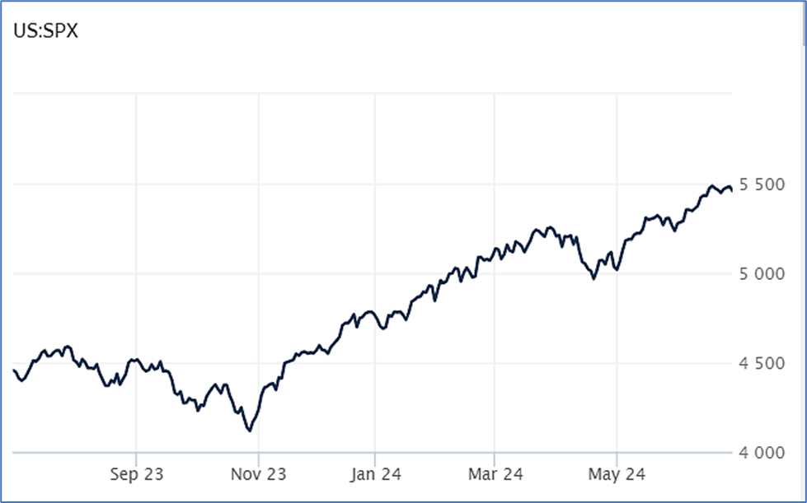

Source: Wall Street Journal

US Growth Revised (Sightly) Up
The US economy grew at a 1.4% annualized rate between the months of January and March, according to the latest estimate from the Bureau of Economic Analysis. Business investment rose at a 4.4% annual pace during the quarter,
up significantly from the prior estimate of 3.2%, driven by investment in factories and software. However, consumer spending – which accounts for about 70% of economic activity – decelerated sharply last quarter. Spending on appliances, furniture, and other goods fell by a 2.3% annual rate while spending on travel, meals, and other services
was up.

Economic growth for the first quarter is slightly below the blistering 3.4% annual rate set during the first quarter of last year, but the US economy continues to defy expectations. Many feared that the Fed's historic series of interest rate hikes could send the economy into a tailspin, but those fears never materialized. A recession is increasingly unlikely at this point. AP News

Consumer Confidence Dips
The way consumers feel about their economic lives dipped slightly in June despite showing some positive signals. The Conference Board Consumer Confidence Index® fell to 100.4 in June compared to 101.3 in May. Consumers' expectations of what's in store for income, business, and labor conditions fell to 73.0, down from a 74.9 reading in May. A reading below 80 – which has been the case for five consecutive months – is often considered a negative signal for the US economy.

On the other hand, how consumers feel about current business and labor market conditions increased to 141.5 from 140.8. According to Dana Peterson, Chief Economist at The Conference Board, "Confidence pulled back in June but remained within the same narrow range that’s held throughout the past two years, as strength in current labor market views continued to outweigh concerns about the future. However, if material weaknesses in the labor market appear, Confidence could weaken as the year progresses." Conference Board

Housing Market Still Struggling
Home sales fell 0.7% in May to an annual rate of 4.11 million units, according to the National Association of Realtors (NAR). Compared to last year’s numbers, sales were down 2.8%. At the end of May, there were 1.3 million unsold homes on the market – 7% more than in April and 18% more than in May of last year. As a result, home prices rose for the 11th straight month in May to a median price of $419,300, up 5.8% from a year earlier and setting an all-time record. Homebuyers who did buy were aggressive, snatching up homes within 24 days of them hitting the market. Plus, 30% of those homes sold for more than the original list price. According to Lawrence Yun, NAR's chief economist, "It’s somewhat of a strange phenomena…We had low home sales activity, prices are hitting record highs and homes look like they’re still getting multiple offers." AP News

This research material was prepared by Tifin Marketing Automation.

This material represents an assessment of the market and economic environment at a specific point in time and is not intended to be a forecast of future events, or a guarantee of future results. Forward-looking statements are subject to certain risks and uncertainties. Actual results, performance, or achievements may differ materially from those expressed or implied. Information is based on data gathered from what we believe are reliable sources. It is not guaranteed as to accuracy, does not purport to be complete and is not intended to be used as a primary basis for investment decisions. It should also not be construed as advice meeting the particular investment needs of any investor. Past performance does not guarantee future results.

Indices are unmanaged and investors cannot invest directly in an index. Unless otherwise noted, performance of indices does not account for any fees, commissions or other expenses that would be incurred. Returns do not include reinvested dividends.

The Standard & Poor's 500 (S&P 500) is an unmanaged group of securities considered to be representative of the stock market in general. It is a market value weighted index with each stock's weight in the index proportionate to its market value.

The Nasdaq Composite Index is a market-capitalization weighted index of the more than 3,000 common equities listed on the Nasdaq stock exchange. The types of securities in the index include American depositary receipts, common stocks, real estate investment trusts (REITs) and tracking stocks. The index includes all Nasdaq listed stocks that are not derivatives, preferred shares, funds, exchange-traded funds (ETFs) or debentures.

The Dow Jones Industrial Average (DJIA) is a price-weighted average of 30 actively traded “blue chip” stocks, primarily industrials, but includes financials and other service-oriented companies. The components, which change from time to time, represent between 15% and 20% of the market value of NYSE stocks.

The Conference Board creates the Present Situation Index (PSI) from survey data of approximately 5000 households across the United States to gauge public opinion about the U.S. economy. When the index is positive, people feel good about the current economic situation. When negative, people are less optimistic. The (PSI) along with the Expectations Index are used by The Conference Board to create the Consumer Confidence Index (CCI) which tells us how optimistic (or not) people are about the future of the economy.

The Expectations Index is a component of the Consumer Confidence Index® (CCI), which is published each month by the Conference Board. The CCI reflects consumers’ short-term—that is, six-month—outlook for, and sentiment about, the performance of the overall economy as it effects them. The Expectations Index is made up of the average of the CCI components that deal with six-month outlooks for business, employment, and income.

©2024 Wealthcare Capital Management LLC, Wealthcare Advisory Partners LLC, and Wealthcare Capital Partners LLC ("Wealthcare") is a registered investment advisor with the U.S. Securities and Exchange Commission (SEC) under the Investment Advisors Act of 1940. All Rights Reserved.

Information contained herein is at a point in time and subject to change without notice. Information is derived from sources which are believed to be reliable but are not independently audited.

This content is for informational purposes only and is not advice for any individual or a recommendation of any specific investment product or strategy. Wealthcare cannot guarantee any specific financial return results for any client or guarantee a client will in all circumstances of changing personal financial goals and market conditions be able to remain in a client's Wealthcare Plan Comfort Zone®. Past performance is not a guide to future returns. All investments carry a degree of risk of loss of principal and there is no assurance that an investment will provide positive performance over any period of time.



Two James Center, 1021 East Cary Street, Suite 702 | RICHMOND, VA 23219 | 804.644.4711
WealthcareGDX.com

