
Monthly Market Recap

August 2024 Market Recap

The stock market proved its resilience again in August. After selling off to start the month, stocks recovered across the board with the Dow Jones Industrial Average® (DJIA) recording a fresh new high. Strong economic reports and optimism that the Federal Reserve (Fed) will begin cutting rates in September supported higher stock prices. The latest reports on inflation, home sales, and consumer confidence were also positive, adding strength to higher stock prices.

Markets Roar Back
After enduring a steep sell-off to begin the month, the broad market S&P 500® (SPX) ultimately led the major indices higher in August, gaining 2.3% on the month to cap off its fourth straight monthly gain. The DJIA also surged higher, making a fresh new high and gaining 1.8% on the month. After a volatile July, the tech-heavy NASDAQ Composite Index (COMP) gained just shy of 1% in August and appears to be back on track.

Buoying stock prices for the month was a string of strong economic reports that included an inflation report in line with expectations, an improving home sales market, and positive news on the consumer confidence front. Also driving interest in stocks was the markets’ anticipation of the Fed starting to cut interest rates in September. The upcoming cut will likely be 25 basis points (0.25%) rather than a more aggressive 50 basis point (0.50%) cut.

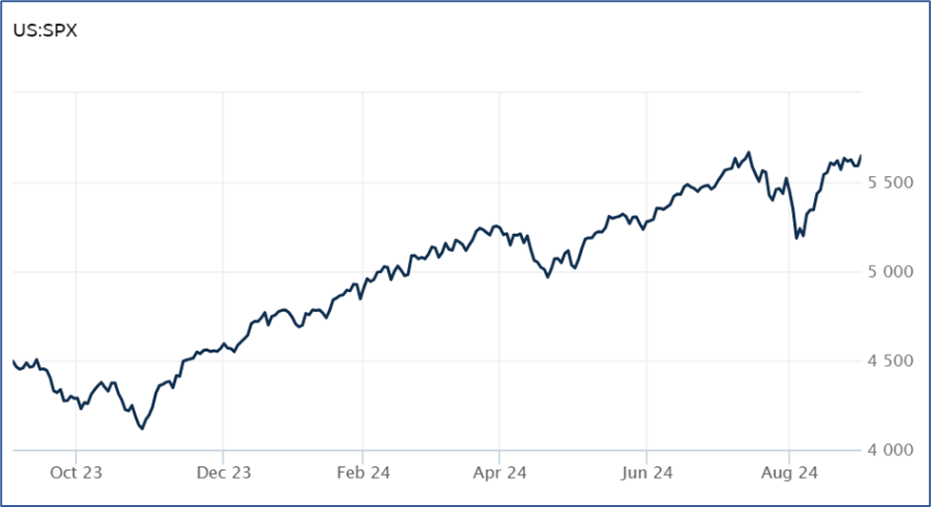

Source: Wall Street Journal

Inflation Report Supports Rate Cuts
The latest numbers on inflation continue to show progress. According to the inflation data from the US Bureau of Economic Analysis, the personal consumption expenditures price index (PCE) rose 0.2% in July and 2.5% compared to a year ago, which aligned with Dow Jones estimates. The yearly numbers have now dropped or stayed the same for the last five months.

Stripping away the more volatile components of food and energy, core PCE increased 0.2% on the month and 2.6% from a year ago. The yearly results were slightly better than the 2.7% estimate, a key point since the Fed considers core PCE a better gauge of longer-term trends. Core prices minus housing – another sticking point for the Fed – increased just 0.1% on the month. On the other hand, shelter costs remain stubborn, rising 0.4% in July. On a yearly basis, food and energy also accelerated, rising 1.4% and 1.9%, respectively.
The latest data also showed that personal income rose 0.3% in July, better than the 0.2% estimate. Consumer spending remained strong, too, rising 0.5% to meet forecasts.
Continuing improvement in inflation has all but guaranteed that the Fed will begin cutting rates in September, most likely at the 25 basis point level. And while the unemployment rate remains low at 4.3%, data suggests the potential of some labor market softening. Lower interest rates could help reduce the risk of that softening. CNBC

Housing Showing Some Improvement
Lower interest rates may be just what the sluggish housing market needs. After reaching a 23-year high of 7.8%, the average rate of the benchmark 30-year fixed rate mortgage now stands around 6.5%, a considerable improvement and the lowest level in 15 months. With interest rate cuts on the horizon, mortgage rates will likely continue to drop.

Those improving rates are likely behind a mixed, but somewhat improving, home sales report. According to the National Association of Realtors (NAR), sales of existing homes rose 1.3% in June to an annual rate of 3.95 million units. July’s sales figures were slightly better than the 3.92 million units expected by economists and reversed a four-month slide.

However, prices remain high and have now increased for 13 straight months. During July, the average price of an existing home rose 4.2% compared to a year ago to $422,600. While that number is down from the record set in June, it marks the highest average home price ever recorded in July.

Home prices have now surged 51% over the past five years, making home ownership tough for many potential buyers, but the outlook could be improving. According to Lawrence Yun, the NAR’s chief economist, "Consumers are definitely seeing more choices, and affordability is improving due to lower interest rates." Many economists also believe the downward trajectory in mortgage rates will continue to boost sales. AP News

Consumer Confidence Upbeat
The latest report on how consumers feel about their economic and professional prospects is upbeat. The Conference Board Consumer Confidence Index® rose to 103.3 in August, up from the 101.9 reading in July. How consumers feel about the current business and labor market conditions also moved higher to 134.4 from 133.1 in July.

The key expectations index – which gauges how consumers feel about the short-term outlook for labor, business, and income – improved to 82.5 in August. After an upward revision of July’s results to 81.1, August was the second consecutive month the expectations index recorded levels above 80. A reading below 80 usually signals the potential for a recession.

According to Dana Petterson, Chief Economist at The Conference Board, "Consumer confidence rose in August but remained within the narrow range that has prevailed over the past two years. Consumers continued to express mixed feelings in August. Compared to July, they were more positive about business conditions, both current and future, but also more concerned about the labor market." Conference Board

This research material was prepared by Tifin Marketing Automation.

This material represents an assessment of the market and economic environment at a specific point in time and is not intended to be a forecast of future events, or a guarantee of future results. Forward-looking statements are subject to certain risks and uncertainties. Actual results, performance, or achievements may differ materially from those expressed or implied. Information is based on data gathered from what we believe are reliable sources. It is not guaranteed as to accuracy, does not purport to be complete and is not intended to be used as a primary basis for investment decisions. It should also not be construed as advice meeting the particular investment needs of any investor. Past performance does not guarantee future results.

Indices are unmanaged and investors cannot invest directly in an index. Unless otherwise noted, performance of indices does not account for any fees, commissions or other expenses that would be incurred. Returns do not include reinvested dividends.

The Standard & Poor's 500 (S&P 500) is an unmanaged group of securities considered to be representative of the stock market in general. It is a market value weighted index with each stock's weight in the index proportionate to its market value.

The Nasdaq Composite Index is a market-capitalization weighted index of the more than 3,000 common equities listed on the Nasdaq stock exchange. The types of securities in the index include American depositary receipts, common stocks, real estate investment trusts (REITs) and tracking stocks. The index includes all Nasdaq listed stocks that are not derivatives, preferred shares, funds, exchange-traded funds (ETFs) or debentures.

The Dow Jones Industrial Average (DJIA) is a price-weighted average of 30 actively traded “blue chip” stocks, primarily industrials, but includes financials and other service-oriented companies. The components, which change from time to time, represent between 15% and 20% of the market value of NYSE stocks.

The Conference Board creates the Present Situation Index (PSI) from survey data of approximately 5000 households across the United States to gauge public opinion about the U.S. economy. When the index is positive, people feel good about the current economic situation. When negative, people are less optimistic. The (PSI) along with the Expectations Index are used by The Conference Board to create the Consumer Confidence Index (CCI) which tells us how optimistic (or not) people are about the future of the economy.

The Expectations Index is a component of the Consumer Confidence Index® (CCI), which is published each month by the Conference Board. The CCI reflects consumers’ short-term—that is, six-month—outlook for, and sentiment about, the performance of the overall economy as it effects them. The Expectations Index is made up of the average of the CCI components that deal with six-month outlooks for business, employment, and income.

©2024 Wealthcare Capital Management LLC, Wealthcare Advisory Partners LLC, and Wealthcare Capital Partners LLC ("Wealthcare") is a registered investment advisor with the U.S. Securities and Exchange Commission (SEC) under the Investment Advisors Act of 1940. All Rights Reserved.

Information contained herein is at a point in time and subject to change without notice. Information is derived from sources which are believed to be reliable but are not independently audited.

This content is for informational purposes only and is not advice for any individual or a recommendation of any specific investment product or strategy. Wealthcare cannot guarantee any specific financial return results for any client or guarantee a client will in all circumstances of changing personal financial goals and market conditions be able to remain in a client's Wealthcare Plan Comfort Zone®. Past performance is not a guide to future returns. All investments carry a degree of risk of loss of principal and there is no assurance that an investment will provide positive performance over any period of time.



Two James Center, 1021 East Cary Street, Suite 702 | RICHMOND, VA 23219 | 804.644.4711
WealthcareGDX.com

