Quarterly Letter


Third Quarter 2024: Quarterly Letter

The past quarter saw the U.S. economy maintain a resilient pace fueled by consumer spending while inflation continued its slow descent. This provided incremental ammunition for the Federal Reserve to deliver a fifty-basis point cut in rates with more rate cuts on the way. Both bonds and equities rejoiced at the news as bonds posted a 5.2% return for the quarter ending September 30th, 2024, as measured by the Bloomberg Aggregate Index, and stocks, as measured by the Russell 3000, returned 6.2%. However, investors don't have time to rejoice as the focus shifts to the upcoming election.

We are heading into the most polarized and likely most contested election in over 100 years, maybe since the Civil War. The races for the Presidency, House of Representatives, and Senate are tight, suggesting that we will end up with a divided government. This is not a bad outcome as it makes extreme policy changes less likely and markets like stability. However, one policy change we would like to see, no matter the election outcome, is for the future Congress and President to address our federal debt problem, which is $27 trillion and growing. Both campaigns' policy proposals end up in the same place – significant budget deficits projected for the foreseeable future. The federal deficit is something that will require attention after the election.

During a presidential election year, it's natural for investors to seek a connection between who wins the White House and which way stocks will go. According to retirementresearcher.com, from 1926 to 2023, we have had a Republican president for 47 years and a Democratic president for 51 years. The difference in returns between the parties is pretty stark. The average annual return for the S&P 500 index when we had a Republican President was 9.32%. When we had a Democratic President, the S&P 500 averaged 14.78% per year. That's a premium of 5.5% per year on average. That's a big difference!

However, like most data, the details matter. If we breakdown the returns by the degree of party control, when either party is in full control – the Presidency, the House, and the Senate – no party is a clear winner as returns are essentially the same (when considering volatility of returns) as shown in the table below, which uses data from 1926 to 2023. When neither party has full control, the results favor the Democrats. The table suggests that the worst-case scenario is a Trump presidency with a Democratic Congress. Any other scenario has produced exceptional stock market returns. So, three of the four outcomes in the table favor investors! This is good to keep in mind.

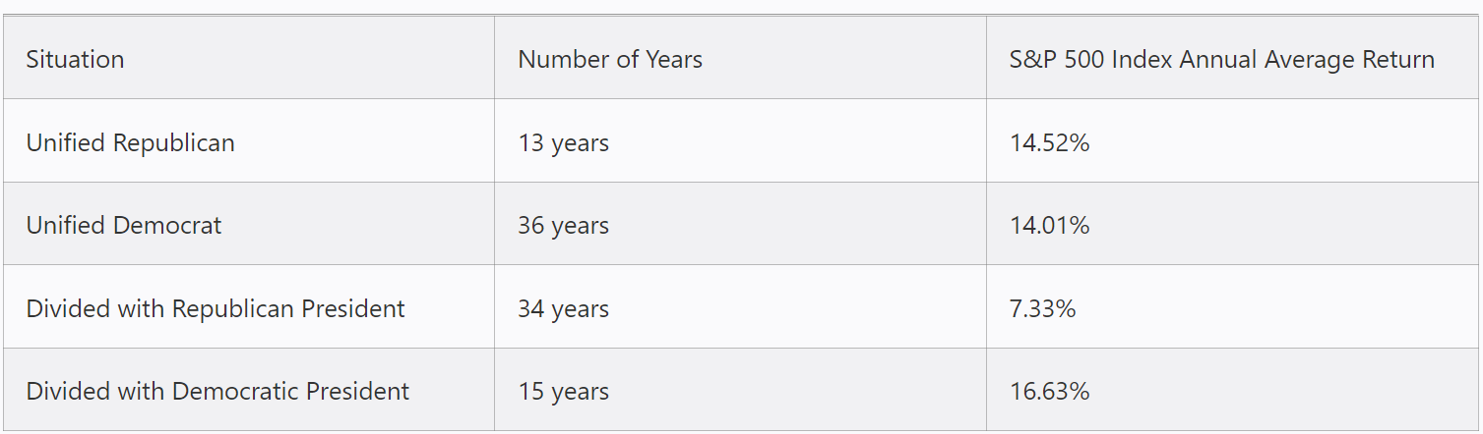
Source: retirementresearcher.com
So, it is worthwhile to remind ourselves of the maxim that it is time in the market, not market timing, that rewards investors over the long run. The infographic from Dimensional Fund Advisors demonstrates that stocks have rewarded disciplined, long-term investors for decades through Democratic and Republican presidencies.

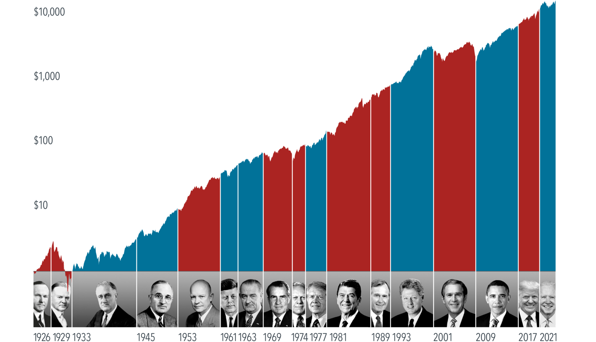

Getting out of the stock market based on a hunch and missing rewarding returns can lead to costly mistakes. There is a stronger case for investors to look past elections and maintain a steady approach to markets—in other words, make a long-term plan and stick to it. Feel free to reach out to me to discuss your asset allocation, your long-term plan, or any questions you may have.

©2024 Wealthcare Capital Management LLC ("Wealthcare") is a registered investment advisor with the U.S. Securities and Exchange Commission (SEC) under the Investment Advisors Act of 1940. All Rights Reserved.
This content is for educational purposes only and not to be considered a solicitation for the purchase or sale of any security and should not be relied upon as financial, tax, or legal advice. The views expressed are those of the author/presenter and all data is derived from sources believed to be reliable.

All market indices discussed are unmanaged and are not illustrative of any particular investment. Indices do not incur management fees, costs, or expenses. Investors cannot invest directly in indices. All economic and performance data is historical and not indicative of future results. Information contained herein is at a point in time and subject to change without notice. Information is derived from sources which are believed to be reliable, but are not independently audited. Wealthcare cannot guarantee any specific financial return results for any client. Past performance is not a guide to future returns.

Two James Center 1021, East Cary Street, Suite 702 | RICHMOND, VA 23219 | 804.644.4711

Wealthcaregdx.com

