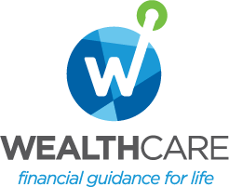
Monthly Market Recap

September 2024 Market Recap

The stock market reached new highs in September with all three major indices posting monthly gains. For the first time in four years, the Federal Reserve (Fed) cut rates while indicating more cuts were likely in the cards this year and next. September also brought more good news on the inflation front. Lower interest rates and geopolitical uncertainty have also driven the price of gold to record levels.

Stocks Surge Higher
Stocks powered through a volatile September, ending with all the major indices in the green. The broad market S&P 500® (SPX) and the popular Dow Jones Industrial Average® (DJIA) set new high-water marks, gaining 1.8% and 2%, respectively. Meanwhile, the tech-heavy NASDAQ Composite Index (COMP) appeared to shake off a topsy-turvy summer and ended September up 2.7% to lead the three indices.

Driving September's solid performance in stocks was a host of factors, including the first interest rate cut by the Fed since March 2020, the steady improvement in the inflation outlook, and a continuing march of positive economic reports across the board. Plus, the Fed's likely refocus on improving the job market could lay the groundwork for more rate cuts, which tend to be good for growth in general and stocks in particular.

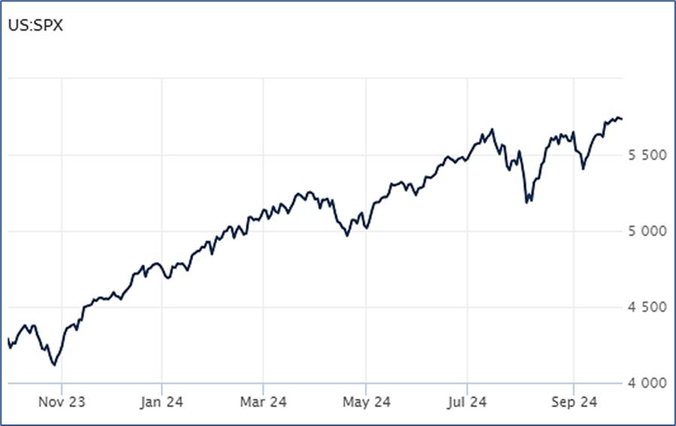

Source: Wall Street Journal

Fed Cuts Rates, Shifts Focus to Jobs
The Fed cut its benchmark interest rate for the first time in four years in September, marking a dramatic shift in the central bank's aggressive inflation-fighting policy. The Fed's inflation work now appears to be largely over as inflation has fallen from a peak of 9.1% in 2022 to a three-year low of 2.5% in August. The Fed's inflation win was also scored without plunging the US economy into recession, a feat many predicted would be highly unlikely.
Still, the Fed's interest rate hikes have been painfully expensive for many Americans, who were forced to contend with higher financing costs practically everywhere, from mortgages to credit cards to business loans. Plus, despite positive inflation numbers, many consumers still face high prices for groceries, gas, rent, and other must-haves. Rate cuts should, however, begin to drive lower financing costs and relieve some of the financial pressure.
According to Fed Chair Jerome Powell, "we know it is time to recalibrate our (interest rate) policy to something that’s more appropriate given the progress on inflation…We’re not saying, ‘mission accomplished’ ... but I have to say, though, we’re encouraged by the progress that we have made." He also added that "the U.S. economy is in a good place and our decision today is designed to keep it there." AP News

Inflation Nears Fed’s 2% Target
Inflation is moving swiftly toward the Fed's 2% inflation target. According to the August data from the US Bureau of Economic Analysis, the personal expenditures price index (PCE) -- the Fed's preferred inflation gauge -- now sits at an annual rate of 2.2%, down significantly from the 2.5% annual rate in July and the lowest level since February 2021. The numbers also beat forecasts, which called for a 2.3% annual rate. Stripping out the more volatile components of food and energy, core PCE was up 2.7% compared to a year ago, up slightly from the 2.6% reading in July.

Despite the positive top-line numbers, housing-related costs were up 0.5% in August, the largest move since January. Services also rose 0.2%.

Still, the positive report is likely to continue to embolden the Fed's rate-cutting plans. The Fed's latest statement indicated as much, saying that the central bank's job has pivoted away from inflation to bolstering a softening job market, which has shown clear signs of slowing. Fed policymakers now expect to cut rates an additional half-point in their final two meetings this year while envisioning more cuts in 2024 and 2025. CNBC

Record Gold Prices
The price of gold is at record levels, with a recent spot price for the precious metal garnering $2,652 per ounce. The gold metal has been on a tear for months and shows little sign of slowing.

The record-high price for gold appears to be driven by a handful of factors. First, growing geopolitical and economic uncertainty have driven interest in the safe-haven asset. Second, gold prices tend to move inversely to interest rates. So, as interest rates go down -- or the market anticipates that they're going to go down -- the price of gold goes up. The current run on gold didn't begin in earnest until this past spring when inflation really began to slow, and rate-cut discussions picked up. CNBC

This research material was prepared by Tifin Marketing Automation.

This material represents an assessment of the market and economic environment at a specific point in time and is not intended to be a forecast of future events, or a guarantee of future results. Forward-looking statements are subject to certain risks and uncertainties. Actual results, performance, or achievements may differ materially from those expressed or implied. Information is based on data gathered from what we believe are reliable sources. It is not guaranteed as to accuracy, does not purport to be complete and is not intended to be used as a primary basis for investment decisions. It should also not be construed as advice meeting the particular investment needs of any investor. Past performance does not guarantee future results.

Indices are unmanaged and investors cannot invest directly in an index. Unless otherwise noted, performance of indices does not account for any fees, commissions or other expenses that would be incurred. Returns do not include reinvested dividends.

The Standard & Poor's 500 (S&P 500) is an unmanaged group of securities considered to be representative of the stock market in general. It is a market value weighted index with each stock's weight in the index proportionate to its market value.

The Nasdaq Composite Index is a market-capitalization weighted index of the more than 3,000 common equities listed on the Nasdaq stock exchange. The types of securities in the index include American depositary receipts, common stocks, real estate investment trusts (REITs) and tracking stocks. The index includes all Nasdaq listed stocks that are not derivatives, preferred shares, funds, exchange-traded funds (ETFs) or debentures.

The Dow Jones Industrial Average (DJIA) is a price-weighted average of 30 actively traded “blue chip” stocks, primarily industrials, but includes financials and other service-oriented companies. The components, which change from time to time, represent between 15% and 20% of the market value of NYSE stocks.

©2024 Wealthcare Capital Management LLC, Wealthcare Advisory Partners LLC, and Wealthcare Capital Partners LLC ("Wealthcare") is a registered investment advisor with the U.S. Securities and Exchange Commission (SEC) under the Investment Advisors Act of 1940. All Rights Reserved.

Information contained herein is at a point in time and subject to change without notice. Information is derived from sources which are believed to be reliable but are not independently audited.

This content is for informational purposes only and is not advice for any individual or a recommendation of any specific investment product or strategy. Wealthcare cannot guarantee any specific financial return results for any client or guarantee a client will in all circumstances of changing personal financial goals and market conditions be able to remain in a client's Wealthcare Plan Comfort Zone®. Past performance is not a guide to future returns. All investments carry a degree of risk of loss of principal and there is no assurance that an investment will provide positive performance over any period of time.



Two James Center, 1021 East Cary Street, Suite 702 | RICHMOND, VA 23219 | 804.644.4711
WealthcareGDX.com

