
Monthly Market Recap

October 2024 Market Recap

The stock market took a breather in October, pulling back slightly as investors took profits and worried about the sustainability of AI-driven investment themes. The US economy continues to hum along at a solid pace despite worries over inflation and jobs. Consumer confidence also surged higher, marking the highest reading since March 2021. The minutes of the September meeting of the Federal Reserve (Fed) also revealed that not all participants agreed on the scope or magnitude of current and future interest rate cuts.

Stocks Take a Breather
After stringing together one new all-time high after another plus a slew of multi-month gains, the major indices took a breather in October. The popular Dow Jones Industrial Average® (DJIA) led the way lower, falling 1.3% for the month and breaking a monthly winning streak that dated back to April. The broad market S&P 500® (SPX) fell 1%, breaking a similar streak. The tech-heavy NASDAQ Composite Index (COMP) fell less than 1%, recording its first down month since July.

One likely driver of the pullback is profit taking as investors begin to cash in on multi-month upswings. Another is the less than spectacular earnings reports from the tech sector, which investors may view as an indication that AI-driven themes may be cooling.

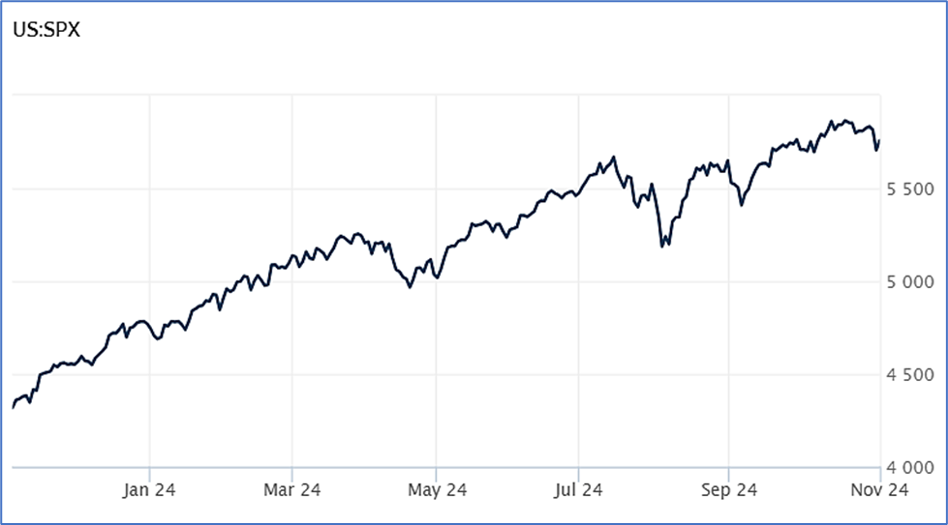

Source: Wall Street Journal

Growth Going Strong
The US economy continued to hum along during the third quarter. According to the US Bureau of Economic Analysis, gross domestic product (GDP) grew at 2.8% during the three-month period from July through September. The first pass of three readings the government will issue was slightly below expectations of 3.1% for the quarter and down slightly from the last reading of 3% for the second quarter. Still, the report confirms that the US continues to expand at a solid rate despite historically high levels of interest rates, worries over slow growth and recessions, and post-covid monetary stimulus hangovers.
Resilient consumer spending highlighted this report as it has others in the past, increasing 9.7% for the quarter, the strongest performance since the first quarter of 2023. Another driver of growth for the quarter was government spending, which grew at a blistering 9.7% pace, fueled by a 14.9% jump in defense outlays. CNBC

Consumer Confidence Jumps
How American consumers feel about their current and future economic lives took a big leap in October. The Conference Board Consumer Confidence Index® increased to 108.7 in October from 99.2 in September, marking the largest monthly gain since March 2021. October's numbers were considerably above expectations, which called for a reading of 99.3. The Present Situation Index -- which gauges how consumers feel about the current labor and business conditions -- jumped by 14.2 to 138. Meanwhile, the Expectations Index -- which measures how consumers feel about the outlook for income, business, and labor -- increased by 6.3 to 89.1.

According to Dana Peterson, the Conference Board’s chief economist, "consumers’ assessments of current business conditions turned positive. Views on the current availability of jobs rebounded after several months of weakness, potentially reflecting better labor market data. Compared to last month, consumers were substantially more optimistic about future business conditions and remained positive about future income." Conference Board

Fed Minutes Reveal Dissension
While no one was surprised by the Fed's interest rate cut in September, the minutes of the Fed meeting producing the cuts reveal not all participants were fully on board. According to Fed officials a "substantial majority" of participants supported lowering rates by 50 basis points, the eventual rate that was voted upon. But some participants would have opted for a more modest 25 basis point decrease and "a few others indicated that they could have supported such a decision."

Those that wanted a more modest 25 basis point decrease were still worried about inflation. They also thought a more gradual decrease in interest rates would allow more time to assess the impacts the policy moves would have on the economy.

The central bank's rate-setting committee was also split on the number of additional interest rate cuts this year. Some participants favor one additional 25 basis point cut while others favor 50 basis points of additional easing. The markets appear to be anticipating two 25 basis point cuts to close out 2024. The minutes also emphasized that it was important that the Fed communicate to market participants that lower rates do not mean the Fed has soured on the US economic outlook. Yahoo Finance

This research material was prepared by Tifin Marketing Automation.

This material represents an assessment of the market and economic environment at a specific point in time and is not intended to be a forecast of future events, or a guarantee of future results. Forward-looking statements are subject to certain risks and uncertainties. Actual results, performance, or achievements may differ materially from those expressed or implied. Information is based on data gathered from what we believe are reliable sources. It is not guaranteed as to accuracy, does not purport to be complete and is not intended to be used as a primary basis for investment decisions. It should also not be construed as advice meeting the particular investment needs of any investor. Past performance does not guarantee future results.

Indices are unmanaged and investors cannot invest directly in an index. Unless otherwise noted, performance of indices does not account for any fees, commissions or other expenses that would be incurred. Returns do not include reinvested dividends.

The Standard & Poor's 500 (S&P 500) is an unmanaged group of securities considered to be representative of the stock market in general. It is a market value weighted index with each stock's weight in the index proportionate to its market value.

The Nasdaq Composite Index is a market-capitalization weighted index of the more than 3,000 common equities listed on the Nasdaq stock exchange. The types of securities in the index include American depositary receipts, common stocks, real estate investment trusts (REITs) and tracking stocks. The index includes all Nasdaq listed stocks that are not derivatives, preferred shares, funds, exchange-traded funds (ETFs) or debentures.

The Dow Jones Industrial Average (DJIA) is a price-weighted average of 30 actively traded “blue chip” stocks, primarily industrials, but includes financials and other service-oriented companies. The components, which change from time to time, represent between 15% and 20% of the market value of NYSE stocks.

The Conference Board creates the Present Situation Index (PSI) from survey data of approximately 5000 households across the United States to gauge public opinion about the U.S. economy. When the index is positive, people feel good about the current economic situation. When negative, people are less optimistic. The (PSI) along with the Expectations Index are used by The Conference Board to create the Consumer Confidence Index (CCI) which tells us how optimistic (or not) people are about the future of the economy.

The Expectations Index is a component of the Consumer Confidence Index® (CCI), which is published each month by the Conference Board. The CCI reflects consumers’ short-term—that is, six-month—outlook for, and sentiment about, the performance of the overall economy as it effects them. The Expectations Index is made up of the average of the CCI components that deal with six-month outlooks for business, employment, and income.

©2024 Wealthcare Capital Management LLC, Wealthcare Advisory Partners LLC, and Wealthcare Capital Partners LLC ("Wealthcare") is a registered investment advisor with the U.S. Securities and Exchange Commission (SEC) under the Investment Advisors Act of 1940. All Rights Reserved.

Information contained herein is at a point in time and subject to change without notice. Information is derived from sources which are believed to be reliable but are not independently audited.

This content is for informational purposes only and is not advice for any individual or a recommendation of any specific investment product or strategy. Wealthcare cannot guarantee any specific financial return results for any client or guarantee a client will in all circumstances of changing personal financial goals and market conditions be able to remain in a client's Wealthcare Plan Comfort Zone®. Past performance is not a guide to future returns. All investments carry a degree of risk of loss of principal and there is no assurance that an investment will provide positive performance over any period of time.



Two James Center, 1021 East Cary Street, Suite 702 | RICHMOND, VA 23219 | 804.644.4711
WealthcareGDX.com

