Quarterly Letter


Fourth Quarter 2024: Quarterly Letter

Last year was a banner year for stocks but not bonds. The S&P 500 ended the year up 25%, while bonds, as measured by the Bloomberg Aggregate Index, returned just 1.3%. Most of the S&P gain occurred before the election, with the S&P 500 returning 22.6% through election day.

Since election day, we have been in a version of Rod Serling's Twilight Zone: "A journey into a wondrous land whose boundaries are that of imagination." This market's Twilight Zone is from election day to January 20th, when President-elect Trump takes office. This is a period when markets can think about the things President Trump will do but not experience them. Post-election, the market imagination was on full display…

- Deregulate: buy stocks
- Cut taxes: buy stocks
- Stronger economy: buy stocks

… and it showed in returns. In the first six days after the election, the S&P was up 3.8%, which is 19 times greater than the historical average weekly return of about 0.2%. So, traders' imaginations ran a bit wild in the week after the election. The frenzy continued for a month, with the S&P returning 5.5% from 11/5 to 12/6. From there, the market imagination turned toward other aspects of President-elect Trump's campaign promises:

- Mass deportations: sell stocks (risks are higher inflation and lower growth)
- Mass Tariffs: sell stocks (risks are higher inflation and a tariff/trade war)
- Tariff retaliation/trade war: sell stocks (bad for growth)

From the 12/6 high to the end of 2024, the S&P 500 lost 3.4%. It was also down for the month of December by 2.4%. So, the market imagination can run wild in both directions.

Herein lies the challenge. This market imagination game is not one we want to play. It is played by short-timeframe traders, some professional, some not. The "not" group is typically pseudo-information traders. They eventually lose their money, like an amateur at a casino blackjack table. The wise ones limit the amount of money they put at risk and call it entertainment, or they don't play at all.

On the other hand, the professional traders, like card-counters, are true information-based traders. Card counters adjust their bets based on how probabilities change as the cards unfold. Likewise, professional information-based traders adjust positions as new information arises (e.g., former President Trump winning re-election) that is not yet reflected in market prices. Through this process, they help keep markets efficient as prices adjust to reflect the new probabilities. They have the necessary resources and capacity to assess and act on new information on a daily or intra-day basis. For professional traders, it is a business, not a game.

Most people do not want to be loser pseudo-information traders, nor are they able to be professional information-based traders. Professional trading is a full-time job, and most of us have full-time jobs already. Further, professional traders also sock money away to live well in retirement like everyone else. When they do, their "live-well" portfolios are invested for the long-term using asset allocation strategies that seek to capture the compensation-for-bearing risk offered by the markets. This typically means setting a strategic asset allocation that aligns with your long-term goals, then adjusting as your situation changes or, at the margin, when relative valuation across asset classes suggests we can improve expected compensation for bearing risk by adjusting. Essentially, live-well investors are valuation-based, long-term growth and income investors.

So, how does a valuation-based, long-term investor see this market? The U.S. economy and stock market have been the envy of the world, having consistently outperformed our peers for many years. The last two years produced an annualized return of over 25% per year. The last time the S&P 500 produced a two-year annualized return of nearly 25% was in 1998 and 1999. That was the peak of the tech bubble. This is not to say that the market is destined to crash from here. That will depend on the evolution of President Trump's policies.

The good news is that Mr. Trump is very sensitive to stock market performance. So, if he makes some early missteps, we would expect him to adjust based on the market response.

The bad news is valuation:
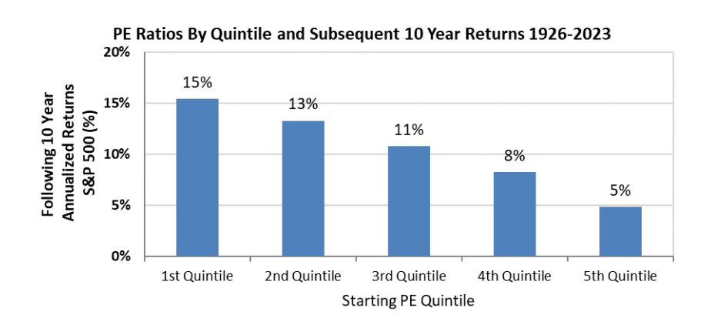
The measure used for the chart is the Shiller (Yale economist who published the book "Irrational Exuberance" at the peak of the tech bubble) cyclically adjusted P/E ratio, also known as the CAPE ratio. It uses 10-year average earnings rather than the trailing 12 months to reduce noise in the measurement.

The 5th quintile historically contains the highest 20% of P/E ratios and has the lowest subsequent 10-year returns. As you can see, valuation is a powerful forecasting tool over 10-year horizons. Currently, we are near the dividing line between the 4th and 5th quintiles, which suggests we can expect a 10-year annualized return somewhere between 5% and 8%.

An 8% 10-year annualized return is not bad. You double your money in 9 years. A 5% 10-year return is not so good, given the riskiness of stocks and the opportunities in bonds and alternatives. In this environment, a well-diversified, balanced portfolio can still serve you well, and with some modest adjustments, you may be able to improve your expected compensation for bearing risk.

If you would like to discuss your portfolio, given current valuation levels and the impact on your ability to achieve your long-term goals, please reach out to me.

©2025 Wealthcare Capital Management LLC ("Wealthcare") is a registered investment advisor with the U.S. Securities and Exchange Commission (SEC) under the Investment Advisors Act of 1940. All Rights Reserved.

This content is for educational purposes only and not to be considered a solicitation for the purchase or sale of any security and should not be relied upon as financial, tax, or legal advice. The views expressed are those of the author/presenter and all data is derived from sources believed to be reliable.

All market indices discussed are unmanaged and are not illustrative of any particular investment. Indices do not incur management fees, costs, or expenses. Investors cannot invest directly in indices. All economic and performance data is historical and not indicative of future results. Information contained herein is at a point in time and subject to change without notice. Information is derived from sources which are believed to be reliable, but are not independently audited. Wealthcare cannot guarantee any specific financial return results for any client. Past performance is not a guide to future returns.

Two James Center 1021, East Cary Street, Suite 702 | RICHMOND, VA 23219 | 804.644.4711

Wealthcaregdx.com

