
Monthly Market Recap

March 2025 Market Recap

All the major stock markets fell again in March as a host of negative factors converged on the markets and the economy, most notably the uncertainty over the Trump Administration's tariff and trade policies. The NASDAQ Composite Index (COMP) is now officially in correction territory, which means a loss of over 10% from a recent high. The latest reading of the Federal Reserve's (Fed) preferred inflation gauge was worse than expectations, although not by much. Consumer confidence essentially vanished in March, dropping to its lowest level in 12 years. Just 37% of consumers feel stock prices will rise this year, a sobering prediction. The Fed held rates during its March meeting, but growth forecasts are shrinking quickly.

Markets Slammed in March
All the major indices were slammed in March, with the COMP leading the way, losing 8.2% for the month. The tech-heavy index has now lost over 14% since its recent high in December, putting it in correction territory. During March, the broad market S&P 500® (SPX) and the Dow Jones Industrial Average® (DJIA) also fell hard, losing 5.7% and 4.2%, respectively. Fueling the significant sell-off across the board is the general uncertainty regarding the White House's tariff and trade policies.
On the bright side, some think high tariffs on imported goods could be a one-off inflationary event, which would likely point to a spike in inflation rather than an ongoing stimulus. Once more certainty is gained around the tariff picture, the markets could begin to claw back.
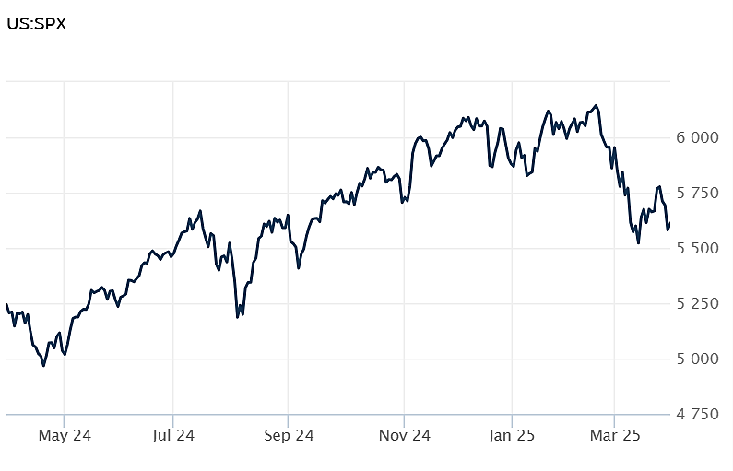
Source: Wall Street Journal

Inflation Higher Than Expected
The Personal Consumption Index (PCE) -- the Fed's preferred inflation gauge -- rose 0.3% in February and 2.5% compared to a year ago. Both numbers were in line with expectations. However, core inflation -- which excludes the more volatile components of food and energy -- rose 0.4% in February and 2.8% compared to a year ago. Both results were worse than estimates, which called for increases of 0.3% and 2.7%, respectively. February's monthly core number was also the largest monthly gain since January 2024.
Prices for goods increased 0.2%, headed by recreational goods and vehicles, which were up 0.5%. Prices for services were also up, gaining 0.4% for the month.
The Fed tends to focus on PCE inflation numbers because they can provide a broader measure of price changes. Plus, the PCE adjusts to changes in consumer behavior while placing less emphasis on housing the Consumer Price Index (CPI), the other major inflation measure.
While February's inflation reading wasn't significantly outside expectations, it remains stubbornly above the Fed's target of 2%. That likely won't encourage the Fed's to accelerate interest rates cuts, which still stand at two for this year. CNBC

Consumer Confidence Vanishes
Consumer confidence plunged in March as consumers took a dim view of their current and future economic outlook, according to the latest data from the Conference Board. The Conference Board Consumer Confidence Index® fell by 7.2 points to 92.9 in March, marking its fourth consecutive monthly decline. Economists surveyed by Dow Jones expected a fall to 93.5.
The Expectations Index -- which measures consumers' short-term outlook for labor, income, and business -- was even gloomier, dropping 9.6 points to 65.2 and marking the lowest level in 12 years. The index is now significantly below the threshold of 80, which usually signals a recession ahead. The Present Situation Index -- which gauges consumers' assessment of current conditions -- didn't fare much better, falling 3.6 points to 134.5.
According to Stephanie Guichard, Senior Economist, "consumer confidence declined for a fourth consecutive month in March, falling below the relatively narrow range that had prevailed since 2022...Meanwhile, consumers' optimism about future income—which had held up quite strongly in the past few months—largely vanished, suggesting worries about the economy and labor market have started to spread into consumers' assessments of their personal situations."
Adding even more to the pessimistic outlook, consumers turned negative about the stock market for the first time since 2023. Right now, only about 37% of respondents think that stocks prices will rise over the year ahead. Conference Board

Fed Holds Rates but Cuts Growth Projections
The Fed held rates steady in March, maintaining its target Federal Funds rate in the 4.25% to 4.5% range, the prevailing rate since December. According to the committee's statement, "recent indicators suggest that economic activity has continued to expand at a solid pace. The unemployment rate has stabilized at a low level in recent months, and labor market conditions remain solid. Inflation remains somewhat elevated."
According to growth projections, the outlook is more dire. The Fed now expects the economy to grow just 1.7% in 2025, down from 2.8% last year. In 2026, the news worsens, with growth expected to come in at just 1.8%. The Fed also expects inflation to pick up slightly to 2.7% from its current rate of 2.5%. The Fed's inflation target rate remains at 2%.
At a news conference, Fed Chair Jerome Powell said that the Trump Administration's tariffs have already began pushing inflation higher and could derail its efforts to curb inflation, which has been in a general decline since 2022. But Powell admitted that those tariffs, while inflationary, could create a one-off price increase event that would not necessarily provide a sustained boost to inflation.
Despite the gloomy projections, the Fed maintains its plans to drop rates twice during 2025, although many expect a more cautious or even delayed timetable. AP News

This research material was prepared by Burritt Research, Inc.

This material represents an assessment of the market and economic environment at a specific point in time and is not intended to be a forecast of future events, or a guarantee of future results. Forward-looking statements are subject to certain risks and uncertainties. Actual results, performance, or achievements may differ materially from those expressed or implied. Information is based on data gathered from what we believe are reliable sources. It is not guaranteed as to accuracy, does not purport to be complete and is not intended to be used as a primary basis for investment decisions. It should also not be construed as advice meeting the particular investment needs of any investor. Past performance does not guarantee future results.

Indices are unmanaged and investors cannot invest directly in an index. Unless otherwise noted, performance of indices does not account for any fees, commissions or other expenses that would be incurred. Returns do not include reinvested dividends.

The Standard & Poor's 500 (S&P 500) is an unmanaged group of securities considered to be representative of the stock market in general. It is a market value weighted index with each stock's weight in the index proportionate to its market value.

The Nasdaq Composite Index is a market-capitalization weighted index of the more than 3,000 common equities listed on the Nasdaq stock exchange. The types of securities in the index include American depositary receipts, common stocks, real estate investment trusts (REITs) and tracking stocks. The index includes all Nasdaq listed stocks that are not derivatives, preferred shares, funds, exchange-traded funds (ETFs) or debentures.

The Dow Jones Industrial Average (DJIA) is a price-weighted average of 30 actively traded "blue chip" stocks, primarily industrials, but includes financials and other service-oriented companies. The components, which change from time to time, represent between 15% and 20% of the market value of NYSE stocks.

The Conference Board creates the Present Situation Index (PSI) from survey data of approximately 5000 households across the United States to gauge public opinion about the US economy. When the index is positive, people feel good about the current economic situation. When negative, people are less optimistic. The (PSI) along with the Expectations Index are used by The Conference Board to create the Consumer Confidence Index (CCI) which tells us how optimistic (or not) people are about the future of the economy.

The Expectations Index is a component of the Consumer Confidence Index® (CCI), which is published each month by the Conference Board. The CCI reflects consumers' short-term—that is, six-month—outlook for, and sentiment about, the performance of the overall economy as it effects them. The Expectations Index is made up of the average of the CCI components that deal with six-month outlooks for business, employment, and income.

©2025 Wealthcare Capital Management LLC, Wealthcare Advisory Partners LLC, and Wealthcare Capital Partners LLC ("Wealthcare") is a registered investment advisor with the US Securities and Exchange Commission (SEC) under the Investment Advisors Act of 1940. All Rights Reserved.

Information contained herein is at a point in time and subject to change without notice. Information is derived from sources which are believed to be reliable but are not independently audited.

This content is for informational purposes only and is not advice for any individual or a recommendation of any specific investment product or strategy. Wealthcare cannot guarantee any specific financial return results for any client or guarantee a client will in all circumstances of changing personal financial goals and market conditions be able to remain in a client's Wealthcare Plan Comfort Zone®. Past performance is not a guide to future returns. All investments carry a degree of risk of loss of principal and there is no assurance that an investment will provide positive performance over any period of time.



Two James Center, 1021 East Cary Street, Suite 702 | RICHMOND, VA 23219 | 804.644.4711
WealthcareGDX.com

