
Monthly Market Recap

May 2025 Market Recap

The markets rebounded with a bang in May as investors began to accept a new tariff-driven reality. The S&P 500® (SPX) and the NASDAQ Composite Index (COMP) delivered their best months since 2023. Inflation also fell slightly. The second reading of US growth showed a pullback, most worrisome in consumer spending. Minutes of the May Federal Reserve (Fed) meeting reveal high levels of anxiety and uncertainty driven by the "evolving" nature of the administration's trade policies.

Market Rebound in May

The markets bounced back decisively in May. The COMP and the SPX gained 9.6% and 6.2% respectively, marking their best months since November 2023. The Dow Jones Industrial Average® (DJIA) also added ground, gaining 3.9%.

Investors were likely buoyed in May by the hope of a trade deal between the US and the UK, although that was likely overshadowed by the news of stalled talks with China, by far the US's most important tariff-related trading partner. Investors also faced a new wave of uncertainty surrounding the fundamental legality of the administration's recent trade actions, with the Court of International Trade halting most of their tariff actions.

May's gains, despite increasing uncertainty and whipsaw tariff messaging from the administration, appear to indicate that investors are simply accepting that, at least for now, this is the tariff-driven investing environment we all find ourselves in.

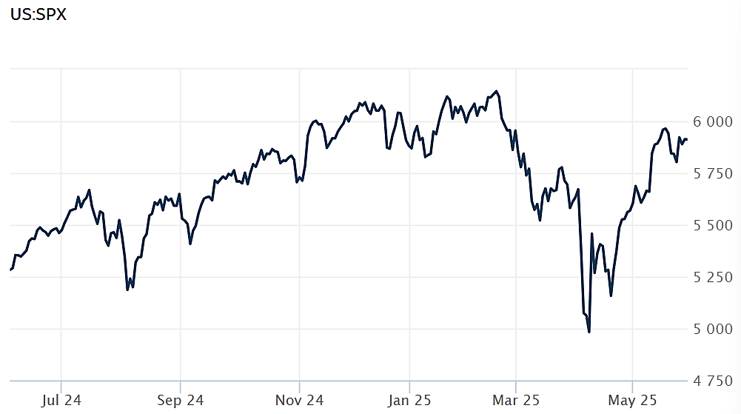
Source: Wall Street Journal

Inflation Falls in April, but Tariffs Loom

Inflation dropped slightly in April, according to the latest data from the Bureau of Economic Analysis. The PCE (personal consumption expenditures price index) increased just 0.1%, bringing the annual inflation rate to 2.1%, the slowest inflation rate in 2025. The monthly reading was in line with Dow Jones forecasts while the annual figure was slightly lower. The Fed tends to prefer PCE as an inflation gauge becomes it includes broader coverage and dynamic weighting.

Excluding food and energy, the core inflation rate was 0.1% for the month and 2.5% compared to a year ago. The monthly number hit estimates while the annual number was slightly below estimates. The Fed – and other central bankers – believe core inflation numbers are better representatives of long-term trends.

Consumer spending– the main driver of the US economy, accounting for 75% of all economic activity – slowed sharply in April, posting just a 0.2% increase, significantly off the 0.7% rate set in March but still in line with expectations. Additional consumer reticence was reflected in the saving rate, which jumped to 4.9%, the highest level in over a year. While saving can be positive from a personal finance perspective, excessive saving is a drag on economic growth.

Despite the positive inflation results in April, many believe that as tariffs are passed on to consumers, inflation – particularly core inflation – will surge, with some looking for a peak in the core number of around 3.5%. CNBC

GDP Falls

The latest reading of growth was marginally better than the first estimate but still shows a rapidly contracting US economy. According to the second estimate by the Bureau of Economic Analysis, gross domestic product (GDP) fell at an annual rate of 0.2% during the first quarter, marking the first economic contraction in three years. While the main culprit was a record level of imports (which subtract from GDP), the underlying fundamentals showed weakness.
Consumer spending rose at a pace of just 1.2% during the first quarter, down from the already tepid reading of 1.8% from the first estimate. That marked the smallest increase in consumer spending in three years and significantly below the 4% pace in the fourth quarter of 2024. The administration's higher tariffs – which have only begun to make their way through the economy -- will likely drag consumer spending even lower.
Corporate profits also tumbled, falling to a 2.9% annual rate during the first quarter. That marked the biggest decline since the pandemic in 2020 and well off the 5.4% annual pace set during the final quarter of 2024.
With imports unlikely to keep the pace set during the first quarter, second quarter GDP is likely to show some improvement. But there is little hope among analysts – which are calling for growth of 2% or less during the second quarter -- that growth will match the pace set during 2024. MSN

Behind the Latest Fed Minutes

While the Fed kept rates unchanged during May, minutes from the meeting reveal a heightened level of anxiety among Fed members across the board. Officials noted that the administration's attempt at resetting the rules of global trade via massive tariff increases is causing new vulnerabilities to the financial system that officials now believe "warrant monitoring."
Even more worrisome was the mention that the so-called Sell America trade could take a toll on the economy. Should investors begin to lose faith that the US is home to the world's safest assets, officials "noted that a durable shift in such correlations or a diminution of the perceived safe-haven status of U.S. assets could have long-lasting implications for the economy." Officials also believe that the downside risks to asset prices have increased.
The minutes showed that while central bankers believe corporations, banks, and households are in good shape, "an economic downturn or higher interest rates could lead to a deterioration in those conditions." All told, the "evolution" of the administration's trade policy has translated into considerable uncertainty about the "scale, scope, time, and persistence of associated economic effects." Axios

This research material was prepared by Burritt Research, Inc.

This material represents an assessment of the market and economic environment at a specific point in time and is not intended to be a forecast of future events, or a guarantee of future results. Forward-looking statements are subject to certain risks and uncertainties. Actual results, performance, or achievements may differ materially from those expressed or implied. Information is based on data gathered from what we believe are reliable sources. It is not guaranteed as to accuracy, does not purport to be complete and is not intended to be used as a primary basis for investment decisions. It should also not be construed as advice meeting the particular investment needs of any investor. Past performance does not guarantee future results.

Indices are unmanaged and investors cannot invest directly in an index. Unless otherwise noted, performance of indices does not account for any fees, commissions or other expenses that would be incurred. Returns do not include reinvested dividends.

The Standard & Poor's 500 (S&P 500) is an unmanaged group of securities considered to be representative of the stock market in general. It is a market value weighted index with each stock's weight in the index proportionate to its market value.

The Nasdaq Composite Index is a market-capitalization weighted index of the more than 3,000 common equities listed on the Nasdaq stock exchange. The types of securities in the index include American depositary receipts, common stocks, real estate investment trusts (REITs) and tracking stocks. The index includes all Nasdaq listed stocks that are not derivatives, preferred shares, funds, exchange-traded funds (ETFs) or debentures.

The Dow Jones Industrial Average (DJIA) is a price-weighted average of 30 actively traded "blue chip" stocks, primarily industrials, but includes financials and other service-oriented companies. The components, which change from time to time, represent between 15% and 20% of the market value of NYSE stocks.

The Conference Board creates the Present Situation Index (PSI) from survey data of approximately 5000 households across the United States to gauge public opinion about the US economy. When the index is positive, people feel good about the current economic situation. When negative, people are less optimistic. The (PSI) along with the Expectations Index are used by The Conference Board to create the Consumer Confidence Index (CCI) which tells us how optimistic (or not) people are about the future of the economy.

The Expectations Index is a component of the Consumer Confidence Index® (CCI), which is published each month by the Conference Board. The CCI reflects consumers' short-term—that is, six-month—outlook for, and sentiment about, the performance of the overall economy as it effects them. The Expectations Index is made up of the average of the CCI components that deal with six-month outlooks for business, employment, and income.

©2025 Wealthcare Capital Management LLC, Wealthcare Advisory Partners LLC, and Wealthcare Capital Partners LLC ("Wealthcare") is a registered investment advisor with the US Securities and Exchange Commission (SEC) under the Investment Advisors Act of 1940. All Rights Reserved.

Information contained herein is at a point in time and subject to change without notice. Information is derived from sources which are believed to be reliable but are not independently audited.

This content is for informational purposes only and is not advice for any individual or a recommendation of any specific investment product or strategy. Wealthcare cannot guarantee any specific financial return results for any client or guarantee a client will in all circumstances of changing personal financial goals and market conditions be able to remain in a client's Wealthcare Plan Comfort Zone®. Past performance is not a guide to future returns. All investments carry a degree of risk of loss of principal and there is no assurance that an investment will provide positive performance over any period of time.



Two James Center, 1021 East Cary Street, Suite 702 | RICHMOND, VA 23219 | 804.644.4711
WealthcareGDX.com

