
Monthly Market Recap

June 2025 Market Recap

The markets blew the doors off in June, setting record highs and effectively erasing all the losses spurred by the Trump administration's chaotic trade policies. The S&P 500® (SPX) and the NASDAQ Composite Index (COMP) booked fresh new highs while the Dow Jones Industrial Average® (DJIA) delivered solid gains. Still, while inflation ticked up just a bit in June, spending and income results were worrisome. Consumer confidence also took a step back. The Federal Reserve (Fed) held rates steady but is still signaling two rate cuts this year.

Markets Set New Record Highs

The markets continued their rebound in June with ferocity. The COMP led the way higher, gaining 6.6% for the month and setting a new record. The SPX also returned to record territory in June, gaining 5.0% while the DJIA gained 4.3%.
Investors now appear to have accepted the Trump administration's unpredictable trade policies as a series of tactical rather than structural shifts, the sum of which will leave the markets relatively untouched. That means that even though Trump's 90-day tariff pause will expire next week, many believe stocks will easily shrug off any bad news. Despite record highs, indications point to even more upside for stocks, especially when viewed through the lens of relatively stable inflation, strong corporate earnings, and a solid labor market.

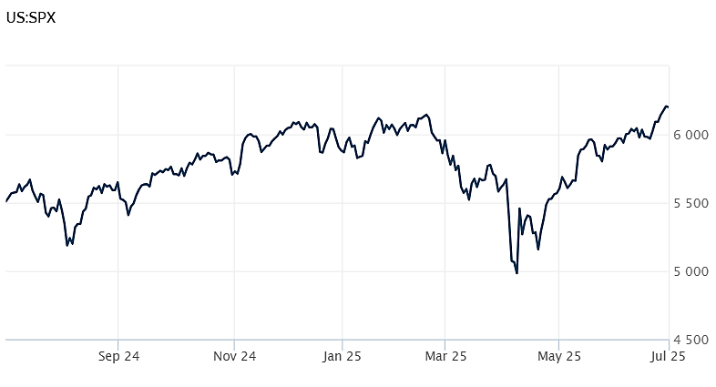
Source: Wall Street Journal

Inflation Edges Higher in May

The personal consumption expenditures price index (PCE) – the Fed's preferred inflation gauge – edged higher in May after taking a dip in April. For the month, the PCE rose 0.1% and 2.3% compared to a year ago. The numbers were in line with economists' expectations.

Excluding food and energy, core PCE was 0.2% in May and 2.7% compared to a year ago. The results were slightly above expectations, which called for increases of 0.1% and 2.6% respectively. The Fed believes that core numbers are more indicative of long term trends because they exclude these two more volatile categories.
During May, food and shelter prices increased while gasoline and other energy goods dropped.

Perhaps more worrisome were the personal spending and income numbers. Consumer spending -- which accounts for 75% of economic activity – fell 0.1% in May compared to estimates, which called for an increase of 0.1%. Personal income also fell 0.4% against estimates, which called for a 0.3% increase.

While the report adds to the evidence of a slowing economy, many believe the full brunt of the Trump tariffs won't be felt until summer and early fall. CNBC

Consumer Confidence Resumes Historic Slide

How Americans feel about their economic and business lives resumed a downward slide in June. The Conference Board Consumer Confidence Index® fell to 93, 5.4 points below the May reading and worse than the uptick many economists expected. In April, consumer confidence slid to its worst level since May 2020, when the country was in the midst of the covid pandemic.
How consumers feel about their present situation fell 6.4 points to 129.1. Meanwhile, how consumers feel about the outlook for income, jobs, and business – the expectations index -- also dropped, falling 4.6 points to 69. A reading below the threshold of 80 typically signals a recession ahead.
Driving consumers' sour appraisal of both current and future conditions were tariffs and their potential impact on the economy and prices. Inflation was also a big concern in June.
According to Stephanie Guichard, Senior Economist, "consumer confidence weakened in June, erasing almost half of May's sharp gains. The decline was broad-based across components, with consumers' assessments of the present situation and their expectations for the future both contributing to the deterioration." Conference Board

Fed Holds Rates Steady but Worries

Taking no one by surprise, the Fed held interest rates steady following its June meeting. The fed funds rate has now been in the target range of 4.25% to 4.5% since its last interest rate cut in December 2024.
The Fed appears to be continuing a wait-and-see attitude. Its statement following the June meeting says that "economic activity has continued to expand at a solid pace" but that "uncertainty about the economic outlook has diminished but remains elevated."
Still, the Fed says that it expects to lower interest rates two times this year. And while they have not indicated a time frame for the cuts, economists project a roughly 60% chance that the first cut will happen in September.
Like many, the Central Bank expects inflation to rise, with the PCE rising to 3% by year-end. The Fed also expects unemployment to rise to 4.5% from its current level of 4.2%.
The impact of the Trump tariffs has the Fed worried, especially unknowns about their impact on prices, growth, and jobs. According to Fed chairman Jerome Powell, "the thing that every outside forecaster and the Fed is saying is that we expect a meaningful amount of inflation to arrive in coming months, and we have to take that into account...what we're waiting for to reduce rates is to understand what will happen with the tariff inflation." CBS

This research material was prepared by Burritt Research, Inc.

This material represents an assessment of the market and economic environment at a specific point in time and is not intended to be a forecast of future events, or a guarantee of future results. Forward-looking statements are subject to certain risks and uncertainties. Actual results, performance, or achievements may differ materially from those expressed or implied. Information is based on data gathered from what we believe are reliable sources. It is not guaranteed as to accuracy, does not purport to be complete and is not intended to be used as a primary basis for investment decisions. It should also not be construed as advice meeting the particular investment needs of any investor. Past performance does not guarantee future results.

Indices are unmanaged and investors cannot invest directly in an index. Unless otherwise noted, performance of indices does not account for any fees, commissions or other expenses that would be incurred. Returns do not include reinvested dividends.

The Standard & Poor's 500 (S&P 500) is an unmanaged group of securities considered to be representative of the stock market in general. It is a market value weighted index with each stock's weight in the index proportionate to its market value.

The Nasdaq Composite Index is a market-capitalization weighted index of the more than 3,000 common equities listed on the Nasdaq stock exchange. The types of securities in the index include American depositary receipts, common stocks, real estate investment trusts (REITs) and tracking stocks. The index includes all Nasdaq listed stocks that are not derivatives, preferred shares, funds, exchange-traded funds (ETFs) or debentures.

The Dow Jones Industrial Average (DJIA) is a price-weighted average of 30 actively traded "blue chip" stocks, primarily industrials, but includes financials and other service-oriented companies. The components, which change from time to time, represent between 15% and 20% of the market value of NYSE stocks.

The Conference Board creates the Present Situation Index (PSI) from survey data of approximately 5000 households across the United States to gauge public opinion about the US economy. When the index is positive, people feel good about the current economic situation. When negative, people are less optimistic. The (PSI) along with the Expectations Index are used by The Conference Board to create the Consumer Confidence Index (CCI) which tells us how optimistic (or not) people are about the future of the economy.

The Expectations Index is a component of the Consumer Confidence Index® (CCI), which is published each month by the Conference Board. The CCI reflects consumers' short-term—that is, six-month—outlook for, and sentiment about, the performance of the overall economy as it effects them. The Expectations Index is made up of the average of the CCI components that deal with six-month outlooks for business, employment, and income.

©2025 Wealthcare Capital Management LLC, Wealthcare Advisory Partners LLC, and Wealthcare Capital Partners LLC ("Wealthcare") is a registered investment advisor with the US Securities and Exchange Commission (SEC) under the Investment Advisors Act of 1940. All Rights Reserved.

Information contained herein is at a point in time and subject to change without notice. Information is derived from sources which are believed to be reliable but are not independently audited.

This content is for informational purposes only and is not advice for any individual or a recommendation of any specific investment product or strategy. Wealthcare cannot guarantee any specific financial return results for any client or guarantee a client will in all circumstances of changing personal financial goals and market conditions be able to remain in a client's Wealthcare Plan Comfort Zone®. Past performance is not a guide to future returns. All investments carry a degree of risk of loss of principal and there is no assurance that an investment will provide positive performance over any period of time.



Two James Center, 1021 East Cary Street, Suite 702 | RICHMOND, VA 23219 | 804.644.4711
WealthcareGDX.com

