
Monthly Market Recap

July 2025 Market Recap

The markets continued to power higher in July -- setting a fresh series of all-time highs – despite on-going uncertainty over the Trump administration's trade policies. The Federal Reserve (Fed) also met, kept interest rates the same, but showed dissention among the ranks. The first US growth numbers were positive but revealed areas of concern. The labor report beat expectations but also had weaknesses.

Markets Push Higher for Another Month
The markets added to their latest streak of all-time highs in July. The NASDAQ Composite Index (COMP) led the way higher again, gaining 3.7% during the month, while the broad market S&P 500® (SPX) was up 2.2%. The popular Dow Jones Industrial Average® (DJIA) eked out a gain in July.

The markets are supported by a continuing string of positive economic reports, strong earnings reports (especially in tech), and a central bank that is showing cracks in its typical solid front. Investors also appear to continue to take the Trump administration's unpredictable trade policies in stride, viewing them more a strategic tactic or bargaining chip than a long-term shift. And even though there are budding indications that tariffs will push up prices, the hard evidence has not shown up yet and will likely take months to do so.

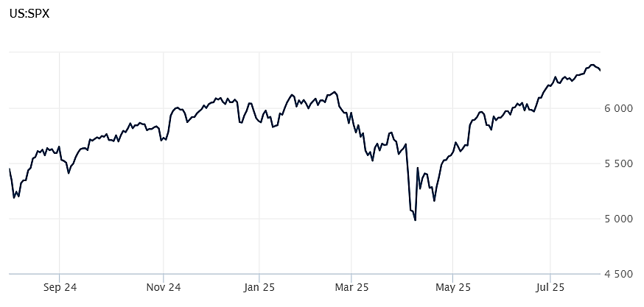
Source: Wall Street Journal

Fed Holds Rates Steady Amid Rising Dissent
Taking no one by surprise the Fed held rates steady during its latest meeting at the end of July. The policy setting Federal Open Market Committee (FOMC) kept the federal funds rate – the overnight borrowing cost between banks – in the target window of 4.25% to 4.5%, the same place it's been since December.

But for the first time in 30 years, two members of the Board of Governors -- Christopher Waller and vice-chair for supervision Michelle Bowman – dissented from the Board's decision, preferring to cut rates by a 0.25%. Both Waller and Bowman are Trump appointees. The Fed has come under increasing pressure from the Trump administration to cut rates.

According to the FOMC statement released after the meeting, the Fed remains "attentive" to its dual mandate of maximum employment and stable prices but that "uncertainty about the economic outlook remains elevated."

Tariffs continue to play a key role in that uncertainty. During a post-meeting press conference, Fed chair Jerome Powell said that "higher tariffs have begun to show more clearly to prices of some goods, but their overall effects on economic activity and inflation remain to be seen." When asked about a potential cut in September, Powell said the economy isn't being held back by its restrictive rate policy. Axios, Federal Reserve

US Economy Surprises
According to the latest data from the Bureau of Economic Analysis, the US economy grew at a solid pace during the second quarter. Gross Domestic Product (GDP) jumped to a 3% annual rate during the April to June period, far outpacing estimates calling for a 2.3% rise. The first or "Advanced" estimate of growth also showed that the economy abruptly reversed the 0.5% decline booked during the first quarter.

The better-than-expected performance was likely due to a 30% drop in imports, reversing a 38% surge during the first quarter. Rising imports make GDP worse since they subtract from production numbers while falling imports make GDP better since they add to production numbers.

The GDP numbers showed strength across key areas of the US economy without benefiting from a rise in federal government spending, which declined almost 4% during the period.

Consumer spending – a key data point since it accounts for about three-fourths of US economic activity – came in at 1.4% in the second quarter, significantly better than the 0.5% growth rate recorded during the first quarter, but still lackluster. CNBC

Hiring Beats Forecasts
The US labor market added 147,000 jobs in June, significantly beating out estimates, which called for an increase of 118,000 jobs. June's numbers were also an improvement over May's 144,000 jobs. According to the US Bureau of Labor Statistics, the unemployment rate was 4.2% in June, also better than forecasts, which expected a jobless rate of 4.3%.
Jobs in healthcare increased by 39,000 while state and local governments added 47,000 and 33,000 jobs respectively. Average hourly wages rose 0.2% from May and a modest 3.7% from a year earlier.
However, private companies hired only 74,000 workers in June, about half the 137,000 added in May. That marked the smallest number of private company hires since last October, a month that suffered significant labor disruptions.
Plus, even with a low employment rate, June's report showed that discouraged workers – those that believe no jobs are available to them – increased by 256,000 to 637,000. Rising discouraged workers is an indication of a weakening job market. AP News

This research material was prepared by Burritt Research, Inc.

This material represents an assessment of the market and economic environment at a specific point in time and is not intended to be a forecast of future events, or a guarantee of future results. Forward-looking statements are subject to certain risks and uncertainties. Actual results, performance, or achievements may differ materially from those expressed or implied. Information is based on data gathered from what we believe are reliable sources. It is not guaranteed as to accuracy, does not purport to be complete and is not intended to be used as a primary basis for investment decisions. It should also not be construed as advice meeting the particular investment needs of any investor. Past performance does not guarantee future results.

Indices are unmanaged and investors cannot invest directly in an index. Unless otherwise noted, performance of indices does not account for any fees, commissions or other expenses that would be incurred. Returns do not include reinvested dividends.

The Standard & Poor's 500 (S&P 500) is an unmanaged group of securities considered to be representative of the stock market in general. It is a market value weighted index with each stock's weight in the index proportionate to its market value.

The Nasdaq Composite Index is a market-capitalization weighted index of the more than 3,000 common equities listed on the Nasdaq stock exchange. The types of securities in the index include American depositary receipts, common stocks, real estate investment trusts (REITs) and tracking stocks. The index includes all Nasdaq listed stocks that are not derivatives, preferred shares, funds, exchange-traded funds (ETFs) or debentures.

The Dow Jones Industrial Average (DJIA) is a price-weighted average of 30 actively traded "blue chip" stocks, primarily industrials, but includes financials and other service-oriented companies. The components, which change from time to time, represent between 15% and 20% of the market value of NYSE stocks.

The Conference Board creates the Present Situation Index (PSI) from survey data of approximately 5000 households across the United States to gauge public opinion about the US economy. When the index is positive, people feel good about the current economic situation. When negative, people are less optimistic. The (PSI) along with the Expectations Index are used by The Conference Board to create the Consumer Confidence Index (CCI) which tells us how optimistic (or not) people are about the future of the economy.

The Expectations Index is a component of the Consumer Confidence Index® (CCI), which is published each month by the Conference Board. The CCI reflects consumers' short-term—that is, six-month—outlook for, and sentiment about, the performance of the overall economy as it effects them. The Expectations Index is made up of the average of the CCI components that deal with six-month outlooks for business, employment, and income.

©2025 Wealthcare Capital Management LLC, Wealthcare Advisory Partners LLC, and Wealthcare Capital Partners LLC ("Wealthcare") is a registered investment advisor with the US Securities and Exchange Commission (SEC) under the Investment Advisors Act of 1940. All Rights Reserved.

Information contained herein is at a point in time and subject to change without notice. Information is derived from sources which are believed to be reliable but are not independently audited.

This content is for informational purposes only and is not advice for any individual or a recommendation of any specific investment product or strategy. Wealthcare cannot guarantee any specific financial return results for any client or guarantee a client will in all circumstances of changing personal financial goals and market conditions be able to remain in a client's Wealthcare Plan Comfort Zone®. Past performance is not a guide to future returns. All investments carry a degree of risk of loss of principal and there is no assurance that an investment will provide positive performance over any period of time.



Two James Center, 1021 East Cary Street, Suite 702 | RICHMOND, VA 23219 | 804.644.4711
WealthcareGDX.com

