
Monthly Market Recap

September 2025 Market Recap

Stocks powered higher again in September as investors largely ignored an already priced-in government shutdown. The latest report on US economic growth was solid, with the unflinching US consumer the star of the show. The Federal Reserve (Fed) followed through on a much-telegraphed rate cut while hinting that more were on their way. The housing market also showed signs of life.

Consumers Keep Spending, Driving Markets to Fresh Highs
The markets sustained their historic rise during September, with the tech-heavy NASDAQ Composite Index (COMP) and the Dow Jones Industrial Average® (DJIA) setting fresh new highs. For the month, the COMP and S&P 500® (SPX) gained 5.6% and 3.5% respectively while the DJIA was up almost 2%. All major indices have now booked at least five months of consecutive monthly gains.

A big driver of record stock prices is the US consumer. Despite a litany of headwinds –including stubborn inflation, a softening job market, and worries about future growth – the American consumer continues to spend. Consumer spending was 2.5% during the second quarter and was in the 3.9% to 4.0% range for most of 2024. Plus, its contribution to Gross Domestic Product (GDP) was above 2.5% during the same period, a significant feat.

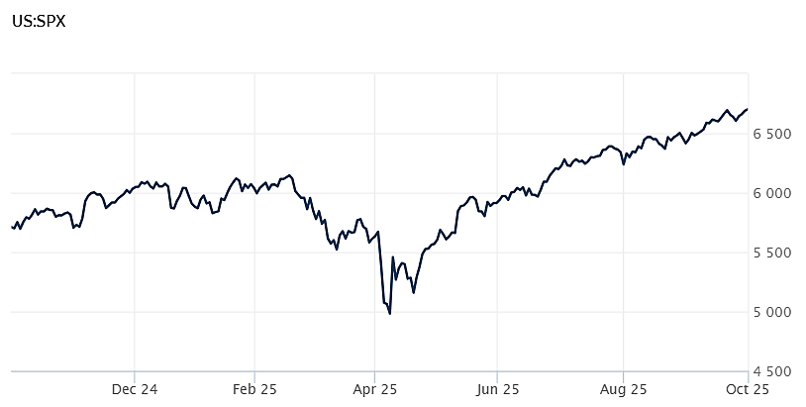
Source: Wall Street Journal

GDP Rebounds as Imports Ease
The nation's output of goods and services rebounded significantly in the second quarter, according to the third and final estimate by the Bureau of Economic Analysis. GDP delivered a 3.8% annual rate, outpacing estimates that called for a 3.3% jump and far better than the 0.6% drop during the first quarter.

The first quarter drop was due to a surge in imports – which subtract from GDP – as businesses tried to stave off the unpredictable effects of the Trump administration's trade policy. Imports normalized as expected during the second quarter, falling by 29% and boosting second quarter growth by more than 5%.

Also adding to growth during the second quarter was -- once again -- the resilience of the US consumer to spend. Despite headwinds from unpredictable erratic trade policies, a slowing job market, and stubborn inflation, consumer spending rose at a 2.5% annual pace during the quarter, up significantly from the 0.6% reading during the first quarter and well above estimates.

Spending on services grew at a 2.6% annual rate, well above expectations. On the other hand, private investment fell during the quarter, including a 5.1% drop in residential investment. Business inventories also fell. The first estimate of third quarter GDP will be released at the end of October. AP News

Fed Cuts Rates, Signal More on the Way
In one of the most highly anticipated and telegraphed moves, the Fed lowered interest rates by 0.25% during its September meeting. The target federal funds rate now stands at a range between 4.00%-4.25%. The 11-to-1 vote was less contentious than predicted, with newly installed Governor Stephen Miran the only policymaker voting against the quarter-point move. Miran wanted a more aggressive half-point reduction.

According to the Fed's post-meeting statement, the central bank continues to manage both upside and downside risks to its dual mandate of maximum employment and 2% inflation. "Job gains have slowed," while inflation "remains somewhat elevated." Meanwhile, "economic activity moderated in the first half of the year."

This balancing act was emphasized by the fact that despite the Fed's reduction in rates, the central bank continues to reduce its security holdings, which have a tightening effect on money supply.

At his post-meeting news conference, Fed Chair Jerome Powell emphasized the Fed's growing concern over the outlook for job growth, saying "the marked slowing in both the supply of and demand for workers is unusual in this less dynamic and somewhat softer labor market...the downside risks to employment appear to have risen."

The Fed also signaled that two more rate cuts are likely before the end of the year.

Trump's well-advertised badgering of the Fed in general and Powell in particular – along with appointment Miran, who is viewed as a Trump loyalist – has many worried that the traditional independence of the central bank may be at risk. CNBC

New Home Sales Surge to Three Year High
The battered housing market got a breath of fresh air in August, according to the latest data from the US Census Bureau. Sales of newly built single-family homes came in at a seasonally-adjusted annual rate of 800,000 during August, up 21% compared to July and 15% better than a year ago.

August's sales were far better than what economists had expected and the highest level since January 2022, over three years ago. The optimistic results also came before mortgage rates dropped below 6.4% in recent weeks.

Driving the results were buyer incentives offered by builders. These incentives include buying down mortgage rates, which gives buyers a credit at closing equivalent to a reduced interest rate. High interest rates have been one of the biggest factors behind a stagnant housing market.

Prices for new homes have also fallen below those for existing homes recently. That has made new home builds more attractive and reverses a long-standing trend.
Builders have also been willing to cut prices, with 39% of builders reporting cutting prices in September, up from 37% during the prior month and the highest price cuts in more than five years. Realtor.com

This research material was prepared by Burritt Research, Inc.

This material represents an assessment of the market and economic environment at a specific point in time and is not intended to be a forecast of future events, or a guarantee of future results. Forward-looking statements are subject to certain risks and uncertainties. Actual results, performance, or achievements may differ materially from those expressed or implied. Information is based on data gathered from what we believe are reliable sources. It is not guaranteed as to accuracy, does not purport to be complete and is not intended to be used as a primary basis for investment decisions. It should also not be construed as advice meeting the particular investment needs of any investor. Past performance does not guarantee future results.

Indices are unmanaged and investors cannot invest directly in an index. Unless otherwise noted, performance of indices does not account for any fees, commissions or other expenses that would be incurred. Returns do not include reinvested dividends.

The Standard & Poor's 500 (S&P 500) is an unmanaged group of securities considered to be representative of the stock market in general. It is a market value weighted index with each stock's weight in the index proportionate to its market value.

The Nasdaq Composite Index is a market-capitalization weighted index of the more than 3,000 common equities listed on the Nasdaq stock exchange. The types of securities in the index include American depositary receipts, common stocks, real estate investment trusts (REITs) and tracking stocks. The index includes all Nasdaq listed stocks that are not derivatives, preferred shares, funds, exchange-traded funds (ETFs) or debentures.

The Dow Jones Industrial Average (DJIA) is a price-weighted average of 30 actively traded "blue chip" stocks, primarily industrials, but includes financials and other service-oriented companies. The components, which change from time to time, represent between 15% and 20% of the market value of NYSE stocks.

The Conference Board creates the Present Situation Index (PSI) from survey data of approximately 5000 households across the United States to gauge public opinion about the US economy. When the index is positive, people feel good about the current economic situation. When negative, people are less optimistic. The (PSI) along with the Expectations Index are used by The Conference Board to create the Consumer Confidence Index (CCI) which tells us how optimistic (or not) people are about the future of the economy.

The Expectations Index is a component of the Consumer Confidence Index® (CCI), which is published each month by the Conference Board. The CCI reflects consumers' short-term—that is, six-month—outlook for, and sentiment about, the performance of the overall economy as it effects them. The Expectations Index is made up of the average of the CCI components that deal with six-month outlooks for business, employment, and income.

©2025 Wealthcare Capital Management LLC, Wealthcare Advisory Partners LLC, and Wealthcare Capital Partners LLC ("Wealthcare") is a registered investment advisor with the US Securities and Exchange Commission (SEC) under the Investment Advisors Act of 1940. All Rights Reserved.

Information contained herein is at a point in time and subject to change without notice. Information is derived from sources which are believed to be reliable but are not independently audited.

This content is for informational purposes only and is not advice for any individual or a recommendation of any specific investment product or strategy. Wealthcare cannot guarantee any specific financial return results for any client or guarantee a client will in all circumstances of changing personal financial goals and market conditions be able to remain in a client's Wealthcare Plan Comfort Zone®. Past performance is not a guide to future returns. All investments carry a degree of risk of loss of principal and there is no assurance that an investment will provide positive performance over any period of time.



Two James Center, 1021 East Cary Street, Suite 702 | RICHMOND, VA 23219 | 804.644.4711
WealthcareGDX.com

