
Monthly Market Recap

October 2025 Market Recap

The markets reached new highs again in October, as investors ignored a government shutdown and the tech sector delivered another round of positive results. The Federal Reserve (Fed) lowered rates 0.25%, a move widely anticipated by the markets. And while they appeared to tamp down the possibility of another rate cut in December, the lingering government shutdown could change that view. The suspension of key economic reports due to the shutdown – including jobs, inflation, and retail sales – could also encourage a more accommodative outlook from the Fed come December.

Markets Hit New Highs as Investors Brush Off Shutdown
Despite a government shutdown, the markets charged ahead in October, printing a brand new set of highs. The tech-heavy NASDAQ Composite Index (COMP) led the markets higher, gaining 4.7% for the month. The popular Dow Jones Industrial Average® (DJIA) and the broad market S&P 500® (SPX) also booked new highs, gaining 2.5% and 2.3%, respectively. All the major indices have now delivered at least 6 months of consecutive monthly gains.

A significant driver of October's record numbers was a highly anticipated rate cut from the Fed, which now leaves the federal funds rate between 3.75% to 4.00%. But with politicians showing little sign of bringing the shutdown to a close, many think the Fed will cut rates more aggressively than previously anticipated. Another big driver is the continuing positive earnings news from the tech sector, the strong outlook for the AI-driven productivity, and improving US-China trade relations.

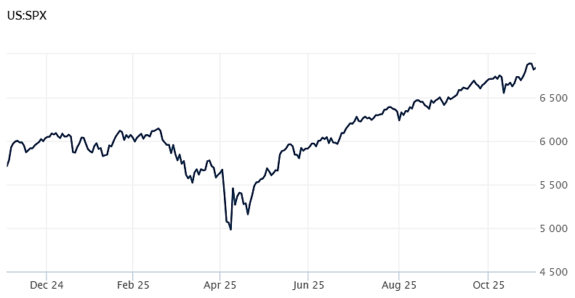
Source: Wall Street Journal

Fed Delivers Second Rate Cut of 2025, Debates Next Move
In a highly anticipated move, the Fed lowered the federal funds rate by 0.25% to the 3.75% to 4.00% range. The Fed has now cut rates twice this year after cutting three times in 2024. The federal funds rate is the overnight rate charged between banks and affects a wide swath of lending in the US, from credit cards to car loans to mortgages.

The decision to lower rates was made by a 10-2 vote. Governor Stephen Miran again cast a dissenting vote, preferring the central bank move more aggressively by cutting rates by one-half point. Kansas City Fed President Jeffrey Schmid also dissented, but for the opposite reason, preferring the Fed not cut rates at all. Miran -- an appointee of President Trump -- has advocated for a more aggressive rate-cutting Fed.

In a post-meeting news conference, Fed chairman Jerome Powell appeared to want to temper expectations of further rate cuts. "In the committee’s discussions at this meeting, there were strongly differing views about how to proceed in December," Powell said. "A further reduction in the policy rate at the December meeting is not a foregone conclusion. Far from it." However, many now believe that the Fed may soften that stance as the government shutdown approaches record length.

The Fed also said that it would refrain from reinvesting proceeds from its maturing bonds, a process known as quantitative tightening (QT). QT tends to restrict the money supply, which can have a similar effect to raising interest rates. CNBC

Existing-Home Sales Rise to Seven-Month High on Lower Rates
Sales of existing US homes surged to a seven-month high in September, according to the National Association of Realtors (NAR). Sales during the month were up 1.5% compared to August, landing at a seasonally adjusted rate of 4.06 million units per year. The results were in line with economists' expectations. Resales increased in the Northeast, South, and West regions but declined in the Midwest. Compared to a year ago, existing home sales were up 4.1%

The average price for a home rose 2.1% compared to a year ago to $415,200 in September. That marks the 27th consecutive month that home prices have gone up on an annual basis while recording the highest average price for a home in September since 1999.

According to Lawrence Yun, NAR's chief economist, "The home sales in September showed an increase, but I would not characterize (it) as a breakout." But he added, "It does show that consumers do respond to lower mortgage rates."
At the end of the month, there were 1.5 million unsold homes on the market, up 1.3% compared to August and up 14% compared to September of last year. That translates to about 4.6 months of supply at the current sales price. Typically, a five to six month supply indicates a balanced market between buyers and sellers. AP News

Mortgage Rates Fall for Fourth Week, Now Near Year Lows
For the fourth week in a row, the average rate on a 30-year fixed-rate US mortgage fell, according to mortgage buyer Freddie Mac. The average rate now stands at 6.17%, down slightly from 6.19% the week before. The last time mortgage rates were this low was over a year ago when they hit 6.12%.

The rate on a fixed-rate 15-year mortgage also eased to 5.41% last week from 5.44% the week earlier. The rate is also considerably below the 5.99% that a 15-year cost a year ago. The 15-year mortgage is popular among homeowners refinancing their homes.

Lenders tend to use the yield on the 10-year Treasury note as a guide to setting rates. In addition, what's happening to the economy and inflation can also influence mortgage rates. When inflation moves up – or is anticipated to move up – rates on the 10-year Treasury can move up as well, bring higher mortgage rates with them. The Fed's interest rate policy can influence mortgage rates, although that is not always the case. AP News

This research material was prepared by Burritt Research, Inc.

This material represents an assessment of the market and economic environment at a specific point in time and is not intended to be a forecast of future events, or a guarantee of future results. Forward-looking statements are subject to certain risks and uncertainties. Actual results, performance, or achievements may differ materially from those expressed or implied. Information is based on data gathered from what we believe are reliable sources. It is not guaranteed as to accuracy, does not purport to be complete and is not intended to be used as a primary basis for investment decisions. It should also not be construed as advice meeting the particular investment needs of any investor. Past performance does not guarantee future results.

Indices are unmanaged and investors cannot invest directly in an index. Unless otherwise noted, performance of indices does not account for any fees, commissions or other expenses that would be incurred. Returns do not include reinvested dividends.

The Standard & Poor's 500 (S&P 500) is an unmanaged group of securities considered to be representative of the stock market in general. It is a market value weighted index with each stock's weight in the index proportionate to its market value.

The Nasdaq Composite Index is a market-capitalization weighted index of the more than 3,000 common equities listed on the Nasdaq stock exchange. The types of securities in the index include American depositary receipts, common stocks, real estate investment trusts (REITs) and tracking stocks. The index includes all Nasdaq listed stocks that are not derivatives, preferred shares, funds, exchange-traded funds (ETFs) or debentures.

The Dow Jones Industrial Average (DJIA) is a price-weighted average of 30 actively traded "blue chip" stocks, primarily industrials, but includes financials and other service-oriented companies. The components, which change from time to time, represent between 15% and 20% of the market value of NYSE stocks.

The Conference Board creates the Present Situation Index (PSI) from survey data of approximately 5000 households across the United States to gauge public opinion about the US economy. When the index is positive, people feel good about the current economic situation. When negative, people are less optimistic. The (PSI) along with the Expectations Index are used by The Conference Board to create the Consumer Confidence Index (CCI) which tells us how optimistic (or not) people are about the future of the economy.

The Expectations Index is a component of the Consumer Confidence Index® (CCI), which is published each month by the Conference Board. The CCI reflects consumers' short-term—that is, six-month—outlook for, and sentiment about, the performance of the overall economy as it effects them. The Expectations Index is made up of the average of the CCI components that deal with six-month outlooks for business, employment, and income.

©2025 Wealthcare Capital Management LLC, Wealthcare Advisory Partners LLC, and Wealthcare Capital Partners LLC ("Wealthcare") is a registered investment advisor with the US Securities and Exchange Commission (SEC) under the Investment Advisors Act of 1940. All Rights Reserved.

Information contained herein is at a point in time and subject to change without notice. Information is derived from sources which are believed to be reliable but are not independently audited.

This content is for informational purposes only and is not advice for any individual or a recommendation of any specific investment product or strategy. Wealthcare cannot guarantee any specific financial return results for any client or guarantee a client will in all circumstances of changing personal financial goals and market conditions be able to remain in a client's Wealthcare Plan Comfort Zone®. Past performance is not a guide to future returns. All investments carry a degree of risk of loss of principal and there is no assurance that an investment will provide positive performance over any period of time.



Two James Center, 1021 East Cary Street, Suite 702 | RICHMOND, VA 23219 | 804.644.4711
WealthcareGDX.com

