
Monthly Market Recap

November 2025 Market Recap

The longest US federal government shutdown on record came to an end in November and surprisingly, little US stock market carnage was left in its path. Crucial government reports began flowing again, with the latest jobs report coming in better than expected. Black Friday sales were also solid, with many anticipating a record season. However, the mixed economic picture continued in November, with US consumer confidence tumbling.

Markets Hold Firm After Shutdown
After a record setting 44 days, the longest federal government shutdown in US history came to an end in November as congress restored much-needed funding and furloughed workers returned to their jobs. Despite the turbulence, the markets held their own. The popular Dow Jones Industrial Average® (DJIA) and the broad market S&P 500® (SPX) both ended higher compared to October, but just barely, gaining 0.32% and 0.13% respectively. Those gains kept their seven month winning streaks alive. Even though the tech-heavy NASDAQ Composite Index (COMP) fell 1.5% for the month, it managed to end the holiday-shorted week with a bang, scoring five consecutive days of gains.

The markets appear to be digesting two competitive narratives. On the one hand, many believe that an interest rate cut by the Federal Reserve (Fed) is likely following its December meeting. That would mark the third consecutive time the central bank has lowered rates. On the other hand, investors now appear to be taking a more measured approach to the outlook for big tech. The AI-driven bonanza in prices is now making many squeamish over sky-high valuations, a fact that many participants simply ignored just a few short weeks ago.

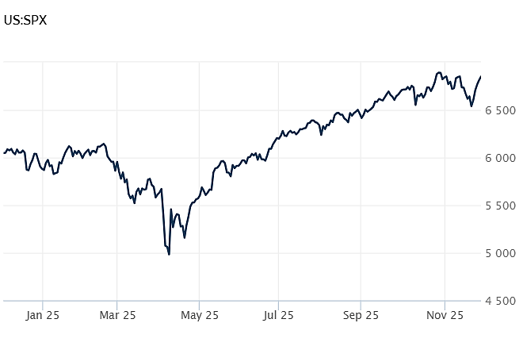
Source: Wall Street Journal

Delayed Jobs Report Delivers Strong Upside Surprise
The long-awaited report on the labor market added more jobs than expected, according to the delayed September report by the Bureau of Labor Statistics. Nonfarm payrolls increased by 119,000 for the month, far outpacing estimates, which called for an increase of just 50,000. September's number was also significantly better than the 4,000 jobs lost in August. July's figures were revised down.

Job gains came from the usual suspects, with health care leading the way, adding 43,000 jobs. Bars and restaurants and socials assistance positions also added workers. Jobs were lost in transportation and housing, the federal government, and professional and business services.

The government also reported that the unemployment rate rose during the month. It now stands at 4.4%, its highest level since October 2021. Average hourly earnings rose 0.2% for the month and 3.8% compared to a year ago. Estimates called for increases of 0.3% and 3.7% respectively. CNBC

Black Friday Spending Beats Expectations
Despite headwinds, shoppers piled into stores and online during Black Friday, the most important shopping day of the year. According to Mastercard US retail sales grew 4.1% compared to last year.

Online shoppers spent $11.8 billion on Black Friday, up 9.1% compared to last year, according to Adobe Analytics. The results were also better than estimates, which called for e-commerce sales of $11.7 billion. At midday on Friday, $12.5 million passed through online shopping carts every minute.

However, many believe the K-shaped bifurcated economy will have a significant effect on holiday shopping. The upper leg of the economy – which includes high-income households with strong assets – have largely been insulated from higher prices and will likely spend accordingly during the holidays. The lower leg of the economy – which includes lower-income households with weaker assets and more credit strain – are likely to be more picky during the holidays, focusing more on deals and value.

The National Retail Foundation expects sales during the November to December holiday shopping season to top $1 trillion, a new record. It also expects retail sales to grow 3.7% and 4.2% respectively during November and December, about the same as last year. CBS

Consumer Confidence Falls to Seven-Month Low
According to the latest data from the Conference Board, how US consumers feel about their economic lives is deteriorated to its lowest level since April. The Conference Board Consumer Confidence Index® fell by 6.8 points in November to 88.7. The Present Situation Index – which measures how consumers feel about the current job and business environment -- fell 4.3 points to 126.9. Meanwhile, the Expectations Index – which measures how consumers feel about the short-term income, business, and labor markets – fell 8.6 points to 63.2. All five components of the overall index were weak.

Most worrisome for consumers include prices and inflation, tariffs and trade, and politics, with the government shutdown playing a significant role. Apprehension about jobs also continued to play a part in consumers' feelings.

According to Conference Board's chief economist Dana M Peterson, "consumers were notably more pessimistic about business conditions six months from now. Mid-2026 expectations for labor market conditions remained decidedly negative, and expectations for increased household incomes shrunk dramatically, after six months of strongly positive readings." Conference Board

This research material was prepared by Burritt Research, Inc.

This material represents an assessment of the market and economic environment at a specific point in time and is not intended to be a forecast of future events, or a guarantee of future results. Forward-looking statements are subject to certain risks and uncertainties. Actual results, performance, or achievements may differ materially from those expressed or implied. Information is based on data gathered from what we believe are reliable sources. It is not guaranteed as to accuracy, does not purport to be complete and is not intended to be used as a primary basis for investment decisions. It should also not be construed as advice meeting the particular investment needs of any investor. Past performance does not guarantee future results.

Indices are unmanaged and investors cannot invest directly in an index. Unless otherwise noted, performance of indices does not account for any fees, commissions or other expenses that would be incurred. Returns do not include reinvested dividends.

The Standard & Poor's 500 (S&P 500) is an unmanaged group of securities considered to be representative of the stock market in general. It is a market value weighted index with each stock's weight in the index proportionate to its market value.

The Nasdaq Composite Index is a market-capitalization weighted index of the more than 3,000 common equities listed on the Nasdaq stock exchange. The types of securities in the index include American depositary receipts, common stocks, real estate investment trusts (REITs) and tracking stocks. The index includes all Nasdaq listed stocks that are not derivatives, preferred shares, funds, exchange-traded funds (ETFs) or debentures.

The Dow Jones Industrial Average (DJIA) is a price-weighted average of 30 actively traded "blue chip" stocks, primarily industrials, but includes financials and other service-oriented companies. The components, which change from time to time, represent between 15% and 20% of the market value of NYSE stocks.

The Conference Board creates the Present Situation Index (PSI) from survey data of approximately 5000 households across the United States to gauge public opinion about the US economy. When the index is positive, people feel good about the current economic situation. When negative, people are less optimistic. The (PSI) along with the Expectations Index are used by The Conference Board to create the Consumer Confidence Index (CCI) which tells us how optimistic (or not) people are about the future of the economy.

The Expectations Index is a component of the Consumer Confidence Index® (CCI), which is published each month by the Conference Board. The CCI reflects consumers' short-term—that is, six-month—outlook for, and sentiment about, the performance of the overall economy as it effects them. The Expectations Index is made up of the average of the CCI components that deal with six-month outlooks for business, employment, and income.

©2025 Wealthcare Capital Management LLC, Wealthcare Advisory Partners LLC, and Wealthcare Capital Partners LLC ("Wealthcare") is a registered investment advisor with the US Securities and Exchange Commission (SEC) under the Investment Advisors Act of 1940. All Rights Reserved.

Information contained herein is at a point in time and subject to change without notice. Information is derived from sources which are believed to be reliable but are not independently audited.

This content is for informational purposes only and is not advice for any individual or a recommendation of any specific investment product or strategy. Wealthcare cannot guarantee any specific financial return results for any client or guarantee a client will in all circumstances of changing personal financial goals and market conditions be able to remain in a client's Wealthcare Plan Comfort Zone®. Past performance is not a guide to future returns. All investments carry a degree of risk of loss of principal and there is no assurance that an investment will provide positive performance over any period of time.



Two James Center, 1021 East Cary Street, Suite 702 | RICHMOND, VA 23219 | 804.644.4711
WealthcareGDX.com

