
Monthly Market Recap

December 2025 Market Recap

Stocks closed out 2025 with a bang, sending all major indices into double digit territory. The year capped another record for stocks, but worries over potential AI-driven risks continue to emerge. The latest economic growth numbers were solid while the late jobs report showed a softening labor market. Not surprisingly, the Federal Reserve (Fed) lowered rates in December but appears to be ready to hit the pause button for now.

Stocks End 2025 With Strong Gains
Despite flat returns in December, investors finished 2025 with double-digit gains. Leading the way higher was the tech-heavy NASDAQ Composite Index (COMP), which gained 20.4% in 2025. The broad market S&P 500® (SPX) and the popular Dow Jones Industrial Average® (DJIA) also rose, gaining 16.4% and 13% respectively.

Stocks rallied in 2025 despite significant headwinds, including a shaky interest rate environment, a chaotic series of tariff policies by the Trump administration, and a record long government shutdown. Many economic indicators posted strong results during 2025, and the latest economic growth numbers continue to show solid growth. However, a deteriorating jobs market and stubborn inflation continue to annoy Fed policy makers and investors.

More worrisome is that many now believe the multi-year advances in stocks is tied to an increasingly risky bet on AI. That bet has produced lofty valuations at best and sky-high at worst. Promised productivity gains and margin improvements have yet to emerge. The earnings concentration in AI-supported mega-cap tech stocks could also translate earnings disappointments into significant downward pressure on all stocks.

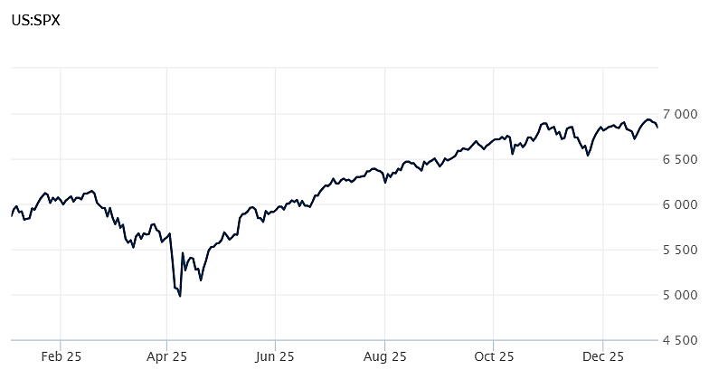
Source: Wall Street Journal

Economic Growth Surges Past Expectations
The US economy grew at a better than expected pace during the third quarter, according to the latest data from the Bureau of Economic Analysis. US gross domestic product (GDP) -- the total output of all goods and services in the wide ranging domestic economy -- grew at a 4.3% annual rate during the July to September period. The results far outpaced estimates, which called for a gain of 3.2%.
Consumer spending was once again the shining star during the third quarter, gaining 3.5% compared to a year ago. The third quarter consumer spending rate was also significantly above the prior quarter 2.5%. Corporate profits soared during the third quarter at an annual rate of 9.1% compared to a year ago.

This was the first estimate of third quarter annual growth and was originally scheduled for release in October but was delayed due to the government shutdown. This release will also replace the second estimate that was scheduled for November. The government will release the final third quarter estimate of growth in January. CNBC, BEA

Hiring Slows as Labor Market Cools
The US economy added 64,000 jobs in November, according to the latest data from the Bureau of Labor Statistics. The results were better than estimates, which called for a gain of 40,000 jobs. The report offers the first look at the state of the US job market following a 6-week hiatus due to the government shutdown. The report also included partial data from October, which showed a loss of 105,000 jobs that month. August and September were also revised down by a total of 33,000 jobs. The unemployment rate during November was 4.6%, the highest level since September 2021.

The data suggests that many employers are hitting the pause button on hiring. Driving the reluctance to add workers is the uncertainty surrounding trade policy, a murky outlook for interest rates, and the potential unfulfilled promises surrounding AI.

While the report was much anticipated, many are taking it with a grain of salt given the questions surrounding data reliability and completeness directly following the shutdown. The Fed will likely place more emphasis on the December jobs report, which will be released in early January. CBS

Fed Cuts Rates Again, Signals Pause Ahead
Not surprisingly, the Fed reduced its key interest rate by a quarter-point following its December meeting. The federal funds target rate now stands at the range of 3.5% to 3.75%. The move marks the third reduction in 2025 which follows three reductions in 2024.

According to the Fed's statement, "available indicators suggest that economic activity has been expanding at a moderate pace. Job gains have slowed this year, and the unemployment rate has edged up through September. More recent indicators are consistent with these developments. Inflation has moved up since earlier in the year and remains somewhat elevated."

During a new conference, Fed Chair Jerome Powell suggested that following the recent cuts, the Fed may take a breather from rate reductions. He said that he "will carefully evaluate the incoming data," while adding that the Fed is "well positioned to wait to see how the economy evolves."

He went on to say that he believes the current rate neither stimulates nor restricts the economy. This neutral interest rate stance is a significant shift from earlier this year when he suggested the rate was high enough to slow growth and, as a result, tamp down inflation.

Powell also said that inflation could increase to start off 2026 as the costs of tariffs begin to work through the economy. After that, he said prices may come down. AP News, Federal Reserve

This research material was prepared by Burritt Research, Inc.

This material represents an assessment of the market and economic environment at a specific point in time and is not intended to be a forecast of future events, or a guarantee of future results. Forward-looking statements are subject to certain risks and uncertainties. Actual results, performance, or achievements may differ materially from those expressed or implied. Information is based on data gathered from what we believe are reliable sources. It is not guaranteed as to accuracy, does not purport to be complete and is not intended to be used as a primary basis for investment decisions. It should also not be construed as advice meeting the particular investment needs of any investor. Past performance does not guarantee future results.

Indices are unmanaged and investors cannot invest directly in an index. Unless otherwise noted, performance of indices does not account for any fees, commissions or other expenses that would be incurred. Returns do not include reinvested dividends.

The Standard & Poor's 500 (S&P 500) is an unmanaged group of securities considered to be representative of the stock market in general. It is a market value weighted index with each stock's weight in the index proportionate to its market value.

The Nasdaq Composite Index is a market-capitalization weighted index of the more than 3,000 common equities listed on the Nasdaq stock exchange. The types of securities in the index include American depositary receipts, common stocks, real estate investment trusts (REITs) and tracking stocks. The index includes all Nasdaq listed stocks that are not derivatives, preferred shares, funds, exchange-traded funds (ETFs) or debentures.

The Dow Jones Industrial Average (DJIA) is a price-weighted average of 30 actively traded "blue chip" stocks, primarily industrials, but includes financials and other service-oriented companies. The components, which change from time to time, represent between 15% and 20% of the market value of NYSE stocks.

The Conference Board creates the Present Situation Index (PSI) from survey data of approximately 5000 households across the United States to gauge public opinion about the US economy. When the index is positive, people feel good about the current economic situation. When negative, people are less optimistic. The (PSI) along with the Expectations Index are used by The Conference Board to create the Consumer Confidence Index (CCI) which tells us how optimistic (or not) people are about the future of the economy.

The Expectations Index is a component of the Consumer Confidence Index® (CCI), which is published each month by the Conference Board. The CCI reflects consumers' short-term—that is, six-month—outlook for, and sentiment about, the performance of the overall economy as it effects them. The Expectations Index is made up of the average of the CCI components that deal with six-month outlooks for business, employment, and income.

©2026 Wealthcare Capital Management LLC, Wealthcare Advisory Partners LLC, and Wealthcare Capital Partners LLC ("Wealthcare") is a registered investment advisor with the US Securities and Exchange Commission (SEC) under the Investment Advisors Act of 1940. All Rights Reserved.

Information contained herein is at a point in time and subject to change without notice. Information is derived from sources which are believed to be reliable but are not independently audited.

This content is for informational purposes only and is not advice for any individual or a recommendation of any specific investment product or strategy. Wealthcare cannot guarantee any specific financial return results for any client or guarantee a client will in all circumstances of changing personal financial goals and market conditions be able to remain in a client's Wealthcare Plan Comfort Zone®. Past performance is not a guide to future returns. All investments carry a degree of risk of loss of principal and there is no assurance that an investment will provide positive performance over any period of time.



Two James Center, 1021 East Cary Street, Suite 702 | RICHMOND, VA 23219 | 804.644.4711
WealthcareGDX.com

