Quarterly Letter
Quarterly Letter
First Quarter 2023 Quarterly Letter

Fourth Quarter 2025: Quarterly Letter

The market narrative in 2025 was dominated by tariffs, artificial intelligence, and questions about the direction of U.S. relationships with the rest of the world. For investors, this resulted in a wild ride, but in the end, investors who stayed invested did just fine, another reminder of the benefit of having a plan and sticking to it. The Russell 3000 finished up 17.1%, the MSCI EAFE index was up a whopping 31.9%, and bonds, as measured by the Bloomberg Aggregate Index, posted a respectable 7.3%.

As we turn the page into 2026, the outlook season is upon us. This is when every bank releases their stock market forecast for the upcoming year. These have been shown to have zero predictive power and should be viewed as nothing more than “content creation.” However, 2026 is shaping up to be an interesting year for several reasons: we will have a new Fed chairman, more clarity on the impact of tariffs, and mid-term elections, which will be a referendum on the Trump Agenda. One item likely to be front and center is the “Affordability Crisis”.
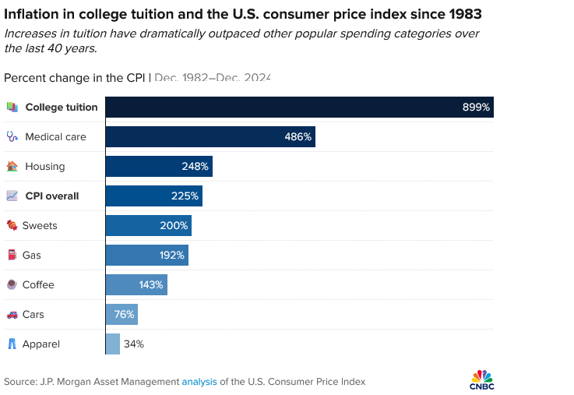
The affordability crisis is the growing situation where people struggle to pay for the basic necessities of life. The chart nearby shows how much college tuition, medical care, and housing prices have outpaced broad-based inflation.
The affordability crisis is not just hitting the lower- and middle-income cohorts but is increasingly affecting the upper-middle class, as Michael Green, a portfolio manager and strategist at Simplify, wrote in a viral Substack post showing his own calculations of essential living costs (housing, childcare, healthcare, transportation, food, etc.). He estimated that a family of four would need roughly $136,000–$140,000 a year just to cope, not live comfortably.
So whether you are a 30-something trying to figure out if you can afford that new house or a senior trying to calculate if you can squeeze in a second vacation given skyrocketing healthcare premiums, I encourage you to reach out to me to update or create a goals-oriented financial plan.

The financial plan will incorporate various goals, ranging from these core-necessities goals, wants such as vacations and new cars, and finally legacy goals. Each goal can have various ranges from acceptable to ideal. In addition to incorporating your goals, we have developed plausible, forward-looking capital market returns. Extrapolating past robust returns is likely to overstate future returns, given current high valuations. We then use Monte-Carlo simulations to assess the probability of attaining your goals. These can be further stress-tested under various conditions, ranging from ‘scrap that second vacation’ or migrate to a more aggressive portfolio.

The financial plan will provide you with a sense of confidence, clarity, and control to kick off the New Year.

Have a Happy and Healthy New Year

Bloomberg (December 23, 2016)

