
Monthly Market Recap

January 2026 Market Recap

Stocks began 2026 slightly higher as investors digested a host of political and economic factors. Kevin Warsh's nomination to head the Federal Reserve (Fed) was largely viewed as positive. Inflation remained elevated but within expectations while personal income rose again. The real estate market also showed a glimmer of hope while consumer confidence fell to its lowest level since 2014.

Stocks Edge Higher in January as Dow Leads Modest Gains
Stocks started out 2026 in positive territory, but barely. The popular Dow Jones Industrial Average® (DJIA) led the way, gaining 1.7% compared to December. The broad market S&P 500® (SPX) also gained ground, adding 1.4% while the tech-heavy NASDAQ Composite Index (COMP) squeaked out a less than 1% uptick.

Following the euphoria of 2025's annual gains, the markets sideways move and a mid-month sell-off wasn't surprising. Investors weathered a politically volatile January as well, including a host of potential tariff actions by the Trump administration, as well as hyperbole surrounding a potential takeover of Greenland.

Most notably, the markets looked favorably upon Trump's nomination of Kevin Warsh as the next Fed chairman. The selection is likely to ease concern over the Fed's independence due to Warsh's experience as a Fed governor and his at times stance against inflation. He is also viewed as unlikely to always follow the president's impulses and will likely maintain credibility at the Fed.

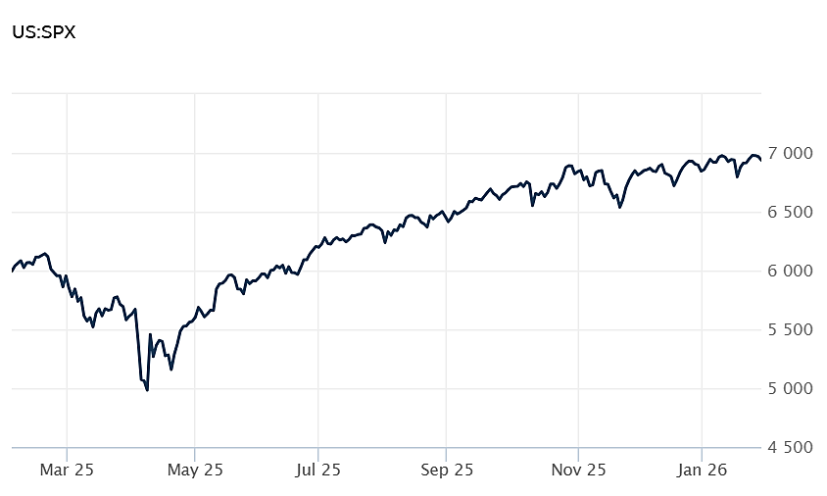
Source: Wall Street Journal

PCE Inflation Steady at 2.8% as Personal Income Rises
According to the latest data from the Bureau of Economic Analysis, the Personal Consumption Expenditure (PCE) -- the Fed's preferred inflation gauge -- rose 0.2% in both October and November compared to prior months. Compared to a year ago, November PCE rose 2.8% for both the headline and the core number. The results were in line with expectations.

November's inflation numbers were led by increases in healthcare, gasoline, energy products, and vehicles and parts. Transportation services declined during the month.

Along with a rise in prices, personal income rose $31 billion in October, followed by an increase of $80 billion in November. That translated into increases 0.1% in October and 0.3% in November. Disposable income also increased at the same rate.

The report points to the inflation that remains steady, not significantly out of line with expectations, but still above the 2% threshold set by the Fed. The report also reveals strong gains in US consumers' personal income. CNBC, BEA

Existing Home Sales Jump 5.1% in December to Three-Year High
Sales of previously owned homes were 4.35 million units in December, according to the National Association of Realtors. That represented a 5.1% increase over November, over two times the 2% gain expected by analysts. December's results were the strongest in nearly 3 years. For the full year, home sales were 4.1 million units, unchanged from 2024.

Monthly increases were recorded across all US regions. Annual increases were recorded in the Northeast and Midwest but were lower in the South and West.

The sales figures are based on closings, so they are likely to reflect contracts executed in October and November when mortgage rates hovered around 6.2% and 6.3%, a rate much lower than the 7% common in spring and summer.

The average home price was $405,000 in December, up 0.4% annually and marking the 30th straight month of annual gains.

"2025 was another tough year for homebuyers, marked by record-high home prices and historically low home sales,” said Lawrence Yun, chief economist for The Realtors. "However, in the fourth quarter, conditions began improving, with lower mortgage rates and slower home price growth." CNBC, NAR

Consumer Confidence Falls to Lowest Level Since 2014
How US consumers feel about their business and economic lives tumbled sharply in January, registering the lowest level of since 2014. The Conference Board Consumer Confidence Index® fell by 9.7 points to 84.5. And while December's numbers were revised slightly upward, January's results resumed the gauge's previous decline.

How American's feel about the short-term outlook for their jobs, incomes, and business conditions -- the Expectations Index -- fell 9.5 points to 65.1. That's well below the threshold of 80, which can signal a recession. The index has now been below 80 for 12 straight months.

Consumers' feelings about their current economic condition -- the Present Situation index -- also went down by 9.9 points in January to end at 113.7.

According to Dana M Peterson, Chief Economist, The Conference Board, "confidence collapsed in January, as consumer concerns about both the present situation and expectations for the future deepened...All five components of the Index deteriorated, driving the overall Index to its lowest level since May 2014 (82.2) -- surpassing its COVID-19 pandemic depths."

Driving the decline was a host of the usual factors including how consumers' feel about inflation, tariffs, trade, politics, and the job market. Conference Board, AP News

This research material was prepared by Burritt Research, Inc.

This material represents an assessment of the market and economic environment at a specific point in time and is not intended to be a forecast of future events, or a guarantee of future results. Forward-looking statements are subject to certain risks and uncertainties. Actual results, performance, or achievements may differ materially from those expressed or implied. Information is based on data gathered from what we believe are reliable sources. It is not guaranteed as to accuracy, does not purport to be complete and is not intended to be used as a primary basis for investment decisions. It should also not be construed as advice meeting the particular investment needs of any investor. Past performance does not guarantee future results.

Indices are unmanaged and investors cannot invest directly in an index. Unless otherwise noted, performance of indices does not account for any fees, commissions or other expenses that would be incurred. Returns do not include reinvested dividends.

The Standard & Poor's 500 (S&P 500) is an unmanaged group of securities considered to be representative of the stock market in general. It is a market value weighted index with each stock's weight in the index proportionate to its market value.

The Nasdaq Composite Index is a market-capitalization weighted index of the more than 3,000 common equities listed on the Nasdaq stock exchange. The types of securities in the index include American depositary receipts, common stocks, real estate investment trusts (REITs) and tracking stocks. The index includes all Nasdaq listed stocks that are not derivatives, preferred shares, funds, exchange-traded funds (ETFs) or debentures.

The Dow Jones Industrial Average (DJIA) is a price-weighted average of 30 actively traded "blue chip" stocks, primarily industrials, but includes financials and other service-oriented companies. The components, which change from time to time, represent between 15% and 20% of the market value of NYSE stocks.

The Conference Board creates the Present Situation Index (PSI) from survey data of approximately 5000 households across the United States to gauge public opinion about the US economy. When the index is positive, people feel good about the current economic situation. When negative, people are less optimistic. The (PSI) along with the Expectations Index are used by The Conference Board to create the Consumer Confidence Index (CCI) which tells us how optimistic (or not) people are about the future of the economy.

The Expectations Index is a component of the Consumer Confidence Index® (CCI), which is published each month by the Conference Board. The CCI reflects consumers' short-term—that is, six-month—outlook for, and sentiment about, the performance of the overall economy as it effects them. The Expectations Index is made up of the average of the CCI components that deal with six-month outlooks for business, employment, and income.

©2026 Wealthcare Capital Management LLC, Wealthcare Advisory Partners LLC, and Wealthcare Capital Partners LLC ("Wealthcare") is a registered investment advisor with the US Securities and Exchange Commission (SEC) under the Investment Advisors Act of 1940. All Rights Reserved.

Information contained herein is at a point in time and subject to change without notice. Information is derived from sources which are believed to be reliable but are not independently audited.

This content is for informational purposes only and is not advice for any individual or a recommendation of any specific investment product or strategy. Wealthcare cannot guarantee any specific financial return results for any client or guarantee a client will in all circumstances of changing personal financial goals and market conditions be able to remain in a client's Wealthcare Plan Comfort Zone®. Past performance is not a guide to future returns. All investments carry a degree of risk of loss of principal and there is no assurance that an investment will provide positive performance over any period of time.



Two James Center, 1021 East Cary Street, Suite 702 | RICHMOND, VA 23219 | 804.644.4711
WealthcareGDX.com

