
Monthly Market Recap

February 2026 Market Recap

The broader stock market was flat in February, but tech stocks posted their largest decline since March of last year, fueled by renewed AI-related fears. US economic growth slowed significantly as the US government shutdown took its toll on spending. Mortgage rates dipped again, breathing hope into a sluggish housing market. Details behind the January's meeting of the Federal Reserve (Fed) revealed a central bank split on what interest rate policy should look like in 2026.

Tech Stocks Tumble in February Amid AI Fears
Following a flat January, the markets failed to recover in February. The tech-heavy NASDAQ Composite Index (COMP) led the way lower, losing 3.4% during the month and posting its largest monthly decline since March 2025. The broad market S&P 500® (SPX) also lost ground, falling about 1%. The broader market has now declined in two of the last three months. The popular Dow Jones Industrial Average® (DJIA) was essentially flat for the month.

Driving stocks lower was the same culprit that propelled them to record highs in 2025: the effects of AI on business models and profits. Last year many viewed AI effects as positive for profits and efficiencies. Now, many fear AI effects may unprofitably disrupt business and growth models going forward. The sell-off in Nvidia shares following stellar earnings at the close of the month is just one example.

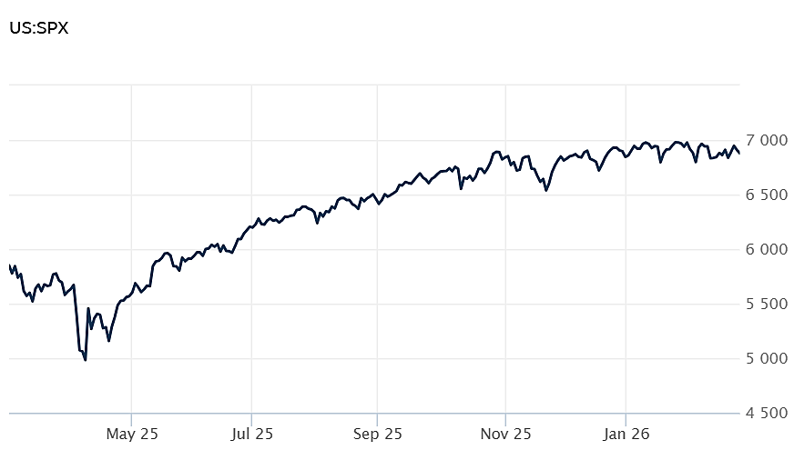
Source: Wall Street Journal

US Economic Growth Slows
US economic growth slowed more than expected during the fourth quarter of 2025 as the government shutdown effected investment and spending. According to the latest reading from the Bureau of Economic Analysis (BEA), Gross Domestic Product (GDP) increased at an annualized rate of just 1.4% during the fourth quarter, significantly below expectations of a 2.5% growth rate.

Consumer spending grew at a slower pace than expected and government spending fell sharply, largely owing to a record length shutdown of the US government. Personal consumption expenditures -- a proxy for consumer outlays -- rose 2.4% during the quarter, below the 3.5% gain booked in the prior period.

The BEA estimated that the shutdown accounted for a full percentage point drag on growth, although it said the precise effect couldn't be quantified. For 2025, the US economy grew at a 2.2% annual rate, well off the 2.8% pace set in 2024. CNBC

Mortgage Rates Fall Below 6%
The average rate of the benchmark long-term US mortgage fell below 6% for the first time since 2022, a welcome sign for a housing market that has been stuck in sluggish mode for years. According to mortgage buyer Freddie Mac, the 30-year fixed rate mortgage fell to 5.98% during the last week of February, down from 6.01% recorded for the previous week. One year ago, the average rate was 6.76%.

Since the beginning of the year, the 30-year mortgage has been flirting with 6%. The fall at the end of February marked the third consecutive decrease. That declining trend began in 2025 and has helped to inject a pickup in home sales toward the end of 2025. Still, the housing market is still struggling with a slump that began in 2022.

Since rates are a key component of home buying decisions, many view the latest news as positive for the upcoming spring home-buying season, which typically kicks off in March. But with most US homes with an outstanding mortgage of 5% or lower, the housing market continues to face significant headwinds. AP News

Fed Minutes Reveal a Divided US Central Bank
According to the minutes from the most recent meeting of the Fed, it now appears clear that the US central bank is deeply divided on where interest rate policy should land in 2026. The Fed is split over how weak the labor market is likely to be in the weeks and months ahead and whether businesses can continue to pass on the costs of tariffs to consumers. The Fed reduced rates three times in 2025, with the most recent reduction coming in December.

The details of the Fed's January meeting revealed that "several participants commented that further downward adjustments to the federal funds rate would likely be appropriate if inflation were to decline in line with their expectations." That sentiment will likely point to further rate cuts down the road.

However, "some participants commented that it would likely be appropriate to hold the policy rate steady for some time ... and a number of these participants judged that additional policy easing may not be warranted until there was clear indication that the progress of disinflation was firmly back on track." That sentiment will likely point to a hold on rate cuts for the time being.

President Trump has long been a proponent of lower rates and a critic of Jerome Powell, the current Fed chair. Powell's term ends on May 23 and Trump has nominated Kevin Warsh as his successor. Should Warsh's nomination proceed in a timely manner, Powell has just two more meetings before he steps down. FRB

This research material was prepared by Burritt Research, Inc.

This material represents an assessment of the market and economic environment at a specific point in time and is not intended to be a forecast of future events, or a guarantee of future results. Forward-looking statements are subject to certain risks and uncertainties. Actual results, performance, or achievements may differ materially from those expressed or implied. Information is based on data gathered from what we believe are reliable sources. It is not guaranteed as to accuracy, does not purport to be complete and is not intended to be used as a primary basis for investment decisions. It should also not be construed as advice meeting the particular investment needs of any investor. Past performance does not guarantee future results.

Indices are unmanaged and investors cannot invest directly in an index. Unless otherwise noted, performance of indices does not account for any fees, commissions or other expenses that would be incurred. Returns do not include reinvested dividends.

The Standard & Poor's 500 (S&P 500) is an unmanaged group of securities considered to be representative of the stock market in general. It is a market value weighted index with each stock's weight in the index proportionate to its market value.

The Nasdaq Composite Index is a market-capitalization weighted index of the more than 3,000 common equities listed on the Nasdaq stock exchange. The types of securities in the index include American depositary receipts, common stocks, real estate investment trusts (REITs) and tracking stocks. The index includes all Nasdaq listed stocks that are not derivatives, preferred shares, funds, exchange-traded funds (ETFs) or debentures.

The Dow Jones Industrial Average (DJIA) is a price-weighted average of 30 actively traded "blue chip" stocks, primarily industrials, but includes financials and other service-oriented companies. The components, which change from time to time, represent between 15% and 20% of the market value of NYSE stocks.

The Conference Board creates the Present Situation Index (PSI) from survey data of approximately 5000 households across the United States to gauge public opinion about the US economy. When the index is positive, people feel good about the current economic situation. When negative, people are less optimistic. The (PSI) along with the Expectations Index are used by The Conference Board to create the Consumer Confidence Index (CCI) which tells us how optimistic (or not) people are about the future of the economy.

The Expectations Index is a component of the Consumer Confidence Index® (CCI), which is published each month by the Conference Board. The CCI reflects consumers' short-term—that is, six-month—outlook for, and sentiment about, the performance of the overall economy as it effects them. The Expectations Index is made up of the average of the CCI components that deal with six-month outlooks for business, employment, and income.

©2026 Wealthcare Capital Management LLC, Wealthcare Advisory Partners LLC, and Wealthcare Capital Partners LLC ("Wealthcare") is a registered investment advisor with the US Securities and Exchange Commission (SEC) under the Investment Advisors Act of 1940. All Rights Reserved.

Information contained herein is at a point in time and subject to change without notice. Information is derived from sources which are believed to be reliable but are not independently audited.

This content is for informational purposes only and is not advice for any individual or a recommendation of any specific investment product or strategy. Wealthcare cannot guarantee any specific financial return results for any client or guarantee a client will in all circumstances of changing personal financial goals and market conditions be able to remain in a client's Wealthcare Plan Comfort Zone®. Past performance is not a guide to future returns. All investments carry a degree of risk of loss of principal and there is no assurance that an investment will provide positive performance over any period of time.



Two James Center, 1021 East Cary Street, Suite 702 | RICHMOND, VA 23219 | 804.644.4711
WealthcareGDX.com

