
Monthly Market Recap

March 2026 Market Recap

The war with Iran delivered major losses to stocks as a new wave of economic and geopolitical uncertainty hit the markets. Gas prices surged to nearly $4 per gallon during March as oil prices eclipsed over $100 a barrel. Jobs tumbled in March as the labor market continued to show signs of fragility. Inflation also remained considerably above the Federal Reserve's (Fed) 2% target.

Stocks Fall Broadly in March as Iran War Weighs on Markets
All the major stock indexes lost significant ground in March. The Dow Jones Industrial Average® (DJIA) led the way lower, losing 5.4%. The broad market S&P 500® (SPX) also lost significant ground in March, shedding 5.1%. The tech-heavy NASDAQ Composite Index (COMP) fell 4.7% during the month. Across the board, stocks represented risk and they were sold at will.

The major factor punishing stocks was the war with Iran, which injected more doubt into the markets, including uncertainty surrounding oil and gas prices and potential instability around global commerce and production. The lack of a clear plan and set of objectives surrounding the war also worried investors. This wave of new anxiety compounded markets already reeling from sell-offs and disappointments surrounding the present and future capabilities of AI.

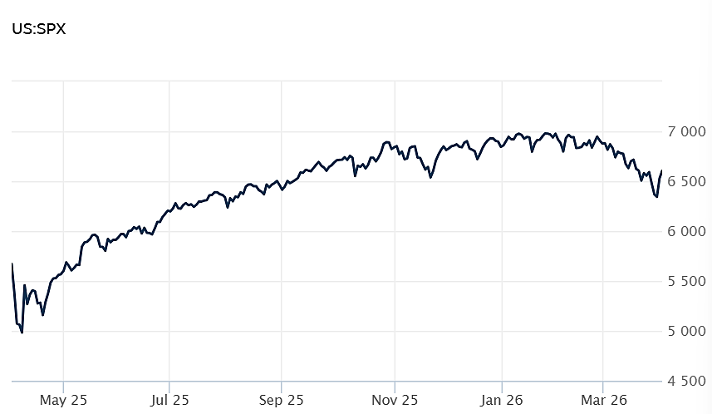
Source: Wall Street Journal

Gas Prices Surge as Iran War Enters Fifth Week
With the Iran war now entering its fifth week, oil prices have surged and along with them gas prices. According to AAA, the national average for a gallon of regular gasoline was $3.98 at the close of March. That marks a 10 cent increase from just one week prior and one dollar compared to the prior month. Current gas prices are now significantly above the national average of $3.15 per gallon recorded a year ago.

The most expensive markets included California ($5.84), Hawaii ($5.33), Washington ($5.30), and Nevada ($4.86). The least expensive included Oklahoma ($3.25), Kansas ($3.27), Iowa ($3.31), and Nebraska ($3.38). Gas prices could peak at $4.36 in May according to research based on Goldman Sachs data.

Many had expected this Spring to usher in a slew of tax law driven refunds and spending. But it now appears that much of that will likely be absorbed by higher gas prices in particular and higher energy costs in general. Many economists now expect higher gas prices to tamp down growth as consumers are forced to spend more on gas and less on discretionary spending like clothes, entertainment, and restaurants.

Gas prices are likely to stay elevated for some time, even if the Iran war ends quickly. That's because disruptions to shipping and production can take considerable time to normalize. AAA, AP News

Payrolls Fall Sharply, Signaling Fragile Job Market
The latest reading of the health of the job market unexpectedly plunged in February, according to the US Bureau of Labor Statistics. The US economy shed 92,000 jobs, significantly above estimates, which called for a loss of 60,000 jobs. While economists were expecting a slowdown in February hiring following a strong January, the results were worse than many had predicted. The unemployment rate increased to 4.4% from 4.3%.

January's job gains were revised down to 126,000 from 130,000 while December's estimated job gains of 48,000 were changed to a loss of 17,000 job swing to the negative. The US economy has now lost jobs in five of the past nine months. All told since May the labor market has lost an aggregate of 19,000 jobs.

The report revealed that most industries lost jobs in February. Leading the way down were losses in health care (down 28,000 jobs); leisure and hospitality (down 27,000 jobs); and construction (down 11,000 jobs).

Many view the job market as fragile, especially considering the net losses since May. Major policy and geopolitical factors are also making hiring risky, including new trade policy rulings from the US Supreme Court, AI-based job losses, and the uncertainty generated by the war with Iran. Together with the on-going risk surrounding tariff policies, businesses are increasingly worn down on the hiring front. CNN

Fed’s Preferred Inflation Gauge Remains Above Target
January's Personal Consumption Index (PCE) booked a gain of 0.3% in January and 2.8% for the year, according to the Bureau of Economic Analysis report. The results were generally in line with economists' expectations, which called for readings of 0.3% and 2.9% respectively. Inflation is still running considerably above the Fed's 2% target.

Ignoring the more volatile components of food and energy prices, the report also showed that so-called core inflation rate came in at 0.4% for the month and 3.1% on an annual basis.

Fed officials typically put more weight on the PCE reading when gauging inflation because it includes broader coverage, better weights, and more contextual reliability. Earlier this month, the other inflation measure -- the Consumer Price Index (CPI) -- came in with a headline number of 2.4% and a core reading of 2.5% for February. The latter reading was the lowest since 2021 but still remained above the Fed's 2% target.

While the Fed held interest rates steady during its March meeting, many believe the war with Iran will have an inflationary effect of many prices up and down the economy.

The report also showed that personal income and spending both increased 0.4% in January. Expectations called for increases of 0.5% and 0.3% respectively. CNBC

This research material was prepared by Burritt Research, Inc.

This material represents an assessment of the market and economic environment at a specific point in time and is not intended to be a forecast of future events, or a guarantee of future results. Forward-looking statements are subject to certain risks and uncertainties. Actual results, performance, or achievements may differ materially from those expressed or implied. Information is based on data gathered from what we believe are reliable sources. It is not guaranteed as to accuracy, does not purport to be complete and is not intended to be used as a primary basis for investment decisions. It should also not be construed as advice meeting the particular investment needs of any investor. Past performance does not guarantee future results.

Indices are unmanaged and investors cannot invest directly in an index. Unless otherwise noted, performance of indices does not account for any fees, commissions or other expenses that would be incurred. Returns do not include reinvested dividends.

The Standard & Poor's 500 (S&P 500) is an unmanaged group of securities considered to be representative of the stock market in general. It is a market value weighted index with each stock's weight in the index proportionate to its market value.

The Nasdaq Composite Index is a market-capitalization weighted index of the more than 3,000 common equities listed on the Nasdaq stock exchange. The types of securities in the index include American depositary receipts, common stocks, real estate investment trusts (REITs) and tracking stocks. The index includes all Nasdaq listed stocks that are not derivatives, preferred shares, funds, exchange-traded funds (ETFs) or debentures.

The Dow Jones Industrial Average (DJIA) is a price-weighted average of 30 actively traded "blue chip" stocks, primarily industrials, but includes financials and other service-oriented companies. The components, which change from time to time, represent between 15% and 20% of the market value of NYSE stocks.

The Conference Board creates the Present Situation Index (PSI) from survey data of approximately 5000 households across the United States to gauge public opinion about the US economy. When the index is positive, people feel good about the current economic situation. When negative, people are less optimistic. The (PSI) along with the Expectations Index are used by The Conference Board to create the Consumer Confidence Index (CCI) which tells us how optimistic (or not) people are about the future of the economy.

The Expectations Index is a component of the Consumer Confidence Index® (CCI), which is published each month by the Conference Board. The CCI reflects consumers' short-term—that is, six-month—outlook for, and sentiment about, the performance of the overall economy as it effects them. The Expectations Index is made up of the average of the CCI components that deal with six-month outlooks for business, employment, and income.

©2026 Wealthcare Capital Management LLC, Wealthcare Advisory Partners LLC, and Wealthcare Capital Partners LLC ("Wealthcare") is a registered investment advisor with the US Securities and Exchange Commission (SEC) under the Investment Advisors Act of 1940. All Rights Reserved.

Information contained herein is at a point in time and subject to change without notice. Information is derived from sources which are believed to be reliable but are not independently audited.

This content is for informational purposes only and is not advice for any individual or a recommendation of any specific investment product or strategy. Wealthcare cannot guarantee any specific financial return results for any client or guarantee a client will in all circumstances of changing personal financial goals and market conditions be able to remain in a client's Wealthcare Plan Comfort Zone®. Past performance is not a guide to future returns. All investments carry a degree of risk of loss of principal and there is no assurance that an investment will provide positive performance over any period of time.



Two James Center, 1021 East Cary Street, Suite 702 | RICHMOND, VA 23219 | 804.644.4711
WealthcareGDX.com

