
Monthly Market Recap

April 2026 Market Recap

Stocks resumed their upward trajectory in April, making significant gains and leaving April's losses firmly in the rearview mirror. The Federal Reserve (Fed) held rates steady, as widely expected. Both key inflation gauges showed high annual numbers, with energy prices a key culprit. Consumer confidence also edged slightly higher but still showed high levels of financial anxiety -- especially about energy prices -- among US consumers.

Stocks Surge in April, Rebound to Record Highs
After a disappointing March, stocks came roaring back in April with all the major indices making significant advances. The broad market S&P 500® (SPX) finished up 10.4% for the month and recorded a new all-time high. The tech-heavy NASDAQ Composite Index (COMP) was up over 15% and recorded a new intra-day high. The Dow Jones Industrial Average® (DJIA) also gained ground, improving 7.1% compared to March.

The markets were buoyed by a mix of positive factors. Investors sold stocks of every stripe without much regard to quality in March and returned in April to bargain hunt. The Fed also didn't make any hawkish surprises and even appears to be open to a rate cut this year. The war with Iran appears to be in a holding pattern for now, which is leading to less general risk in the markets. Better-than-expected corporate results from household names like Alphabet, Amazon, and Eli Lilly also helped stock prices.

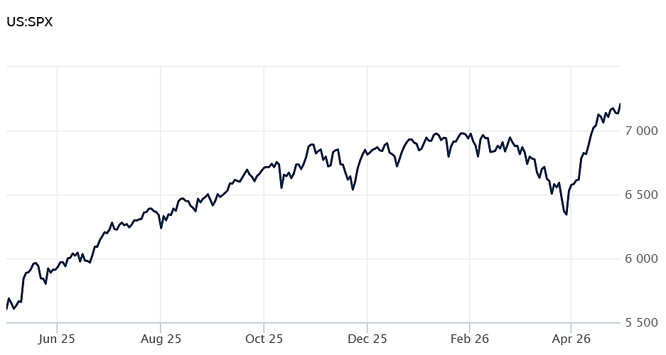
Source: Wall Street Journal

Fed Holds Rates Steady; Rare Split Highlights Policy Divide
Taking no one by surprise, the Fed held interest rates steady during its latest meeting at the end of April. The US central bank's Federal Open Market Committee (FOMC) maintained the benchmark federal funds rate in a target range of 3.5% to 3.75%. The Fed's decision marks the third consecutive time this year the Fed has decided to stand pat. Last year, policy maker cut rates three times.

The Fed indicated that it was sensitive to its dual mandate of price stability and maximum employment but is obviously worried about the Iran war. "Developments in the Middle East are contributing to a high level of uncertainty about the economic outlook," the Fed's statement said.

Notably, the Fed's decision was split along 8-4 lines -- the last time that many FOMC members dissented was October 1992.

The four dissenters were driven by varied reasons. One the one hand Governor Stephen Miran -- as he has done before -- dissented in favor of a quarter point reduction. The other three dissenters -- which included Beth Hammack of Cleveland, Neel Kashkari of Minneapolis and Lorie Logan of Dallas -- agreed with the hold on rates, but disliked the easing bias in the statement, namely "in considering the extent and timing of additional adjustments to the target range for the federal funds rate, the Committee will carefully assess incoming data, the evolving outlook, and the balance of risks."

After the March meeting, Fed officials envisioned one cut this year and another in 2027. FRB, CNBC

PCE Inflation Jumps to 3.5% as Energy Costs Surge
Consumers continue to face a steady rise in prices as the inflationary effects of the Iran war work their way through the economy. The Personal Consumption Index (PCE) -- the Fed's preferred inflation gauge -- grew 0.7% in March, according to the latest report from the Bureau of Economic Analysis. Compared to a year ago, prices are now 3.5% higher, significantly above the Fed's 2% target.

Excluding the more volatile food and energy components, the core PCE -- a less noisy inflation tool employed by policy makers -- rose 0.3% in March and 3.2% compared to a year ago. Core inflation now stands at its highest level since November 2023.

The bulk of the higher prices came from a 1.4% rise in goods prices and, not surprisingly, an 11.6% jump in energy goods and services.

Both the top line and core PCE numbers were in line with forecasts.

The PCE inflation report echoed the Consumer Price Index (CPI) inflation report by the Bureau of Labor Statistics released earlier in the month. CPI increased at an annual rate of 3.3%, driven by a 10.9% jump in energy costs. The rate was the highest since April 2024. CNBC, CNBC

Consumer Confidence Ticks Up but Remains Near Pandemic-Era Lows
Consumer confidence edged up slightly in April, according to the latest reading from the Conference Board. The Conference Board Consumer Confidence Index® increased by 0.6 points to 92.8 from 92.2 in March, which was revised upward. The Expectations Index -- which reflects consumers' short-term outlook for jobs, business, and income -- also rose 1.2 points to 72.2. On the other hand, how consumers feel about the current job and business conditions -- the Present Situation Index -- fell by 0.3 points to 123.8. Even though the index ticked up slightly, it remains stuck at levels not seen since the covid era.

Consumers' write-in responses highlighted continuing worry over the economy in April, as comments about oil and gas, prices, and war increased in frequency compared to March. Consumers are increasingly worried about how the fallout from the Iran war will affect their economic lives.

According to Dana M Peterson, Chief Economist, "consumer confidence edged up in April but was overall little changed, despite material concern about rising gasoline prices as the war in the Middle East prompted a surge in Brent crude oil prices ... Consumer appraisals of current and expected business conditions declined moderately compared to last month. This was offset by modest improvements in consumers’ perceptions of the labor market, both current and expected, as well as income expectations, which were slightly more optimistic in April." Conference Board, AP News

This research material was prepared by Burritt Research, Inc.

This material represents an assessment of the market and economic environment at a specific point in time and is not intended to be a forecast of future events, or a guarantee of future results. Forward-looking statements are subject to certain risks and uncertainties. Actual results, performance, or achievements may differ materially from those expressed or implied. Information is based on data gathered from what we believe are reliable sources. It is not guaranteed as to accuracy, does not purport to be complete and is not intended to be used as a primary basis for investment decisions. It should also not be construed as advice meeting the particular investment needs of any investor. Past performance does not guarantee future results.

Indices are unmanaged and investors cannot invest directly in an index. Unless otherwise noted, performance of indices does not account for any fees, commissions or other expenses that would be incurred. Returns do not include reinvested dividends.

The Standard & Poor's 500 (S&P 500) is an unmanaged group of securities considered to be representative of the stock market in general. It is a market value weighted index with each stock's weight in the index proportionate to its market value.

The Nasdaq Composite Index is a market-capitalization weighted index of the more than 3,000 common equities listed on the Nasdaq stock exchange. The types of securities in the index include American depositary receipts, common stocks, real estate investment trusts (REITs) and tracking stocks. The index includes all Nasdaq listed stocks that are not derivatives, preferred shares, funds, exchange-traded funds (ETFs) or debentures.

The Dow Jones Industrial Average (DJIA) is a price-weighted average of 30 actively traded "blue chip" stocks, primarily industrials, but includes financials and other service-oriented companies. The components, which change from time to time, represent between 15% and 20% of the market value of NYSE stocks.

The Conference Board creates the Present Situation Index (PSI) from survey data of approximately 5000 households across the United States to gauge public opinion about the US economy. When the index is positive, people feel good about the current economic situation. When negative, people are less optimistic. The (PSI) along with the Expectations Index are used by The Conference Board to create the Consumer Confidence Index (CCI) which tells us how optimistic (or not) people are about the future of the economy.

The Expectations Index is a component of the Consumer Confidence Index® (CCI), which is published each month by the Conference Board. The CCI reflects consumers' short-term—that is, six-month—outlook for, and sentiment about, the performance of the overall economy as it effects them. The Expectations Index is made up of the average of the CCI components that deal with six-month outlooks for business, employment, and income.

©2026 Wealthcare Capital Management LLC, Wealthcare Advisory Partners LLC, and Wealthcare Capital Partners LLC ("Wealthcare") is a registered investment advisor with the US Securities and Exchange Commission (SEC) under the Investment Advisors Act of 1940. All Rights Reserved.

Information contained herein is at a point in time and subject to change without notice. Information is derived from sources which are believed to be reliable but are not independently audited.

This content is for informational purposes only and is not advice for any individual or a recommendation of any specific investment product or strategy. Wealthcare cannot guarantee any specific financial return results for any client or guarantee a client will in all circumstances of changing personal financial goals and market conditions be able to remain in a client's Wealthcare Plan Comfort Zone®. Past performance is not a guide to future returns. All investments carry a degree of risk of loss of principal and there is no assurance that an investment will provide positive performance over any period of time.



Two James Center, 1021 East Cary Street, Suite 702 | RICHMOND, VA 23219 | 804.644.4711
WealthcareGDX.com

